Verizon WCAG 2.1 AA Guidelines
Verizon WCAG 2.1 AA Guidelines 1
Section 1: WCAG 2.1 AA Requirement: 9
1.1 Text Alternatives 9
1.1.1 Non-text Content 9
1.2 Time-based Media 9
1.2.1 Audio- only and Video- only (Prerecorded) 10
1.2.2 Captions (Prerecorded) 10
1.2.3 Audio Description or Media Alternative (Prerecorded) 10
1.2.4 Captions (Live) 10
1.2.5 Audio Description (Prerecorded) 11
1.3 Adaptable 11
1.3.1 Info and Relationships 11
Tables Tabular Data: 11
1.3.2 Meaningful Sequence 11
Table Captions: 12
1.3.3 Sensory Characteristics 12
1.3.4 Orientation 12
Label Proximity: 12
1.3.5 Identify Input Purpose 12
1.4 Distinguishable 13
1.4.1 Use of Color 13
1.4.2 Audio Control 13
1.4.3 Contrast (Minimum) 13
1.4.4 Resize Text 14
1.4.5 Images of Text 14
1.4.10 Reflow 14
1.4.11 Non-text Contrast 14
1.4.12 Text Spacing 15
1.4.13 Content on Hover or Focus 15
2.1 Keyboard Accessible 15
2.1.1 Keyboard 15
2.1.2 No Keyboard Trap 15
2.1.4 Character Key Shortcuts 16
2.2 Enough Time 16
2.2.1 Time Adjustable 16
2.2.2 Pause, Stop, Hide 16
2.3 Seizures and Physical Reactions 16
2.3.1 Three Flashes or Below Threshold 17
2.4 Navigable 17
2.4.1 Bypass Blocks 17
Bypass blocks & VZ Accessibility required Landmarks: 17
2.4.2 Page Titled 17
Page Title: Change of context. 18
2.4.3 Focus Order 18
2.4.4 Link Purpose (In Context) 18
2.4.5 Multiple Ways 18
2.4.6 Headings and Labels 19
2.4.7 Focus Visible 19
2.5 Input Modalities 19
2.5.1 Pointer Gestures 19
2.5.2 Pointer Cancellation 19
2.5.3 Label in Name 20
2.5.4 Motion Actuation 20
2.5.5 Target Size 20
3.1 Readable 21
3.1.1 Language of Page 21
3.1.2 Language of Parts 21
3.2 Predictable 21
3.2.1 on Focus 22
3.2.2 on Input 22
3.2.3 Consistent Navigation 22
3.2.4 Consistent Identification 23
3.3 Input Assistance 23
3.3.1 Error Identification 23
3.3.2 Labels or instructions 24
3.3.3 Error Suggestions 24
3.3.4 Error Prevention 25
4.1 Compatible 25
4.1.1 Parsing 25
4.1.2 Name, Role, Value 26
Nesting and Relationships: 26
4.1.3 Status Messages 26
Section 2: Component Requirements: 28
All items not meeting these guidelines are considered Verizon Priority High unless they create a critical blocker for the customer, where there is no alternative interaction. 28
Accordion: 28
1.4 Distinguishable: 28
2.4 Navigable 28
4.1 Compatible: 29
Background Videos and Animations 30
4.1 Compatible: 30
1.4 Distinguishable: 30
2.4 Navigable: 30
Button: 31
1.4 Distinguishable: 31
2.4 Navigable: 31
4.1 Compatible 31
Bread Crumbs: 32
1.4 Distinguishable: 32
2.4 Navigable: 32
4.1 Compatible: 32
Calendar: 33
1.4 Distinguishable: 33
2.4 Navigable 33
4.1 Compatible: 34
Carousels: 34
Carousel Tilelet 35
Tilelet Carousel Interactions: 35
Tilelet Contrast and Color: 36
Mobile App Experience: 36
Carousels Type 1: Complex 36
Standardized All Carousel Interactions (except Tilelet carousel) 36
Complex Carousel Keyboard Navigation Key Notes: 37
Complex Carousel Screen reader Navigation: 38
Complex Carousel Contrast and Color: 39
Carousel Type 2: Medium 40
Standardized All Carousel Interactions (except Tilelet Carousel): 40
Medium Carousel Keyboard Navigation: 41
Medium Carousel Screen reader Navigation: 42
Medium Carousel Contrast and Color: 43
Carousel Type 3: Simple 43
Standardized All Carousel Interactions (except Tilelet Carousel) : 43
Simple Carousel Keyboard Navigation: 44
Simple Carousel Screen reader Navigation: 45
Simple Carousel Contrast and Color: 46
Carousel Standardized interactions (except Tilelet Carousel): 46
Carousel Mobile Navigation: 47
Carousel Mobile Screen reader Navigation: 48
Carousel Contrast and Color: 48
CheckBox 48
1.4 Distinguishable: 49
2.4 Navigable: 49
4.1 Compatible 49
DropDown Select: 49
1.4 Distinguishable: 50
2.4 Navigable 50
4.1 Compatible 51
Dropdown Select Marketing: 52
1.4 Distinguishable: 52
2.4 Navigable 53
4.1 Compatible 54
Dropdown Select – Inline Label: 55
1.4 Distinguishable: 55
2.4 Navigable 56
4.1 Compatible 57
Drag and Drop Component 58
1.4 Distinguishable: 58
2.4 Navigable: 58
4.1 Compatible 59
Headers 60
4.1 Compatible: 60
1.4 Distinguishable: 60
Iframe: 61
4. 1 Compatible 61
Images 61
4.1 Compatible: 61
1.4 Distinguishable: 62
2.4 Navigable: 62
Input Field: 62
1.4 Distinguishable: 62
2.4 Navigable: 63
4.1 Compatible: 63
Input Field – Date: 64
1.4 Distinguishable: 64
2.4 Navigable: 64
4.1 Compatible: 64
Input Field – Phone Number: 65
1.4 Distinguishable: 65
2.4 Navigable: 65
4.1 Compatible: 66
Input Field – Security Code: 67
1.4 Distinguishable: 67
2.4 Navigable: 67
4.1 Compatible: 67
Input Stepper 68
1.4 Distinguishable: 69
2.4 Navigable: 69
Landmarks: 70
4. 1 Compatible 70
3.4 Navigable: 71
Language - Page: 71
4. 1 Compatible 71
Line: 71
1.4 Distinguishable: 71
4.1 Compatible: 71
Link - Text Link: 72
1.4 Distinguishable: 72
2.4 Navigable: 72
4.1 Compatible: 72
Link - Text Link Caret: 73
1.4 Distinguishable: 73
2.4 Navigable: 73
4.1 Compatible: 74
Lists: 75
Unordered lists, Ordered Lists, and Description list 75
1.4 Distinguishable: 75
2.4 Navigable: 75
4.1 Compatible 75
Loader: 76
1.4 Distinguishable: 77
4.1 Compatible: 77
Lockup Pricing: 77
1.4 Distinguishable: 77
4.1 Compatible: 77
Modal (Default): 78
1.4 Distinguishable: 78
2.4 Navigable 78
4.1 Compatible: 79
Navigation - Skip Navigation Links: 79
2.4 Navigable: 79
1.4 Distinguishable: 79
4.1 Compatible: 80
Notification: 80
1.4 Distinguishable: 80
2.4 Navigable: 80
4.1 Compatible: 80
Pagination: 81
1.4 Distinguishable: 81
2.4 Navigable: 81
4.1 Compatible: 82
Radio Box: 82
1.4 Distinguishable: 82
2.4 Navigable: 82
4.1 Compatible: 83
Radio Button 83
1.4 Distinguishable: 83
2.4 Navigable: 83
4.1 Compatible: 84
Radio Swatch: 84
1.4 Distinguishable: 84
2.4 Navigable: 85
4.1 Compatible: 85
Session Timeout 86
4.1 Compatible: 86
2.4 Navigable: 86
1.4 Distinguishable: 86
Superscripts (In-Text Citations): 86
1.4 Distinguishable: 86
2.4 Navigable: 87
4.1 Compatible: 87
Table: 87
Table - Data: 88
1.4 Distinguishable: 88
2.4 Navigable 88
4.1 Compatible: 88
Table Layout: 89
1.4 Distinguishable: 89
2.4 Navigable 89
4.1 Compatible 90
Tabs: 90
1.4 Distinguishable: 90
2.4 Navigable: 90
4.1 Compatible 91
Text Resize and Reflow: 91
Desktop Zoom: 91
Mobile Zoom: 92
One Scroll Direction Only: 92
Tilelet 92
4 Distinguishable: 92
2.4 Navigable: 92
4.1 Compatible 93
Title 93
4. 1 Compatible 93
1.4 Distinguishable: 93
Title Accented: 93
1.4 Distinguishable: 93
Toggle: 94
1.4 Distinguishable: 94
2.4 Navigable: 94
4.1 Compatible: 94
Tooltip: 95
1.4 Distinguishable: 95
2.4 Navigable: 95
4.1 Compatible: 96

NOTICE: Verizon WCAG Guidelines originated from the W3C WCAG which were created for web and mobile but the concepts can be used for other applications and situations, as applicable, to help with overall accessibility. The W3C WCAG 2.1 AA is available for further definition and techniques but this document provides the overview and what we have altered for Verizon Accessibility including severity will high as the highest; however, if when review or creating a defect if the element, interaction, or experience creates a blocker, without a workaround, it will be opened as a critical defect and escalated for resolution. We have adjusted to meet Verizon's needs for our customers and our employees. We have made some optional WCAG 2.1 AA guidelines required for Verizon and have noted accordingly.
We recommend using Verizon Design System (VDS) for components, when possible. The document is formatted to match the layout of VDS breakout of components. The advantage to using VDS is that the Accessibility team partners with VDS on each and every component used to review, discuss, and validate plus if an error does exist the VDS component can be fixed and it will be fixed anywhere that the component is used.
Keep-in-mind even though the guidelines, within this document, are our standards, accessibility can be personal based on experience, so if any Verizon Group employee needs accommodation for any aspect of their work life, it can be requested through BAU accommodation request.
Postscript: Images are for visual purposes only and are print screens from Brand Central and VDS. If an image is used from an external location, source is provided. We use Table of Contents for Quick Reference which can create issues for Screen Reader users. An alternate PDF is available for a cleaner experience. Lastly, we reference the WCAG 2.1 Guideline # for each component, it can seem repetitive but we want to be sure that it is clear what is important for each component as it relates to the guidelines.
Requests for changes or updates to this document go to Barbara Gionti.
For information related to the uniqueness of the following items – please also feel free to use the following for additional references below and reach out to Fred Moltz/Barbara Gionti with questions/clarifications.
- Print Documentation
- Physical space ADA Guidelines
- Hardware 508 section 400
- VDS
- Android native Developer App quality and Accessible Actions
- IOS native Human Interface and Apple Developer
- VZ Red and Black Accessibility

Section 1: WCAG 2.1 AA Requirement:

1.1 Text Alternatives
1. This is a required WCAG 1.1 accessibility guideline and Verizon adjusted priority is high.
2. Provide text alternatives for any non-text content so that it can be changed into other forms people need, such as large print, braille, speech, symbols or simpler language.
3. If an image is informative (i.e., chart/graph, etc.), the alt text should not be more than 150 characters.
4. Images that are informative or provide value to the content must have alt-text that accurately conveys the image purpose. Images that are informative or provide additional value to the content must have an alt-text that accurately conveys the image purpose. If the image purpose exceeds 150 characters, a summary (extended) description should be added below the image.
5. Images that are purely decorative or not informative should be given empty (null) alternative text. i.e., alt=”’. alt null needs to be related code of double quotes

Non-text Content
- This is a required WCAG 1.1.1 accessibility requirement and Verizon adjusted priority is high.
- All non-text content that is presented to the user has a text alternative that serves the equivalent purpose.
- Visual content can be informative or decorative. The same goes for audio and video content.
- The alternative text of an informative image must have a descriptive content, so the same level of information is conveyed to the user. Images that are informative or provide additional value to the content
- In order to provide a descriptive and informative text alternative for an image, an alt attribute on the img element must be used; so that the screen readers can interpret the images easily.
- Alternative text should be used to clearly communicate the intent, purpose, and meaning of the image.
- Alternative text should not include words such as graphic or image so that the screen readers do not announce the redundant information.
- The alternative text length for informative images should not be more than 150 characters.

1.2 Time-based Media
- This is a required WCAG 1.2 accessibility guideline and Verizon adjusted priority is high.
- Time-based media includes various forms of media like video, audio, slides, computer simulations, or any other media that has duration as a property and is presented over time.
- Content is considered time-based media if it's:
- Audio-only
- Video-only
- A combination of audio/video
- Audio and or video combined with an interaction.
- Time-based media helps people with visual impairments, certain cognitive disabilities, language disabilities, hard-of-hearing or deaf, certain cognitive, language, and learning disabilities.
- Text alternatives and captioning are the two most common ways to enhance accessibility for people who have trouble processing the audio portion of a multimedia presentation.

Audio- only and Video- only (Prerecorded)
- This is a required WCAG 1.2.1 accessibility requirement and Verizon adjusted priority is Medium.
- Pre Recorded video files that contain no dialog MUST come with an adjacent or easily reachable text or audio description of what happens on the visual track.
- For prerecorded audio-only and prerecorded video-only media, the following are true, except when the audio or video is a media alternative for text and is clearly labeled as such:
- Prerecorded Audio-only
An alternative for time-based media is provided that presents equivalent information for prerecorded audio-only content.
- Prerecorded Video-only
either an alternative for time-based media or an audio track is provided that presents equivalent information for prerecorded video-only content.
- A text OR audio description must be provided:
- That describes the video content.
- Is easy for all users to locate.
- That describes important video only content.

1.2.2 Captions (Prerecorded)
- This is a required WCAG 1.2.2 accessibility guideline and Verizon adjusted priority is high.
- Captions are provided for all pre-recorded audio content in synchronized media, unless the alternative is clearly labeled as an alternative to captions.
- Prerecorded, web-based video objects/files must come with text-based synchronized captions.
- Pre Recorded audio content may have synchronized captions though a text transcript should be sufficient.

1.2.3 Audio Description or Media Alternative (Prerecorded)
- This is a required WCAG 1.2.3 accessibility guideline and Verizon adjusted priority is Medium.
- An alternative for time-based media or audio description of the prerecorded video content is provided for synchronized media, except when the media is a media alternative for text and is clearly labeled as such.
- Pre Recorded video files containing essential information that is only conveyed visually must come with an adjacent text alternative describing the important visual details.

1.2.4 Captions (Live)
- This is a required WCAG 1.2.4 accessibility guideline with adjustments by Verizon
- The Verizon adjusted priority is high.
- All live multimedia containing audio must come with text-based synchronized captions.
- Verify that the captions:
- Are visible with sufficient color contrast between background and caption text unless the user has the ability to select their own caption settings (background/foreground).
- Are synchronized with the video track
- Identify all speakers
Verizon Accessibility notation of legal interpretation: In meetings, auto generated captions are sufficient if CART (Communication Access real-time translation) is not available by live person, automated can be used as long as it is 90% or above accessible.
- Provide full-text transcripts made available (not live)
- Describe important music and sound effects if relevant to the meaning
- People who are deaf or have a hearing loss can access the auditory information in the synchronized media content through captions.
- All live video with dialog must have synchronized captions.
- Live audio consisting mainly of dialog should have synchronized captions.

Audio Description (Prerecorded)
- This is a required WCAG 1.2.5 accessibility guideline. Verizon adjusted priority is high.
- Audio description is provided for all prerecorded video content in synchronized media.
- All web-based video files containing essential information that is only conveyed visually must come with a synchronized soundtrack with audio.
- People who are blind or have low vision, and those with cognitive limitations will benefit from audio description of visual information.
- Prerecorded multimedia must include audio descriptions.
- Prerecorded video-only content MUST include audio descriptions OR a text transcript.
- Audio descriptions may be provided for live multimedia content and live video-only content.

1.3 Adaptable
- This is a required WCAG 1.3 accessibility guideline. Verizon adjusted priority is high.
- Create content that can be presented in simpler layouts without losing information or structure.
- The purpose of this guideline is to ensure that all information is available in a form that can be perceived by all users.

Info and Relationships
- This is a required WCAG 1.3.1 accessibility guideline. Verizon adjusted priority is high.
- Information, structure, and relationships conveyed through presentation should be available in text.
- When moving or setting focus, the destination element must contain discernible text (either standard text or programmatically associated text).
- Elements must be used according to their meaning, not because of how they appear visually.
- Data cells must be explicitly associated with header cells for data tables, descriptive table captions, and summaries.
- Labels must be associated with form input elements, using label, title, aria-labelledby or aria-label.
- Headings must be marked using the platform heading element. If the headers are visually split on multiple lines, use a break tag then add aria-hidden="true" within the break tag to read properly for screen reader users.
- Lists must be marked using real HTML list elements.

Tables Tabular Data:
- This is a required Verizon Accessibility guideline. Verizon adjusted priority is high.
- Tabular data should be represented in a <table>. Even if the data is not seen visually as in a table.

1.3.2 Meaningful Sequence
- This is a required WCAG 1.3.2 accessibility guideline. Verizon adjusted priority is high.
- The order of the content on a web page must be ordered in such a way that it provides a meaningful sequence.
- Reading and navigating order must be logical and intuitive.
- This Success Criterion may help people who rely on assistive technologies that read content aloud.
- Content must not be inserted into the page at an incorrect location.
- When modal, overlays, popups and tooltips are opened, the content must be announced to the assistance technology (screen readers). Clarification: It is not a defect if all of the content does not read for a modal or overlay at once, if programmatically the title is read and the user can use the arrow key up/down to read all of the information. If all the content is read at one time, the user must be able to stop it from being read and use the arrow key up or down to read the previous or next sentence.
- The content that appears on a page dynamically such as notifications, alerts etc must be announced immediately.

Table Captions:
- This is a required Verizon Accessibility guideline. Verizon priority is medium.
Data tables should have a programmatically-associated <caption> or name (e.g. via aria-label or aria-labelledby).

1.3.3 Sensory Characteristics
- This is a required WCAG 1.3.3 accessibility guideline. Verizon adjusted priority is high.
- Instructions provided for understanding and operating content do not rely solely on sensory characteristics of components such as shape, size, visual location, orientation, or sound.
- The intent of this Success Criterion is to ensure that all users can access instructions for using the content, even when they cannot perceive shape or size or use information about location or orientation.
- People who are blind and people who have low vision may not be able to understand information if it is conveyed by shape or location. Providing additional information other than shape or location will allow them to understand the information.
- Instructions provided to users must rely on more than just visual cues, sounds or auditory cues.

Orientation
- This is a required WCAG 1.3.4 accessibility guideline. Verizon adjusted priority is high.
- Content does not restrict its view and operation to a single display orientation such as portrait or landscape unless a specific display orientation is essential.
- Users with dexterity impairments who have a mounted device will be able to use the content in their fixed orientation.
- Users with low-vision will be able to view content in the orientation that works best for them, for example to increase the text size by viewing content in landscape.

Label Proximity:
- This is a required Verizon Accessibility guideline. Verizon adjusted priority is medium.
- Labels should be visually adjacent to their controls.

1.3.5 Identify Input Purpose
- This is a required WCAG 1.3.5 accessibility guideline. Verizon adjusted priority is high.
- The purpose of each input field collecting information about the user can be programmatically determined when:
- The input field serves a purpose identified in the Input Purposes for User Interface Components section.
- The content is implemented using technologies with support for identifying the expected meaning for form input data.
- Following users will be benefited by this criteria:
- Users with cognitive disabilities and impaired memory who may have difficulties filling out forms will be benefited.
- Users with cognitive disabilities who prefer to use custom icon sets to label forms rather than words will be benefited.
- Users with motor disabilities who have difficulty filling out forms and benefit from the speed of autocomplete will be benefited.

1.4 Distinguishable
- This is a required WCAG 1.4 accessibility guideline. Verizon priority is high.
- Make it easier for users to see and hear content including separating foreground from background.
- Specific techniques for meeting each Success Criterion for this guideline are listed below:
- Using Brand Guideline font
- Making sure any text in images of text is at least 14 points (or digital font) or meets the contrast.
- Providing a highly visible highlighting mechanism for links or controls when they receive keyboard focus.

1.4.1 Use of Color
- This is a required WCAG 1.4.1 accessibility guideline. Verizon adjusted priority is high.
- Color is not used as the only visual means of conveying information, indicating an action, prompting a response, or distinguishing a visual element.
- Color alone must not be used to distinguish links from surrounding text unless the color contrast between the link and the surrounding text is at least 3:1 and an additional differentiation is provided when the link is hovered or receives focus.
- Links must be visually distinguishable from surrounding non-link text.
- Following users will be benefited by this criteria:
- Users with partial sight often experience limited color vision.
- Users who have color-blindness benefit when information conveyed by color is available in other visual ways.
- Users who have problems distinguishing between colors can look or listen for text cues.
- People using Braille displays can detect text cues by touch.
- NOTE: Our Brand Guidelines and Accessibility agree that the use of black on red background or red on black background will not be used except for logo’s or decorative items. The reason is to the common color blindness that can not distinguish the two colors together (if black text on red reads as all black and vice versa)

Audio Control
- This is a required WCAG 1.4.2 accessibility guideline. Verizon adjusted priority is high.
- A mechanism must be provided to stop, pause, mute, or adjust volume for audio that automatically plays on a page for more than 3 seconds.
- This success criterion also benefits people who have difficulty focusing on visual content (including text) when audio is playing.
- Individuals who use screen reading technology need to be able to use the controls to stop sounds that auto play so that they can hear their screen reader.

1.4.3 Contrast (Minimum)
- This is a required WCAG 1.4.3 accessibility guideline. Verizon adjusted priority is high.
- The visual presentation of text and images has a contrast ratio of at least 4.5:1, except for the following:
- Large text and images have a contrast ratio of at least 3:1.
- Text or images of text that are pure decoration, not visible to anyone or that are part of a picture have no contrast requirement.
- Text that is part of a logo or brand name has no contrast requirement.
- Regular text and images of text must have a contrast ratio of at least 4.5:1 with the background.
- Large text and images of large text (at or over 18 point/24px /1.5em or bold 14 point/19px/1.2em) must have a contrast ratio of at least 3:1 with the background.
- Note: as discussed with the Brand team, on our brand colors (red/black) red typeface should not be used on black background and black should not be used on red background. Large text and images of large text (at or over 18 point/24px /1.5em or bold 14 point/19px/1.2em)

1.4.4 Resize Text
- This is a required WCAG 1.4.4 accessibility guideline. Verizon adjusted priority is Medium.
- Web pages should be designed so that users can scale the content up to 200% and the page will still be readable and will not lose any functionality except for captions and images of text.
- The page must be readable and functional when browser zoom is set to 200% of its initial size.
- The page must allow users to zoom in on mobile devices.
- People who have low vision benefit from being able to zoom into the content so they can read it.

Images of Text
- This is a required WCAG 1.4.5 accessibility guideline. Verizon adjusted priority is high.
- If the same visual presentation can be made using text alone an image must not be used to present that text.
- If the technologies being used can achieve the visual presentation, text is used to convey information rather than images of text except for the following:
- The image of text can be visually customized to the user's requirements.
- A particular presentation of text is essential to the information being conveyed.
- This criteria is helpful for the people with low vision, for the people with visual tracking problems and for the people with cognitive disabilities that affect reading.

1.4.10 Reflow
- This is a required WCAG 1.4.10 accessibility guideline. Verizon adjusted priority is high.
- Content can be presented without loss of information or functionality, and without requiring scrolling in two dimensions for:
- Vertical scrolling content at a width equivalent to 320 CSS pixels;
- Horizontal scrolling content at a height equivalent to 256 CSS pixels.
- Content must not require scrolling in two directions (both vertically and horizontally) unless both scrolling directions are essential to the usage or meaning of the content.
- This criteria helps for the users with low vision who magnify their screens and for the users who use mobile devices.

1.4.11 Non-text Contrast
- This is a required WCAG 1.4.11 accessibility guideline. Verizon adjusted priority is high.
- This criteria benefits the people with Low Vision.
- Any visual boundary that indicates the region where a pointer can activate the control must have sufficient contrast of 3:1 with the adjacent background.
- The visual state of an active interface, such as focus, hover, press, check etc., must have sufficient contrast of 3:1 with the background/foreground. Note: If an item is not in active state (such as disabled) it does not need to meet color contrast ratio.
- NOTE: Our Brand Guidelines and Accessibility agree that the use of black on red background or red on black background will not be used except for logo’s or decorative items. The reason is to the common color blindness that can not distinguish the two colors together (if black text on red reads as all black and vice versa)

1.4.12 Text Spacing
- This is a required WCAG 1.4.12 accessibility guideline. Verizon adjusted priority is high.
- This criteria benefits people with Low Vision.
- In content implemented using markup languages that support the following text style properties, no loss of content or functionality occurs by setting all of the following and by changing no other style property:
- Line height (line spacing) to at least 1.5 times the font size;
- Spacing following paragraphs to at least 2 times the font size;
- Letter spacing (tracking) to at least 0.12 times the font size;
- Word spacing at least 0.16 times the font size.
- The spacing between letters, words, lines of text and paragraphs can be adjusted.

1.4.13 Content on Hover or Focus
- This is a required WCAG 1.4.13 accessibility guideline. Verizon adjusted priority is high.
- This criteria benefits people with Low Vision.
- When receiving and then removing pointer hover or keyboard focus triggers additional content to become visible and then hidden, the following are true:
- A mechanism is available to dismiss the additional content such as modal, tooltips, sub menus etc without moving pointer hover or keyboard focus unless the additional content communicates an input error.
- If pointer hover can trigger the additional content such as a modal, tooltips, sub menus etc then the pointer can be moved over the additional content.
- The additional content remains visible until the hover or focus trigger is removed or the user dismisses it.

2.1 Keyboard Accessible
- This is a required WCAG 2.1 accessibility requirement. Verizon adjusted priority high.
- All functionalities should be available using a keyboard.
- People who are blind, or have low vision or people with hand tremors find using a mouse very difficult and therefore usually use a keyboard.
- This guideline uses keyboard interface to acknowledge that web content should be controlled from keyboard keystrokes.

2.1.1 Keyboard
- This is a required WCAG 2.1.1 accessibility requirement. Verizon adjusted priority is high.
- All functionality of the content is operable through a keyboard interface without requiring specific timings for individual keystrokes.
- Page functionalities must be available using the keyboard alone.
- Add tabindex="0" attribute to put all the interactive elements in the keyboard tab order.
- Content that can be operated with a mouse must also be made operable with keyboard or keyboard interface alone.
- Links, buttons, and interactive elements must be keyboard focusable.
- All interactive elements should be navigable using Tab/Shift+Tab/arrow keys and are activated using the Enter/Spacebar keys.
- People who are blind, or have low vision or people with hand tremors find using a mouse very difficult and therefore usually use a keyboard.

2.1.2 No Keyboard Trap
- This is a required WCAG 2.1.2 accessibility requirement. Verizon adjusted priority is high.
- Keyboard focus must not be locked or trapped in a particular page element. The user must be able to navigate to and from all navigable page elements using only a keyboard.
- People who are blind or with physical disabilities rely on a keyboard interface to use the web.
- The intent of this success criterion is to ensure that that content does not trap keyboard focus within subsections of content on a web page.
- Ensure that users can tab to and away from all parts of the web page.
- If a user is trapped on a portion of the web page for a purpose a clear instruction must be provided for the user to end that keyboard trap.

2.1.4 Character Key Shortcuts
- This is a required WCAG 2.1.4 accessibility requirement. Verizon adjusted priority is high.
- If a keyboard shortcut is implemented in content using only upper and lower-case letters, punctuation, number, or symbol characters then at least the single character keys can be turned off, remapped or are only active when the relevant user interface component is in focus.
- This helps users who interact with their computers through speech and users with mobility issues.

2.2 Enough Time
- This is a required WCAG 2.2 accessibility requirement. Verizon priority high.
- Provide users enough time to read and use content.
- Ensuring that users are able to complete the tasks required by the content with their own individual response times.
- The primary approaches deal with eliminating time constraints or providing users enough additional time to allow them to complete their tasks.
- Exception: timing based on security requirements

2.2.1 Time Adjustable
- This is a required WCAG 2.2.1 accessibility requirement. Verizon adjusted priority is high.
- If a page or application has a time limit the user must be given options to turn off, adjust or extend that time limit.
- User login sessions must not timeout the user or kick the user out without first providing an accessible timeout warning and session extension method.
- The mechanism must be visually accessible with a mouse and gain immediate focus with a keyboard and screen reader and allow for the extended time to be selected.
- People with reading disabilities, physical disabilities, cognitive limitations, and learning disabilities should have additional time to read the information.
- People who are blind or with low vision using screen readers may need more time to understand screen layouts, to find information and to operate controls.

2.2.2 Pause, Stop, Hide
- This is a required WCAG 2.2.2 accessibility requirement. Verizon adjusted priority is high.
- For any moving, blinking or scrolling information that starts automatically, or lasts more than 5 seconds there is a mechanism for the user to pause, stop, or hide.
- Automatically updating content must be able to be paused, stopped, or hidden by the user or the user can manually control the timing of the updates.
- People with reading disabilities, cognitive limitations, and learning disabilities who may need more time to read or comprehend information can have additional time to read the information by pausing the content.

2.3 Seizures and Physical Reactions
- This is a required WCAG 2.3 accessibility requirement. Verizon priority high.
- We should not design content that is known to cause any seizures or physical reactions.
- People with seizure disorders can have a seizure if the page has any flashing visual content.

2.3.1 Three Flashes or Below Threshold
- This is a required WCAG 2.3.1 accessibility requirement. Verizon adjusted priority is high.
- A page must not contain content that flashes more than 3 times per second unless that flashing content is sufficiently small and the flashes are of low contrast.
- The intent of this Success Criterion is to enable users to access the entire content of a page without inducing seizures due to photosensitivity.
- People who have photosensitive epilepsy and other photosensitive seizure disorders will benefit from this requirement.

2.4 Navigable
- This is a required WCAG 2.4 accessibility requirement. Verizon priority high.
- Provide ways to help users navigate, find content, and determine where they are in a page.
- The intent of this guideline is to help users find the content they need and allow them to keep track of where they are within a page.

2.4.1 Bypass Blocks
- This is a required WCAG 2.4.1 accessibility requirement. Verizon adjusted priority is high.
- A mechanism is available to bypass blocks of content that are repeated on multiple web pages.
- A method must be provided to skip navigation and other page elements that are repeated across web pages.
- The page must have a skip link, proper heading structure or landmarks.
- The skip link provided must become visible when it receives focus.
- The skip link to the main content should be the first link on the page.
- Frames must have descriptive, informative and unique titles.
- Following users will be benefited by this criteria:
- People who use only the keyboard can reach content with fewer keystrokes that can save time and cause less physical pain for the users.
- People who use screen magnifiers do not have to search through the same headings or other blocks of information to find where the content begins each time they enter a new page.
- People with cognitive limitations as well as people who use screen readers may benefit when links are grouped into lists

Bypass blocks & VZ Accessibility required Landmarks:
- This is a required Verizon Accessibility requirement. Verizon adjusted Priority is medium.
- Landmarks of header, banner, navigation, main, and footer are required.
- Landmarks may be designated with either HTML tags or their equivalent aria roles.

2.4.2 Page Titled
- This is a required WCAG 2.4.2 accessibility requirement. Verizon adjusted priority is high.
- Web Pages must have descriptive and informative page titles that describe the topic or purpose.
- A descriptive title simultaneously gives useful context about the content in the page and identifies which page the user is on.
- This criterion benefits all users in allowing users to quickly and easily identify whether the information contained in the Web page is relevant to their needs
- People with visual disabilities will benefit from being able to differentiate content when multiple Web pages are open.
- People with cognitive disabilities, limited short-term memory and reading disabilities also benefit from the ability to identify content by its title.

Page Title: Change of context.
- This is a required Verizon Accessibility requirement. Priority is high.
- If a page is the result of a user action or scripted change of context, the text of the <title> should describe the result or change of context to the user.

2.4.3 Focus Order
- This is a required WCAG 2.4.3 accessibility requirement. Verizon adjusted priority is high.
- If a Web page can be navigated sequentially and the navigation sequences affect meaning or operation, focusable components receive focus in an order that preserves meaning and operability.
- The navigation order of links, form elements, etc. must be logical and intuitive.
- When a field specific form error message is returned, focus must be moved to that error message or the field specific to the error.
- Focus must be maintained (trapped) within a modal or overlay. Using only a keyboard, the user must not be able to interact with anything outside of the modal area.
- When the modal is activated, focus must be automatically placed inside of the modal.
- When the modal is closed, keyboard, screen reader and visual focus must be placed on the triggering element; or the element that last had focus before the modal appeared.
- Tab Order must be logical and intuitive and follow the visual order and natural reading order of the page.
- People with motor disabilities, reading disorders, People who are blind or have low vision and rely on screen reader and keyboard would need a logical focus order.

Link Purpose (In Context)
- This is a required WCAG 2.4.4 accessibility requirement. Verizon adjusted priority is high.
- The purpose of a link should be clear and easy to understand for all users. Wherever possible, the link text should describe its purpose without needing additional context.
- When it is not possible to add a descriptive link, visually, an aria label needs to be added. For instance, if the visual link is 'buy now' then add an aria label of what the buy now is related to such as "Buy iPhone 15 now". Avoid using repetitive wording such as "go to", "click here", or "click this link".
- People with motion impairment, cognitive limitations and visual disabilities will be able to determine the purpose of a link by exploring the link's context.
- Ideally you should not have a link going to the same destination on the same page. However, if you do then you need to make sure that each of the links going to the same destination page have the same visual descriptive link and the same aria label.

2.4.5 Multiple Ways
- This is a required WCAG 2.4.5 accessibility requirement. Verizon adjusted priority is Medium.
- A page should provide more than one way to navigate through the site to help users locate content in a manner that meets their needs.
- At least two ways should be available to navigate through the page such as a list of related pages, table of contents, site map, site search, or list of all available web pages.
- Blind, visually impaired and cognitive disability users would benefit by having multiple ways of navigation on a page.

2.4.6 Headings and Labels
- This is a required WCAG 2.4.6 accessibility requirement. Verizon adjusted priority is high.
- Headings and labels describe topic or purpose.
- Page headings must be unique, accurate and informative.
- Page headings must follow a sequential hierarchical order except for fixed sections of a page
- All pages must have the main heading as < h1> and only one H1 on the page. The beginning of the main content should start with <h1>.
- Heading text needs to be concise and relatively brief. Text that acts as a heading visually or structurally should be designated as a true heading (<h1>, <h2>, etc.) in the markup.
- Headers that appear on multiple lines should be read as a single unit when navigating with the quick key “h” or when displaying a list of headings on the page. If the page headings are visually split on multiple lines using break tag then add aria-hidden=”true” in the break tag to display the header as a single line to screen readers.
- Labels for form and interactive controls must be informative.
- Labels for form and interactive controls must clearly describe the purpose of the control.
- If multiple buttons on the page have the same name but perform different actions it must be conveyed via text associated with the individual button the distinct purpose of the individual button.
- When a label cannot be provided, ensure that the title attribute or a hidden text is added to the label to make it informative and unique for users of screen readers.
- Users with low vision, motor impaired & cognitive users will benefit from this requirement.

2.4.7 Focus Visible
- This is a required WCAG 2.4.7 accessibility requirement. Verizon adjusted priority is high.
- Any keyboard operable user interface has a mode of operation where the keyboard focus indicator should be visible.
- It must be visually apparent which page element has the current keyboard focus (i.e., tabbing through a page should show where the user is on the page).
- Must provide a consistent visual focus indicator for all interactive elements when they receive keyboard focus.
- This Success Criterion helps anyone who relies on the keyboard to operate the page, by letting them visually determine the component on which keyboard operations will interact at any point in time.

2.5 Input Modalities
- This is a required WCAG 2.5 accessibility requirement. Verizon priority is high.
- Make it easier for users to operate functionality through various inputs other than keyboard.

Pointer Gestures
- This is a required WCAG 2.5.1 accessibility requirement. Verizon adjusted priority is high.
- All functionality that uses multipoint or path-based gestures for operation can be operated with a single pointer unless a multipoint or path-based gesture is essential.
- The purpose of this requirement is to ensure that content can be operated using simple inputs on a wide variety of pointing devices.
- The simpler the gesture, the easier it may be for people with certain cognitive or motor impairments to perform.

2.5.2 Pointer Cancellation
- This is a required WCAG 2.5.2 accessibility requirement. Verizon adjusted priority is high.
- For functionality that can be operated using a single-pointer at least one of the following is true: no down-event, abort/undo, up reversal or essential.
- The purpose of this requirement is to make it easier for users to prevent accidental or erroneous input and provide an outline for enabling users to cancel pointer operations

2.5.3 Label in Name
- This is a required WCAG 2.5.3 accessibility requirement. Verizon adjusted priority is high.
- For user interface components with labels that include text or images of text, the name contains the text that is presented visually.
- Accessible names must be used because Assistive technology uses the accessible names to read to the screen reader user and it needs, whenever possible, to match what is seen visually because not everyone that uses screen readers is completely blind and depend on visual presentation to help them navigate with their assistive technology. If unable to match what is seen on the screen, the accessible name needs to provide more information to help users understand why the screen reader is reading something that is different than what they might see.

2.5.4 Motion Actuation
- This is a required WCAG 2.5.4 accessibility requirement. Verizon adjusted priority is high.
- Ensure that for functionality that can be triggered by device motion (like shaking, tilting) or user gestures detected by device sensors (including a camera) that both of the following are true:
- Motion actuation can be disabled.
- The functionality can be operated without using device motion or user gestures.
- The following users will be benefited by this criteria:
- Users with limited mobility who may have difficulty completing the movements.
- Users whose devices are mounted, like some wheelchair users.
- Users who may accidentally activate gesture functions because of tremors.

2.5.5 Target Size
- Ensure touch targets are large enough to touch accurately.
- The Verizon adjusted priority is high.
- The W3C recommends a minimum target size of 44 x 44 px to ensure that users are able to activate them.
- The size of the target for pointer inputs is at least 44 by 44 CSS pixels except when:
- If the function of a touch target can be performed by touching another target on the same page that is 44 by 44 px, then the target does not need to meet this requirement.
- If the target is inline in a block of text, such as a link or a footnote, then it does not need to be 44 by 44 px.
- If the size of the target is controlled by the user, then it does not need to be 44 px.
- If the target is required to be a specific size, and changing it would affect information or functionality, then it can be smaller than 44 by 44 px.
- Ensure inactive space is provided around all touch targets.
- Provide padding around links and ensure all actionable controls are minimally 7mm across. Use larger controls, i.e. 9mm, or increase the padding around the content to ensure a large touch area
- For text elements include white space around the text in the element frame.
- Mobile users ( Android):
- All pages must function the same way when using a keyboard and gestures with or without screen reader.
- When control options that are triggered by physically manipulating the device (e.g. shaking or tilting) are provided, touch and keyboard operable alternative control options.
- The touchable area of focusable items to be a minimum of 48dp x 48dp. Larger is even better.
- Mobile users ( iOS):
- All pages must function the same way when using a keyboard and gestures with or without screen reader.
- When control options that are triggered by physically manipulating the device (e.g. shaking or tilting) are provided, touch and keyboard operable alternative control options.
- All functionality of the content is operable through a keyboard interface without requiring specific timings for individual keystrokes, except where the underlying function requires input that depends on the path of the user's movement and not just the endpoints.
- This exception relates to the underlying function, not the input technique. For example, if using handwriting to enter text, the input technique (handwriting) requires path-dependent input but the underlying function (text input) does not.
- This does not forbid and should not discourage providing mouse input or other input methods in addition to keyboard operation.
- The following users will be benefited by this criteria:
- Users with mobility or fine motor control impairments.
- Users with tremors.
- Users who can never quite hit that button on the first try.

3.1 Readable
- This is a required WCAG 3.1 accessibility requirement. Verizon priority high.
- Make text content readable and understandable.
- The intent of this guideline is to allow text content to be read by users and by assistive technology.

3.1.1 Language of Page
- This is a required WCAG 3.1.1 accessibility requirement.
- The Verizon adjusted priority is high.
- The default language of each web page can be programmatically determined.
- The primary language of the page MUST be identified accurately on the <html> element.
- People who use screen readers or other technologies, who find it difficult to read written material with fluency and accuracy, people with certain cognitive, language and learning disabilities and people who rely on captions for synchronized media will be benefited by this requirement.

3.1.2 Language of Parts
- This is a required WCAG 3.1.2 accessibility requirement.
- The Verizon adjusted priority is Medium.
- The language of each passage or phrase in the content can be programmatically determined.
- The language of sections of content that are different from the page’s default language must be identified using a valid HTML Lang attribute.
- People who use screen readers or other technologies, who find it difficult to read written material with fluency and accuracy, people with certain cognitive, language and learning disabilities and people who rely on captions for synchronized media will be benefited by this requirement.

3.2 Predictable
- This is a required WCAG 3.2 accessibility requirement. Verizon priority is high.
- Make Web pages appear and operate in predictable ways.
- The intent of this guideline is to help users with disabilities by presenting content in a predictable order from web page to web page and by making the behavior of functional and interactive components predictable.

3.2.1 on Focus
- This is a required WCAG 3.2.1 accessibility requirement.
- The Verizon adjusted priority is high.
- When any user interface component receives focus it does not initiate a change of context.
- When a page element receives focus, it must not cause a substantial change to the page, the spawning of a pop-up window, an additional change of keyboard focus, or any other change that could confuse or disorient the user.
- The loading of a web page must not cause another window or popup to automatically gain focus.
- If an element receives visual focus, the keyboard focus must also be focused and not moved or redirected.
- Elements on a page that receive focus using a keyboard must not cause an unannounced change on the page.
- The intent of this Success Criterion is to ensure that functionality is predictable as users navigate their way through a page. Any component that is able to trigger an event when it receives focus must not change the context.
- Examples of changing context when a component receives focus include:
- Forms submitted automatically when a component receives focus.
- New windows launched when a component receives focus.
- Focus is changed to another component when that component receives focus.
- Elements on a page that receive focus using a keyboard must not cause an unannounced change on the page.
- This success criterion helps people with visual disabilities, cognitive limitations, and motor impairments by reducing the chance that a change of context will occur unexpectedly.

3.2.2 on Input
- This is a required WCAG 3.2.2 accessibility requirement.
- The Verizon adjusted priority is high.
- Changing the setting of any user interface component does not automatically cause a change of context unless the user has been advised of the behavior before using the component.
- The intent of this Success Criterion is to ensure that entering data or selecting a form control has predictable effects.
- Make sure that forms don’t submit on input of data.
- Make sure that focus doesn’t move to next form control once a form field is populated with data.
- Provide a submit button for all forms.
- Ensure that control over how data is populated is in the hands of your users.
If there is a change of context, then provide an instruction that is available for all user groups.
- This Success Criterion helps users with disabilities by making interactive content more predictable. Users with visual disabilities or cognitive limitations, Individuals who are blind or low vision who are unable to use the content are benefited by this criteria.

3.2.3 Consistent Navigation
- This is a required WCAG 3.2.3 accessibility requirement.
- The Verizon adjusted priority is high.
- Navigational mechanisms that are repeated on multiple Web pages within a set of Web pages occur in the same relative order each time they are repeated, unless a change is initiated by the user.
- The intent of this Success Criterion is to encourage the use of consistent presentation and layout for users who interact with repeated content within a set of Web pages and need to locate specific information or functionality more than once.
- Keep navigation menus in the same location.
- Present the navigation menus in the same order on all pages.
- Represent all the standard elements like logo, search functionality, and skip links etc. in the same location on all the pages.
- Using a standard template will help achieve this success criteria.
- This helps users with cognitive limitations, users with low vision, users with intellectual disabilities, and also those who are blind.

3.2.4 Consistent Identification
- This is a required WCAG 3.2.4 accessibility requirement.
- The Verizon adjusted priority is Medium.
- Elements such as labels, names, and text alternatives for content that have the same functionality across multiple web pages must be consistently identified.
- The intent of this Success Criterion is to ensure consistent identification of functional components that appear repeatedly within a set of Web pages.
- Icons & images that are used repeatedly and provide the same function must be provided with the same alternative text.
- Elements with the same function should be named & labeled consistently.
- Use icons/images that are consistent. For example print, twitter, Facebook etc.
- Images that have different meaning in different contexts will need different alternative text depending on the context.
- People who depend on text alternatives can have a more predictable experience. They can also search for the component if it has a consistent label on different pages.

3.3 Input Assistance
- This is a required WCAG 3.3 accessibility requirement. Verizon priority is high.
- Help users avoid and correct mistakes.
- When people do make mistakes this criteria refers to the techniques that help them recover from errors.
- This guideline seeks to reduce the number of serious errors that users make, increase the likelihood that users will notice their errors, and help users understand what they must do to correct errors.

3.3.1 Error Identification
- This is a required WCAG 3.3.1 accessibility requirement.
- The Verizon adjusted priority is high.
- Focus must go to the input field that has the error. If there are multiple items that have errors the user must be notified which fields have the issues so that they can be resolved. Focus goes to the alert message than to the next interactive field so the user can review each to fix.
- If an input error is automatically detected, the item that is in error is identified and the error is described to the user in text.
- Efficient, intuitive and clearly identified text-based alerts must be provided to users for form validation cues and errors.
- Error message must identify which field has the error.
- The error icon next to a field that has failed validation must identify the field or the error must be described in text.
- The message that indicates that form submission failed must be exposed to assistive technologies.
- Input validation failures must be described in text.
- The intent of this Success Criterion is to ensure that users are aware that an error has occurred and can determine what is wrong. The error message should be as specific as possible.
- Make sure that errors are in text and use aria-describedby to bind the form control with the error programmatically.
- Don’t use color or visual cues to point out form errors. NOTE: Our Brand Guidelines and Accessibility agree that the use of black on red background or red on black background will not be used except for logo’s or decorative items. The reason is to the common color blindness that can not distinguish the two colors together (if black text on red reads as all black and vice versa)
- Make sure that errors are distinguished from the regular text on the web page.
- Make sure error feedback should be made available immediately after form submission and error feedback must be descriptive and informative.
- This Success Criterion may help people who are blind, with cognitive, language, and learning disabilities who have difficulty understanding the meaning represented by icons and other visual cues.

3.3.2 Labels or instructions
- This is a required WCAG 3.3.2 Accessibility requirement.
- The Verizon adjusted priority is high.
- Labels or instructions are provided when content requires user input.
- Unique labels for form field elements must be provided. Form elements labels must be descriptive and visible.
- Labels must be descriptive, informative and accurate.
- Labels for form field elements must be provided for all users.
- The visible label must be persistent. For example, a placeholder cannot be used as the only visual label for a text field. The placeholder is not visible after data is entered in the text field.
- The visible label must convey the purpose of the form control clearly.
- The visible label must be properly positioned directly next to or above the form field.
- Sufficient instructions for form field elements must be provided.
- Essential instructions needed for successful form element validation must be available in text for all users.
- Instructions must be complete, accurate and not misleading.
- Labels, instructions, or error messages must be provided when form fields require user input.
- People with cognitive disabilities benefit out of this criteria by providing persistent, visible labels and instructions.

3.3.3 Error Suggestions
- This is a required WCAG 3.3.3 accessibility requirement.
- The Verizon adjusted priority is high.
- If an input error is automatically detected and suggestions for correction are known, then the suggestions are provided to the user, unless it would jeopardize the purpose of the content.
- Error messages must:
- Indicate expected data format.
- Indicate expected range of data values.
- Instruct users how to fix the error.
- Provide descriptive errors.
- Provide visible hints that will enable users to avoid errors during form submissions.
- Associate the errors with form controls using aria-describedby.
- People who are visually impaired, cognitive and motor disabled users understand more easily the nature of the input error and how to correct it.

3.3.4 Error Prevention
- This is a required WCAG 3.3.4 accessibility requirement.
- The Verizon adjusted priority is high.
- If input errors are automatically detected, suggestions must be provided in text for fixing the input in a timely and accessible manner before the data is submitted to the server.
- The intent of this Success Criterion is to help users with disabilities avoid serious consequences as the result of a mistake when performing an action that cannot be reversed.
- A mechanism should be available after data submissions for reversibility.
- Data entered by the user is checked for input errors and the user is provided an opportunity to correct them.
- A mechanism is available for reviewing, confirming, and correcting information before finalizing the submission.
- Instructions are provided explaining how to reverse or cancel the transaction.
- If the user can change or delete data, the changes/deletions must be reversible, verified, or confirmed.
- Users must have the ability to undo an accidental deletion or cancellation of the data types.
- Users must be given the opportunity to review and edit information before data is submitted.
- This criteria helps people with cognitive and motor disabilities to understand the nature of the error and how to correct it.

4.1 Compatible
- This is a required WCAG 4.1 accessibility requirement. Verizon Priority is high.
- Maximize compatibility with current and future assistive technology users including assistive technologies.
- The purpose of this guideline is to support compatibility with current and future assistive technology users.

4.1.1 Parsing
- This is a required WCAG 4.1.1 accessibility requirement but as of 6/30/2023 it is no longer a required Verizon guideline and it will be removed officially from WCAG when WCAG 2.2 is completed/published.
  - In content implemented using markup languages, elements have complete start and end tags, elements are nested according to their specifications, elements do not contain duplicate attributes, and any IDs are unique, except where the specifications allow these features.
  - The intent of this Success Criterion is to ensure that assistive technology users can accurately interpret and parse content.
  - Elements must have complete start and end tags.
  - Elements must be nested to their specifications.
  - Elements must not contain duplicate attributes.
  - Element IDs must be unique.

4.1.2 Name, Role, Value
- This is a required WCAG 4.1.2 accessibility requirement.
- The Verizon adjusted priority is high.
- The name, role and value of page components must be programmatically determinable by assistive technologies.
- The intent of this Success Criterion is to ensure that Assistive technologies can gather information about, activate and keep up to date on the status of user interface controls in the content.
- Use native HTML elements wherever possible.
- Non-HTML standard controls (customized controls) for example, DIV and SPAN - must be keyboard accessible and have ARIA roles, states and property values that must always be defined.

Examples of roles, states, and values for a button are:
- role=”button” to announce a button
- aria-pressed=”true” to announce state of toggle button
- aria-expanded="true" to announce expanded/collapsed state of trigger element

Nesting and Relationships:
- This is a required Verizon accessibility requirement. Verizon priority is high.
- Markup must adhere to required parent-child relationships of elements and attributes. ARIA relationships (e.g. parent-child, aria-owns, etc.) should adhere to WAI-ARIA Authoring Practices
- Providing role, state, and value information on all user interface components enables compatibility with assistive technology, such as screen readers, screen magnifiers, and speech recognition software, used by people with disabilities.

4.1.3 Status Messages
- This is a required WCAG 4.1.3 accessibility requirement.
- The Verizon adjusted priority is high.
- In content implemented using markup languages, status messages can be programmatically determined through role or properties such that they can be presented to the user by assistive technologies without receiving focus.
- The intent of this success criterion is to make users aware of important changes in content that are not given focus, and to do so in a way that doesn't unnecessarily interrupt their work.
- The scope of this success criterion is specific to changes in content that involve status messages. There are two main criteria that determine whether something meets the definition of a status message:
- The message provides information to the user on the success or results of an action, on the waiting state of an application, on the progress of a process, or on the existence of errors. For e.g. after a user presses a Search button, the page content is updated to include the results of the search, which are displayed in a section below the Search button. The change to content also includes the message "5 results returned" near the top of this new content. This text is given an appropriate role for a status message. A screen reader announces, "Five results returned".'
- The message is not delivered via a change in context. For e.g. after a user submits a form, text is added to the existing form which reads, "Your form was successfully submitted." The screen reader announces the same message.
- When there are more than 1 interactive element on the notification, Initial focus should always be on the Close Button and on tab key focus it should move to another interactive element in the notification.
- The intended beneficiaries are blind and low vision users of assistive technologies with screen reader capabilities.
- An additional benefit is that assistive technologies for users with cognitive disabilities may achieve an alternative means of indicating status messages, as preferred by the user.

Section 2: Component Requirements:

All items not meeting these guidelines are considered Verizon Priority High unless they create a critical blocker for the customer, where there is no alternative interaction.

Accordion:
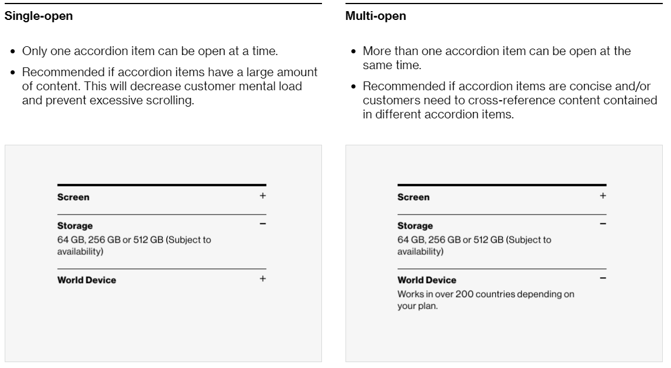

1.4 Distinguishable:
- Ensure that the color contrast meet rules;
- h Images and Large text (at or over 18 point/24px /1.5em or bold 14 point/19px/1.2em) must provide a color contrast ratio of at least 3:1
- Regular text (below 18 point/24px /1.5em or bold 14 point/19px/1.2em) must provide a color contrast ratio of at least 4.5:1
- Do not use color as only indicator.
- Content must not rely solely on visual characteristics such as shape, size, visual location, or orientation to convey meaning.
- NOTE: Our Brand Guidelines and Accessibility agree that the use of black on red background or red on black background will not be used except for logo’s or decorative items. The reason is to the common color blindness that can not distinguish the two colors together (if black text on red reads as all black and vice versa)

2.4 Navigable
1. All accordion buttons or elements must be accessible using the keyboard alone (without a mouse), e.g. using the Tab and Shift Tab key.
2. All accordion buttons or elements must have the ability to be activated using the
ENTER or SPACEBAR keys, i.e., anything that can be clicked on with a mouse device, must also activate upon pressing the Enter or Spacebar key.
- All accordion interactive elements must show a visual indicator when in a focus. And the color contrast for the focus indicator (at least 3px by 3px) against the background must be at least 3 to 1.
- Screen reader users should be able to use the quick navigation key “b” to bring focus and navigate between the buttons.
- If the expanded content does not expand to the right or below the trigger element, then screen reader focus should be moved to the start of the expanded content to preserve meaning and operability.
- For Mobile Screen Reader users, the swipe right and left gesture should be used to navigate through the page, with the focus rendering in a consistent manner.
- Double-tapping on the trigger element expands and collapses the related content.

4.1 Compatible:
1. All the accordion button elements on the page must provide a unique label that informs the user to either “Expand/Collapse” and that it is an interactive element (“Button”)
- <button> or role=”button” to announce a button
- aria-expanded="true" to announce expanded state of trigger element
- aria-expanded="false" to announce collapse state of trigger element
- aria-controls=“IDRefContent” Refers to the expanded content associated with the trigger element.
2. The accordion content should have an aria-hidden attribute that is toggled between true or false.
- aria-hidden=“true” the hidden content must not be announced by Screen Readers.
- id=“IDRefContent” uniquely identifies the hidden content referenced by aria-
controls.
- The accordion content container element cannot be a child/descendant of the triggering CTA.

Background Videos and Animations

4.1 Compatible:
1. Important content MUST NOT be conveyed through background videos and animations, unless users have full control over playback, and full access to any required captions, transcripts, and audio descriptions.
2. A method MUST be provided to pause, stop, or hide any background videos or animations that begin playing automatically and which last 5 seconds or more.
3. The media player itself must be accessible for keyboard interaction, and screen reader interaction.
4. A method SHOULD be provided to pause and restart background videos and animations.
5. Movement within background videos and animations SHOULD be minimal.
6. Background videos and animations SHOULD NOT contain sounds.
7. Prerecorded video-only content must include an audio description (narrated video description) of important visual content.
8. All prerecorded audio and video must have a transcript of dialog, narration, and other informative and descriptive sounds.
8. Prerecorded video-only must include a text description.
9. Prerecorded audio or video-only content must have synchronized captions.
10. Page must not have content that flashes more than 3 times per second unless that flashing content is sufficiently small, the flashes are of low contrast, and do not violate general flash thresholds.

1.4 Distinguishable:
- Ensure that the color contrast meet rules;
  - Images and Large text (at or over 18 point/24px /1.5em or bold 14 point/19px/1.2em) must provide a color contrast ratio of at least 3:1
  - Regular text (below 18 point/24px /1.5em or bold 14 point/19px/1.2em) must provide a color contrast ratio of at least 4.5:1
- Do not use color as only indicator.
- Content must not rely solely on visual characteristics such as shape, size, visual location, or orientation to convey meaning.

2.4 Navigable:
1. If the video is an interactive element it must be keyboard navigable and operable using the Tab key to navigate between the CTA’s and Spacebar or Enter Key to interact with the CTA.
2. All interactive elements must show a visual indicator when in a focus. And the color contrast for the focus indicator (at least 3px by 3px) against the background) must be at least 3 to 1.
3. For mobile all informative and interactive content of the video should be accessible with the left and right swipe gestures. Double tap should activate interactive content.

Button:
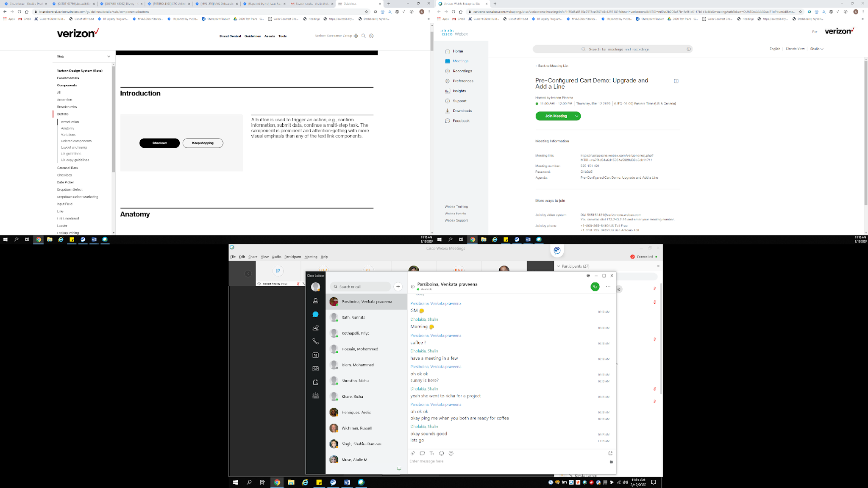

1.4 Distinguishable:
- Ensure that the color contrast meet rules;
- Images and Large text (at or over 18 point/24px /1.5em or bold 14 point/19px/1.2em) must provide a color contrast ratio of at least 3:1
- Regular text (below 18 point/24px /1.5em or bold 14 point/19px/1.2em) must provide a color contrast ratio of at least 4.5:1
- Do not use color as only indicator.
- Content must not rely solely on visual characteristics such as shape, size, visual location, or orientation to convey meaning.

2.4 Navigable:
- All buttons must be accessible using the keyboard alone (without a mouse), e.g. using the Tab and Shift Tab key.
- All buttons must have the ability to be activated using the ENTER or SPACEBAR keys, i.e., anything that can be clicked on with a mouse device, must also activate upon pressing the Enter or Spacebar key.
- Screen reader users should be able to use the quick navigation key “b” to bring focus to and navigate between buttons.
- All interactive elements must show a visual indicator when in a focus. And the color contrast for the focus indicator (at least 3px by 3px) against the background) must be at least 3 to 1.
- For Mobile Screen Reader users, the swipe right and left gesture should be used to navigate through the page, with the focus rendering in a consistent manner.
- Double-tapping on an interactive element activates the CTA.

4.1 Compatible
- All the button elements on the page must be provided a unique label that is informative to the user. E.g. “next slide”, “Close overlay”, “edit color and storage”, etc.
- Each button has a unique id associated and should have ARIA roles, states and property values that must always be defined.
- <button role=”button”> indicates a button element.
- aria-pressed=”true” (optional) indicates selected state.
- aria-label=”some text” (optional) provides the label on a single line.

Bread Crumbs:

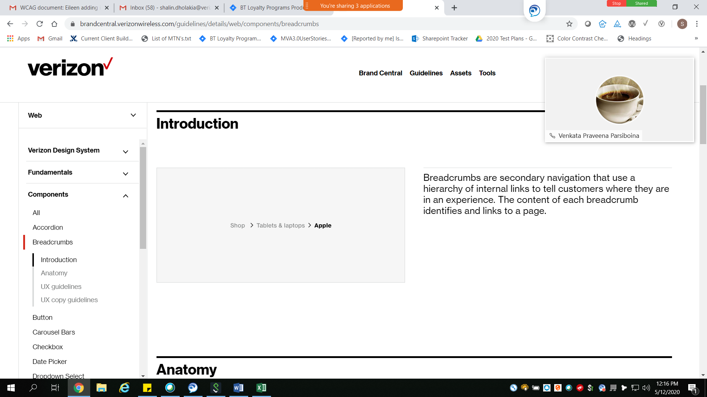

1.4 Distinguishable:
- Ensure that the color contrast meet rules;
- Images and Large text (at or over 18 point/24px /1.5em or bold 14 point/19px/1.2em) must provide a color contrast ratio of at least 3:1
- Regular text (below 18 point/24px /1.5em or bold 14 point/19px/1.2em) must provide a color contrast ratio of at least 4.5:1
- Do not use color as only indicator.
- Content must not rely solely on visual characteristics such as shape, size, visual location, or orientation to convey meaning.

2.4 Navigable:
- All links must be accessible using the keyboard alone (without a mouse), e.g. using the Tab and Shift Tab key.
- All links must have the ability to be activated using the ENTER or SPACEBAR keys, i.e., anything that can be clicked on with a mouse device, must also activate upon pressing the Enter or Spacebar key.
- All links and interactive elements must show a visual indicator when in a focus. And the color contrast for the focus indicator (at least 3px by 3px) against the background) must be at least 3 to 1.
- For Mobile Screen Reader users, the swipe right and left gesture should be used to navigate through the page, with the focus rendering in a consistent manner.
- Double-tapping on an interactive element activates the CTA.

4.1 Compatible:
1. All link elements on the page must be provided a unique label that is informative to the user. Links should tell users where they are going. For example, “learn more about Google Pixel 2 XL”, “Buy the Google Pixel 2 XL now”, “shopping cart 2 items”, etc.
2. Each link has a unique id associated and should have ARIA roles, states and property values that must always be defined.
- <div role=”navigation” aria-label=”breadcrumb”> identifies the container for the bread crumb links.
- <a role=”link”> to announce a link
- aria-label=”some text” (optional) provides the label on a single line.
- tabindex=”0” inserts the link into the tab focus order.
- tabindex=”-1” REMOVES the link FROM the tab focus order.
- aria-hidden=”true” (not recommended for link element) hides the link but does not remove the link from tab focus order, and creates confusion for assistive technology.
- aria-current=”true” (optional) indicates the currently selected bread crumb.
- HTML disabled or aria-disabled (optional) indicates the link is not available.
3. Ensure there is no HTML code within aria labels; examples include:
- &sup;
- &trad;
- <br>

Calendar:
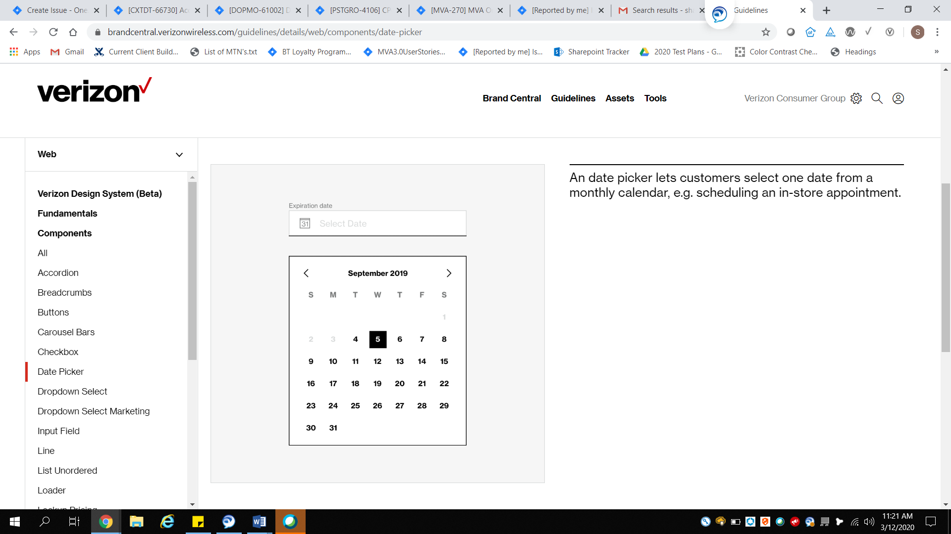

1.4 Distinguishable:
- Ensure that the color contrast meet rules;
- Images and Large text (at or over 18 point/24px /1.5em or bold 14 point/19px/1.2em) must provide a color contrast ratio of at least 3:1
- Regular text (below 18 point/24px /1.5em or bold 14 point/19px/1.2em) must provide a color contrast ratio of at least 4.5:1
- Do not use color as only indicator.
- Content must not rely solely on visual characteristics such as shape, size, visual location, or orientation to convey meaning.

2.4 Navigable
- All Calendar/Date Pickers must be accessible using the keyboard alone (without a mouse), e.g. using the Tab and Shift Tab key.
- All Calendar/Date Pickers must have the ability to be activated using the ENTER or SPACEBAR keys, i.e., anything that can be clicked on with a mouse device, must also activate upon pressing the Enter or Spacebar key.
- Keyboard focus order should be from the first interactive element and then move in sequential order from top to bottom, left to right.
- Escape key should close the calendar widget and focus should return to the trigger element, i.e., the calendar button.
- Users should never be forced to tab or swipe through the entire calendar to reach subsequent page elements. Users should never be trapped tabbing or swiping through a continuously scrolling calendar.
- All interactive elements within the calendar must show a visual indicator when in a focus. And the color contrast for the focus indicator (at least 3px by 3px) against the background) must be at least 3 to 1.
- For Mobile Screen Reader users, the swipe right and left gesture should be used to navigate through the page, with the focus rendering in a consistent manner.
- Double-tapping on an interactive element activates the CTA.

4.1 Compatible:
1. All link elements on the page must be provided with a unique label that is informative to the user, avoid using repetitive wording (i.e. "go to", "click here to", “this is a”, etc.)
2. Each link has a unique id associated and should have ARIA roles, states and property values that must always be defined.
3. The layout of the calendar should include:
- Line 1: Month and year, (Previous and Next Month buttons, Previous and Next Year buttons)
- Line 2: Days of the Week
- Next few lines: show dates of the month in grid format
Screen reader Labels announce the Day of the Week, Month, Date, and Year.
- An edit field should be provided for the user to input the date, with instructions for the correct format (i.e. MM/DD/YYYY) (optional)
4. Provide a visual focus indicator for all interactive elements in the calendar widget.
5. If there is a disabled/Unavailable option; informative text should be rendered.

Carousels:
Since carousels are not a good accessibility experience, we have tweaked the guidelines to make sure that we are addressing carousels in a consistent fashion and that we make sure that a consistent approach for keyboard only and screen reader users is created to avoid a trap and to make the experience as seamless as it can be when single or multiple navigational elements are included. Additionally, Verizon Design System has provided abridged notes on items to consider. Available upon request to Barbara Gionti.
The easiest to navigate for people using assistive technology is the Tilelet Carousel.

Carousel Tilelet
Note: Any interactive element within the tile must follow its related guidelines. For instance, if there is a video it also must meet the video related guidelines. 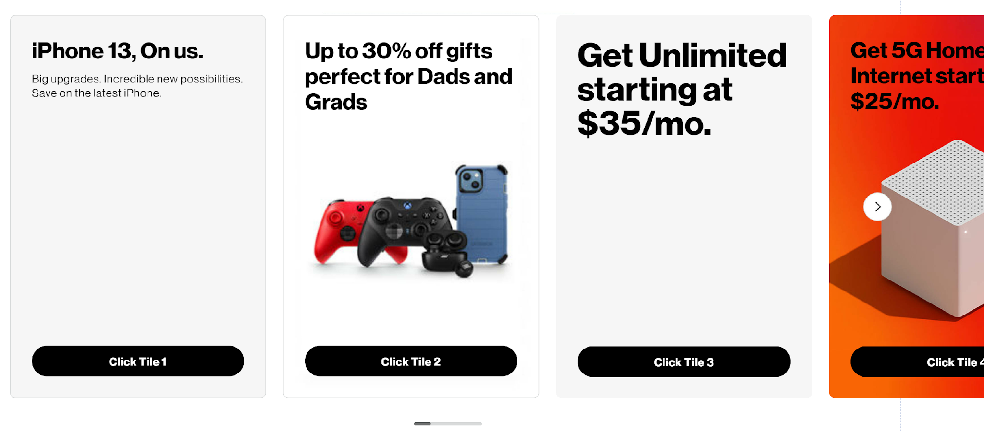
Tilelet Carousel displays a collection of Tilelet components in sequential order and includes:
- Tilelet that can be configured with a background image but is fully clickable container with Title, subtitle, optional directional and descriptive icons with a badge (optional).
- The previous button and the next button navigate the user through the Tilelet carousel
- Scroll bar identifies where, in progress, the user is within the carousel and is meant as a visual indicator of progress even though it can be moved with a mouse, it is meant as a guide and the same interaction type can be accomplished with a keyboard only (left / right) or screen reader using the using the pagination arrows (previous/next) or navigational element that moves the slides forward.

Tilelet Carousel Interactions:
- The previous button and the next button navigate the user through the Tilelet carousel to the previous group of tiles or the next group of tiles. The tiles are moved in groups of either 1, 2, 3, 4 or more.
- The scroll bar is a visual indicator of progress and although it can be interacted with the mouse, like all scroll bars, interaction with the Tilelet carousel scroll bar for keyboard only and screen reader users is keyboard only (left / right) or screen reader using the using the pagination arrows (previous/next) or navigational element that moves the slides forward.
- The previous and next buttons, within the carousel are activated with enter or space on the keyboard. Once user has activated (Pressing Enter/Spacebar) the focus shifts to the first active tile in the group. The group includes 1, 2, 3, 4 or more tiles. A tile, within the Tilelet carousel is an interactive element and entire tile receives focus
- Each tile, in the Tilelet carousel, is coded as a button and can be activated with space or enter on the keyboard.
- User can use the tab key, on the keyboard, to navigate through all interactive elements within the Tilelet carousel. The tile, in the Tilelet carousel can contain interactive elements such as a tooltip, button, or other interactive elements and the focus must be logical and go in order of placement on the tile. Tab key, on the keyboard moves user to next tile after the last interactive element on the current tile. The exception to this is when the last tile in the group is reached (group of 1, 2, 3, 4 or more), focus will go to the next arrow button (navigational element) on the Tilelet carousel. This allows the user to activate the next arrow button or tab to get out of the Tilelet carousel.
- The user must never be trapped within the Tilelet carousel using keyboard (tab key or previous/next buttons) nor with screen reader (using arrow keys) and user must be able to use background navigation, shift+tab, on keyboard, to go back to the last interactive element visited within the Tilelet carousel.
- For screen reader users the title of the tile must be read with number of tiles within the Tilelet carousel and where they are within that count. For example, if I am on the 3rd tile and that 3rd tile is the iPhone 14 Pro Trade-in Promotion code must include slide title and slide number of x “iPhone 14 Pro Trade-in Promotion tile 3 of 12
- Screen reader users must be able to use the arrow keys (up/down), on the keyboard to ‘read ahead’ the content within the Tilelet carousel.
- A peak through to indicate that a tile, in the Tilelet is available may occur and is used as a visible indicator. The previous button and the next button will move the peekable slide to focus.

Tilelet Contrast and Color:
- All elements within the Tilelet carousel must meet the minimum color contrast ratio of 3:1. The most at-risk area for color contrast will be the Tilelet background and the previous button and the next button based on placement.
- All interactive elements within the Tilelet carousel must have a visible focus indicator and that visible focus indicator must meet color contrast ratio of 3:1 minimum.

Mobile App Experience:
The only difference between the mobile experience (app or dotcom experience) is that the method for interaction changes based on the mobile gestures:
- Double tap to activate/open the tile, in the Tilelet.
- Swiping right or left the screen reader moves the user between the tiles, in the Tilelet group.
- Double tap activates tiles.
- Double tap on the navigational elements (previous/next) to display the next group of tiles. Double tap moves focus to the first tiles in the group.
The more difficult to use carousels are outlined below with

Carousels Type 1: Complex
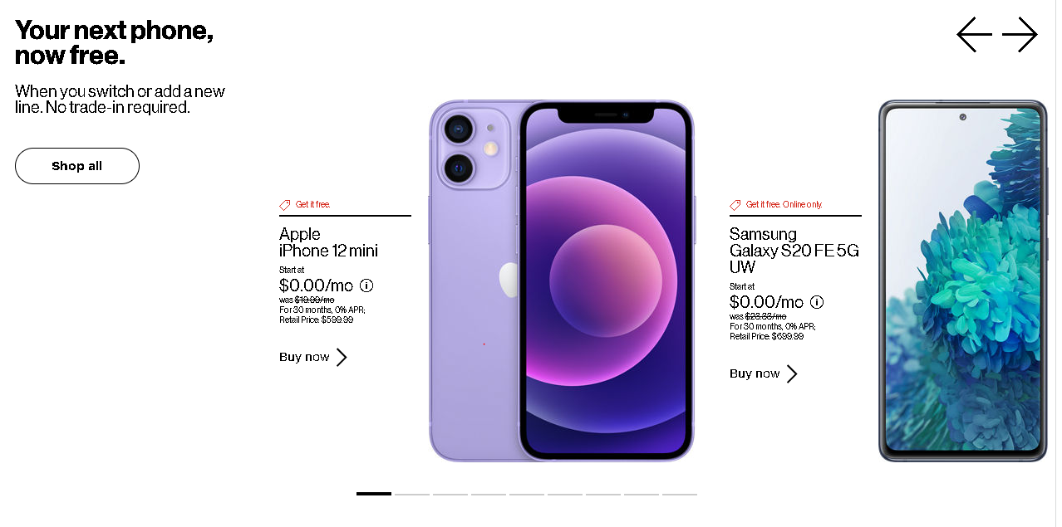

Standardized All Carousel Interactions (except Tilelet carousel)
- The navigational elements of the carousels are Previous button, Next button and the Pagination bars.
- The navigational elements (Previous/Next and Pagination Bars) should be activated using Enter/Spacebar key.
- Once user has activated (Pressing Enter/Spacebar) the navigational elements (Previous/Next and Pagination Bars) the keyboard and screen reader focus should shift only to the first interactive element of the active visible slide and not on the entire carousel or slide.
- If there are no interactive elements on the slide then once user has activated (Pressing Enter/Spacebar) the navigational elements (Previous/Next and Pagination Bars), the keyboard and screen reader focus should stay on the navigational elements (Previous/Next and Pagination Bars) and an alert should be announced for screen reader users.
- When user navigates using the tab key or the keyboard arrow keys, and enters the carousel, focus should move in a logical order, for the slide which will start with the navigational elements (Previous/Next or Pagination Bars).
- The first interactive element on all carousels is the first navigational element (Previous/Next or Pagination Bars) whichever appears visually first.
- The navigation elements Previous/Next follows the same rules for the pagination bars, the Previous/Next navigation is just a secondary navigational element and all actions are the same as using pagination bars. Accessibility recommendation is to only use one navigational element on a carousel but if more than one exists, or if previous/next exists and no pagination bars the interactions follow the same actions to activate (Pressing Enter/Spacebar) tab or arrow to move through them.
- User does not need to go through all pagination bars, if they have activated the pagination bar using Enter or Spacebar key.
- At the end of the pagination bars, the last one, if the user does not activate any and they hit tab again, the focus will go to the next available interactive element on the page, outside of the carousel.
- Ensure that user is never trapped within the carousel with keyboard (using tab key) or screen reader (using arrow keys) and should be able to go back to the carousel using shift+tab.
- For screen reader users ensure that the carousel information such as the number of slides and slide name is announced.
- For screen reader users ensure that all carousel content is announced using keyboard arrow keys.
- The visual, keyboard and screen reader experiences should match as closely as possible throughout the carousel interaction.

Complex Carousel Keyboard Navigation Key Notes:
- Once user has activated (Pressing Enter/Spacebar) the visible focus indicator should be shown only on the interactive elements of the slide and not on the whole slide.
- After activating (Pressing Enter/Spacebar) only the current active slide, first interactive element receives focus and not the entire carousel or slide.
- When the carousel has multiple navigational elements (Previous/Next and Pagination Bars) the action for the navigational elements are the same for keyboard users where tab key will navigate between the Previous/Next buttons and on pressing Enter/Spacebar keyboard focus should move to the first interactive element of the slide.
- If user does not activate a slide within the Previous/Next navigation, at the end of the slides, within the previous/next they are taken to the Pagination Bars (second navigational element). They use tab key to navigate through Pagination Bars and then goes to the next interactive element on the page, outside of the Carousel.
- When the user first presses the tab key, and enters the carousel, the visible tab key focus indicator should move in a logical order, for the slide which will start with the navigational elements (Previous/Next or Pagination Bars).
- The visual, keyboard and screen reader experiences should match as closely as possible throughout the carousel interaction. One of the key difference will be that when the slide becomes visible to visual viewers for users of screen readers it will not receive focus until or if the user activates (Pressing Enter/Spacebar).
- The carousel slide, once activated (Pressing Enter/Spacebar) to first interactive element, for instance on the print screen provided the first interactive element is the Tooltip, using tab key second interactive element is the Buy Now CTA. If none of those are activated, on pressing tab key visible focus indicator will be on the Pagination Bars to allow user to navigate through the slides. To leave the carousel, the user will press tab key through all of the Pagination Bars, without activating any additional slides, and at the end will be taken to the next interactive element, on the page, outside of the carousel.
- Use Tab key to navigate through the navigational elements (Previous/Next and Pagination Bars) and the new slide should come into view.
- On activation (Pressing Enter/Spacebar) of the navigational elements (Previous/Next and Pagination bars) focus should shift to the first interactive element of the slide.
- Note: users should be able to activate the pagination bar with space or enter. User does not need to go through all pagination bars, if they have activated using the pagination bar using space or enter.
- If the user continues to tab (Tab key) then the user should be able to navigate through all the pagination bars.
- Note: At the end of the pagination bars, the last one, if the user does not activate any and they hit tab again, the user will go to the next available interactive element on the page, outside of the carousel. If a user wants to go back to the carousel using shift+tab BAU will allow them to get back to the carousel and navigate through the pagination bars. Key is to make sure there is not a keyboard trap for any user.
- The visible focus indicator should appear on the current keyboard focus.
- The selected pagination bars should display a visually selected state.
- Ensure that you can come out of the carousel on tab key.

Complex Carousel Screen reader Navigation:
- Screen reader should announce the carousel information such as the number of slides appearing in the carousel. For instance in the print screen provided screen reader will announce “Carousel containing 4 slides.”
- It should not announce the slide contents that are hidden, inactive or not visible.
- Use Tab/arrow keys to navigate between the navigational elements (Previous/Next and Pagination Bars) and ensure that the slide should come into view.
- Note: Users should be able to use the arrow key to move through the navigational elements (Previous/Next and Pagination Bars) to 'read' what is ahead - arrow key is what screen reader users tend to use to 'see' what is ahead. If for screen reader users the slide does not come into view as they move through the pagination bars until the bar is activated, with space/enter, that is okay but must come into view for keyboard only users. Ideally, consistent experience since it does not impact screen reader users if it is in view or not making it in view for all reduces potential issues for keyboard only users.
- Screen reader should announce "Slide x of y and the slide title/header of the current slide when navigating between navigational elements (Previous/Next and Pagination Bars) using tab/arrow keys. For instance in the print screen provided above screen reader should announce as “slide 1of 8 Apple iPhone 12 mini”.
- On activation (Pressing Enter/Spacebar) of the navigational elements (Previous/Next and Pagination Bars), the screen reader should announce the selected state and the slide content as an alert and focus should go to the first interactive element of the active slide. For instance in the print screen provided screen reader should announce “Slide 1of 4 Apple iPhone 12 mini” button pressed followed by all of the slide content (slide tile, sub title and all the CTA’s).
- For the pagination bars ensure that role= “button “state is pressed / unpressed. The label should include slide # of # and the slide header.
- If there is also, in addition to pagination bars, another navigational element such as the Previous/Next arrows on the slides the action should be the same as the pagination bar except the previous/next should be read as "Previous Slide 1of 4 Apple iPhone 12 mini ' or Next slide 2 of 12 Samsung S20" when activated using Enter/Spacebar screen reader announces the selected state and the slide content as an alert. And focus goes to the first interactive element on the slide.
- Screen reader users can use keyboard arrow keys left/right to "read" content. The keyboard arrow key allows screen reader users to 'read/see' what is visually shown to users that do not use screen readers.
- If the user continues to tab then the screen reader user should be able to navigate through all the pagination bars or previous/next navigation element.
- Note: At the end of the pagination bars (or previous/next navigation), the last one, if the user does not activate any and they hit tab or arrow key again, the user will go to the next available interactive element on the page, outside of the carousel. If a user wants to go back to the carousel using shift+tab BAU will allow them to get back to the carousel and navigate through the pagination bars. Key is to make sure there is no trap for any user.
- To go backwards to a specific slide in the carouse press shift+tab, at any time using the carousel.
- If the image appearing in the slide is decorative then alt text should be null and screen reader should skip the image.
- For the CTA’s like "iPhone 11, Learn more, Buy now etc." should have unique and descriptive labels that reflect the visible text. For E.g. label for Learn more can be “Learn more about iPhone 11”.
- For the link images like arrow icons proper label should be provided. For e.g. Screen reader should render arrow icons as “Previous/Next slide button” Or “Previous/Next button”.
- Ensure that you can come out of the carousel with tab/ arrow key.

Complex Carousel Contrast and Color:
- Ensure that the arrow icons (-> and <-) and the selected/ unselected pagination bars meet the minimum color contrast ratio of 3:1.
- Check that color is not the only means of conveying information for the pagination bars. Along with the color there should be a visual cue provided to differentiate between the selected and unselected pagination bars. For instance in the print screen provided we see a black thicker bold line for the selected pagination bars which are being differentiated by the unselected buttons.

Carousel Type 2: Medium
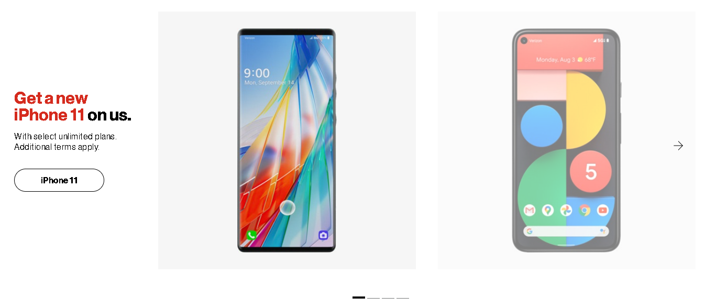

Standardized All Carousel Interactions (except Tilelet Carousel):
- The navigational elements of the carousels are Previous button, Next button and the Pagination bars.
- The navigational elements (Previous/Next and Pagination Bars) should be activated using Enter/Spacebar key.
- Once user has activated (Pressing Enter/Spacebar) the navigational elements (Previous/Next and Pagination Bars) the keyboard and screen reader focus should shift only to the first interactive element of the active visible slide and not on the entire carousel or slide.
- If there are no interactive elements on the slide then once user has activated (Pressing Enter/Spacebar) the navigational elements (Previous/Next and Pagination Bars), the keyboard and screen reader focus should stay on the navigational elements (Previous/Next and Pagination Bars) and an alert should be announced for screen reader users.
- When user navigates using the tab key or the keyboard arrow keys, and enters the carousel, focus should move in a logical order, for the slide which will start with the navigational elements (Previous/Next or Pagination Bars).
- The first interactive element on all carousels is the first navigational element (Previous/Next or Pagination Bars) whichever appears visually first.
- The navigation elements Previous/Next follows the same rules for the pagination bars, the Previous/Next navigation is just a secondary navigational element and all actions are the same as using pagination bars. Accessibility recommendation is to only use one navigational element on a carousel but if more than one exists, or if previous/next exists and no pagination bars the interactions follow the same actions to activate (Pressing Enter/Spacebar) tab or arrow to move through them.
- User does not need to go through all pagination bars, if they have activated the pagination bar using Enter or Spacebar key.
- At the end of the pagination bars, the last one, if the user does not activate any and they hit tab again, the focus will go to the next available interactive element on the page, outside of the carousel.
- Ensure that user is never trapped within the carousel with keyboard (using tab key) or screen reader (using arrow keys) and should be able to go back to the carousel using shift+tab.
- For screen reader users ensure that the carousel information such as the number of slides and slide name is announced.
- For screen reader users ensure that all carousel content is announced using keyboard arrow keys.
- The visual, keyboard and screen reader experiences should match as closely as possible throughout the carousel interaction.

Medium Carousel Keyboard Navigation:
- Once user has activated (Pressing Enter/Spacebar) the visible focus indicator should be shown only on the interactive elements of the slide and not on the whole slide.
- After activating (Pressing Enter/Spacebar) only the current active slide, first interactive element receives focus and not the entire carousel or slide.
- When the carousel has multiple navigational elements (Previous/Next and Pagination Bars) the action for the navigational elements are the same for keyboard users where tab key will navigate between the Previous/Next buttons and on pressing Enter/Spacebar keyboard focus should move to the first interactive element of the slide.
- If user does not activate a slide within the Previous/Next navigation, at the end of the slides, within the previous/next they are taken to the Pagination Bars (second navigational element). They use tab key to navigate through Pagination Bars and then goes to the next interactive element on the page, outside of the Carousel.
- When the user first presses the tab key, and enters the carousel, the visible tab key focus indicator should move in a logical order, for the slide which will start with the navigational elements (Previous/Next or Pagination Bars).
- The visual, keyboard and screen reader experiences should match as closely as possible throughout the carousel interaction. One of the key difference will be that when the slide becomes visible to visual viewers for users of screen readers it will not receive focus until or if the user activates (Pressing Enter/Spacebar).
- The carousel slide, once activated (Pressing Enter/Spacebar) to first interactive element, for instance on the print screen provided the first interactive element is the CTA, If none of the CTAs are activated, on pressing tab key visible focus indicator will be on the Pagination Bars to allow user to navigate through the slides. To leave the carousel, the user will press tab key through all of the Pagination Bars, without activating any additional slides, and at the end will be taken to the next interactive element, on the page, outside of the carousel.
- Use Tab key to navigate through the navigational elements (Previous/Next and Pagination bars) and the new slide should come into view.
- On activation (Pressing Enter/Spacebar) of the navigational elements (Previous/Next and Pagination bars) focus should shift to the first interactive element of the slide.
- Note: users should be able to activate the pagination bar with space or enter. User does not need to go through all pagination bars, if they have activated using the pagination bar using space or enter.
- If the user continues to tab (Tab key) then the user should be able to navigate through all the pagination bars.
- Note: At the end of the pagination bars, the last one, if the user does not activate any and they hit tab again, the user will go to the next available interactive element on the page, outside of the carousel. If a user wants to go back to the carousel using shift+tab BAU will allow them to get back to the carousel and navigate through the pagination bars. Key is to make sure there is not a keyboard trap for any user. On activation (pressing Enter/Spacebar) of the Previous/Next and Pagination bars focus should remain on the activated element (Previous/Next and Pagination bars).
- The visible focus indicator should appear on the current keyboard focus.
- The selected pagination bars should display a visually selected state.
- Ensure that you can come out of the carousel on tab key.

Medium Carousel Screen reader Navigation:
- Screen reader should announce the carousel information such as the number of slides appearing in the carousel. For e.g. in the print screen provided screen reader will announce “Carousel containing 4 slides.”
- It should not announce the slide contents that are hidden, inactive or not visible.
- Use Tab/arrow keys to navigate between the navigational elements (Previous/Next and Pagination Bars) and ensure that the slide should come into view.
- Note: Users should be able to use the arrow key to move through the navigational elements (Previous/Next and Pagination Bars) to 'read' what is ahead - arrow key is what screen reader users tend to use to 'see' what is ahead. If for screen reader users the slide does not come into view as they move through the pagination bars until the bar is activated, with space/enter, that is okay but must come into view for keyboard only users. Ideally, consistent experience since it does not impact screen reader users if it is in view or not making it in view for all reduces potential issues for keyboard only users.
- Screen reader should announce "Slide x of y and the slide title/header of the current slide when navigating between the navigational elements (Previous/Next and Pagination Bars) using tab/arrow keys. For instance in the print screen provided above screen reader should announce as “Slide 1of 4 Apple iPhone 12 mini”.
- On activation (Pressing Enter/Spacebar) of the navigational elements (Previous/Next and Pagination Bars), the screen reader should announce the selected state and the slide content as an alert and focus should go to the first interactive element of the active slide. For e.g. screen reader should announce “Slide 1of 4 Apple iPhone 12 mini” button pressed followed by all of the slide content (slide tile, sub title and all the CTA’s).
- For the pagination bars ensure that role= “button “state is pressed / unpressed. The label should include slide # of # and the slide header.
- If there is also, in addition to pagination bars, another navigational element such as the previous/next arrows on the slides the action should be the same as the pagination bar except the previous/next should be read as "Previous Slide 1of 4 Apple iPhone 12 mini ' or Next slide 2 of 12 Samsung S20" when activated using Enter/Spacebar. Screen reader announces the selected state and the slide content (slide header and the CTA) as an alert. And keyboard focus goes to the first interactive element on the slide.
- Screen reader users can use keyboard arrow keys left/right to "read" content. The keyboard arrow key allows screen reader users to 'read/see' what is visually shown to users that do not use screen readers.
- If the user continues to tab then the screen reader user should be able to navigate through all the pagination bars or previous/next navigation element.
- Note: At the end of the pagination bars (or previous/next navigation), the last one, if the user does not activate any and they hit tab again, the user will go to the next available interactive element on the page, outside of the carousel. If a user wants to go back to the carousel using shift+tab BAU will allow them to get back to the carousel and navigate through the pagination bars. Key is to make sure there is not a keyboard trap for any user.
- To go backwards to a specific slide in the carouse press shift+tab, at any time using the carousel.
- If the image appearing in the slide is decorative then alt text should be null and screen reader should skip the image.
- For the CTA’s like "iPhone 11, Learn more, Buy now etc." should have unique and descriptive labels that reflect the visible text. For E.g. label for Learn more can be “Learn more about iPhone 11”.
- For the link images like arrow icons (->) proper label should be provided. For e.g. Screen reader should render (->) as “Next slide button” Or “Next button”.
- Ensure that you can come out of the carousel with tab/ arrow key.

Medium Carousel Contrast and Color:
- Ensure that the arrow icon (->) and the selected/ unselected pagination bars meet the minimum color contrast ratio of 3:1.
- Check that color is not the only means of conveying information for the pagination bars. Along with the color there should be a visual cue provided to differentiate between the selected and unselected pagination bars. For instance in the print screen provided we see a black thicker bold line for the selected pagination bars which are being differentiated by the unselected buttons.

Carousel Type 3: Simple
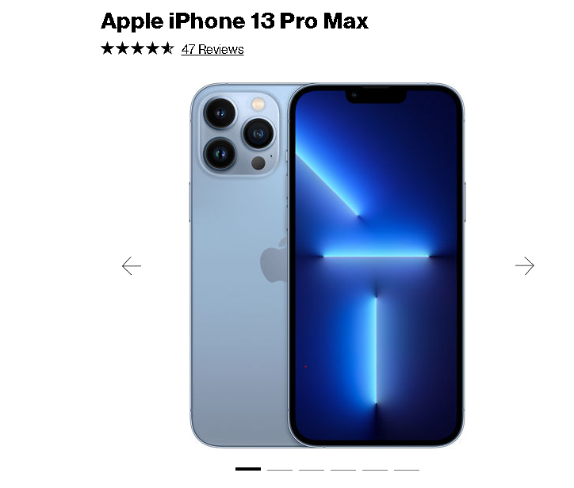

Standardized All Carousel Interactions (except Tilelet Carousel) :
- The navigational elements of the carousels are Previous button, Next button and the Pagination bars.
- The navigational elements (Previous/Next and Pagination Bars) should be activated using Enter/Spacebar key.
- Once user has activated (Pressing Enter/Spacebar) the navigational elements (Previous/Next and Pagination Bars) the keyboard and screen reader focus should shift only to the first interactive element of the active visible slide and not on the entire carousel or slide.
- If there are no interactive elements on the slide then once user has activated (Pressing Enter/Spacebar) the navigational elements (Previous/Next and Pagination Bars), the keyboard and screen reader focus should stay on the navigational elements (Previous/Next and Pagination Bars) and an alert should be announced for screen reader users.
- When user navigates using the tab key or the keyboard arrow keys, and enters the carousel, focus should move in a logical order, for the slide which will start with the navigational elements (Previous/Next or Pagination Bars).
- The first interactive element on all carousels is the first navigational element (Previous/Next or Pagination Bars) whichever appears visually first.
- The navigation elements Previous/Next follows the same rules for the pagination bars, the Previous/Next navigation is just a secondary navigational element and all actions are the same as using pagination bars. Accessibility recommendation is to only use one navigational element on a carousel but if more than one exists, or if previous/next exists and no pagination bars the interactions follow the same actions to activate (Pressing Enter/Spacebar) tab or arrow to move through them.
- User does not need to go through all pagination bars, if they have activated the pagination bar using Enter or Spacebar key.
- At the end of the pagination bars, the last one, if the user does not activate any and they hit tab again, the focus will go to the next available interactive element on the page, outside of the carousel.
- Ensure that user is never trapped within the carousel with keyboard (using tab key) or screen reader (using arrow keys) and should be able to go back to the carousel using shift+tab.
- For screen reader users ensure that the carousel information such as the number of slides and slide name is announced.
- For screen reader users ensure that all carousel content is announced using keyboard arrow keys.
- The visual, keyboard and screen reader experiences should match as closely as possible throughout the carousel interaction.

Simple Carousel Keyboard Navigation:
- Once user has activated (Pressing Enter/Spacebar) the visible focus indicator should be shown only on the interactive elements of the slide and not on the whole slide. If there is no interactive element on the slide then focus should stay on the navigational elements (Previous/Next and Pagination Bars).
- After activating (Pressing Enter/Spacebar) only the current active slide, first interactive element receives focus and not the entire carousel or slide. If there is no interactive element on the slide then focus should stay on the navigational elements (Previous/Next and Pagination Bars).
- When the carousel has multiple navigational elements (Previous/Next and Pagination Bars) the action for the navigational elements are the same for keyboard users where tab key will navigate between the Previous/Next buttons and on pressing Enter/Spacebar keyboard focus should move to the first interactive element of the slide.
- If user does not activate a slide within the Previous/Next navigation, at the end of the slides, within the previous/next they are taken to the Pagination Bars (second navigational element). They use tab key to navigate through Pagination Bars and then goes to the next interactive element on the page, outside of the Carousel.
- When the user first presses the tab key, and enters the carousel, the visible tab key focus indicator should move in a logical order, for the slide which will start with the navigational elements (Previous/Next or Pagination Bars).
- The visual, keyboard and screen reader experiences should match as closely as possible throughout the carousel interaction. One of the key difference will be that when the slide becomes visible to visual viewers for users of screen readers it will not receive focus until or if the user activates (Pressing Enter/Spacebar).
- Use Tab key to navigate through navigational elements (Previous/Next and Pagination Bars) and the new slide should come into view.
- On activation (Pressing Enter/Spacebar) of the navigational elements (Previous/Next and Pagination Bars) focus should remain on the activated element (Previous/Next and Pagination Bars) as there are no interactive elements on the slide and on next tab goes to the first interactive element outside the carousel.
- If the user continues to tab (Tab key) then the user should be able to navigate through all the pagination bars.
- Note: At the end of the pagination bars, the last one, if the user does not activate any and they hit tab again, the user will go to the next available interactive element on the page, outside of the carousel. If a user wants to go back to the carousel using shift+tab BAU will allow them to get back to the carousel and navigate through the pagination bars. Key is to make sure there is not a keyboard trap for any user. On activation (Pressing Enter/Spacebar) of the navigational elements (Previous/Next and Pagination Bars) focus should remain on the activated element (Previous/Next and Pagination Bars).
- The visible focus indicator should appear on the current keyboard focus.
- The selected pagination bars should display a visually selected state.
- Ensure that you can come out of the carousel on tab key.

Simple Carousel Screen reader Navigation:
- Screen reader should announce the carousel information such as the number of slides appearing in the carousel. For instance in the print screen provided screen reader will announce “carousel containing 6 slides.”
- On down arrow it should announce the current selected slide content. For instance in the print screen provided if the first slide is selected then it should announce the alt text of the selected image as no other text content is available.
- It should not announce the slide contents that are hidden, inactive or not visible.
- Use Tab/arrow keys to navigate through the navigational elements (Previous/Next and Pagination Bars) and the slide should come into view.
- Note: Users should be able to use the arrow key to move through the pagination bars to 'read' what is ahead - arrow key is what screen reader users tend to use to 'see' what is ahead. If for screen reader users the slide does not come into view as they move through the pagination bars until the bar is activated, with space/enter, that is okay but must come into view for keyboard only users. Ideally, consistent experience since it does not impact screen reader users if it is in view or not making it in view for all reduces potential issues for keyboard only users.
- Screen reader should announce "Slide x of y and the slide title/header of the current slide when navigating using tab/arrow keys. For instance in the print screen provided screen reader should announce “slide 1of 6 Apple iPhone 11 Pro”.
- If there are no interactive elements on the slide then once user has activated (Pressing Enter/Spacebar) the navigational elements (Previous/Next and Pagination Bars), the screen reader focus should stay on the navigational elements (Previous/Next and Pagination Bars) and an alert should be announced.
- For the pagination bars ensure that role= “button “state is pressed / unpressed. The label should include slide # of # and the slide header. e.g. “Slide 1of 4 Apple iPhone 12 mini” button pressed.
- If there is also, in addition to pagination bars, another navigational element such as the previous/next arrows on the slides - the action should be the same as the pagination bar except the previous/next should be read as "Previous Slide 1of 4 Apple iPhone 12 mini ' or Next slide 2 of 12 Samsung S20" when activated using Enter/Spacebar. Screen reader announces the selected state and the slide content (slide header and the CTA) as an alert. And keyboard focus goes to the first interactive element on the slide.
- Screen reader users can use keyboard arrow keys left/right to "read" content. The keyboard arrow key allows screen reader users to 'read/see' what is visually shown to users that do not use screen readers.
- If the user continues to tab then the screen reader user should be able to navigate through all the pagination bars or previous/next navigation element.
- Note: At the end of the pagination bars (or previous/next navigation), the last one, if the user does not activate any and they hit tab again, the user will go to the next available interactive element on the page, outside of the carousel. If a user wants to go back to the carousel using shift+tab BAU will allow them to get back to the carousel and navigate through the pagination bars. Key is to make sure there is not a keyboard trap for any user.
- To go backwards to a specific slide in the carouse press shift+tab, at any time using the carousel.
- For the link images like arrow icons proper label should be provided. For e.g. Screen reader should render arrow icons as “Next/Previous slide button” Or “Next/Previous button”.
- Ensure that you can come out of the carousel with tab/ arrow key.
- As the user presses the tab key, the visible tab key focus indicator should move from top to bottom, left to right. The next item to receive focus will vary depending on where the next, previous and pagination bars are positioned
Visually around the slide. The visual, keyboard and screen reader experiences should match as closely as possible.

Simple Carousel Contrast and Color:
- Ensure that the arrow icons (-> and <-) and the selected/ unselected pagination bars meet the minimum color contrast ratio of 3:1.
- Check that color is not the only means of conveying information for the pagination bars. Along with the color there should be a visual cue provided to differentiate between the selected and unselected pagination bars. For instance in the print screen provided we see a black thicker bold line for the selected pagination bars which are being differentiated by the unselected buttons.
Mobile Carousel


Carousel Standardized interactions (except Tilelet Carousel):
- The navigational elements of the carousels are Previous button, Next button and the Pagination bars.
- The navigational elements (Previous/Next and Pagination Bars) should be activated using Enter/Spacebar key.
- Once user has activated (Pressing Enter/Spacebar) the navigational elements (Previous/Next and Pagination Bars) the keyboard and screen reader focus should shift only to the first interactive element of the active visible slide and not on the entire carousel or slide.
- If there are no interactive elements on the slide then once user has activated (Pressing Enter/Spacebar) the navigational elements (Previous/Next and Pagination Bars), the keyboard and screen reader focus should stay on the navigational elements (Previous/Next and Pagination Bars) and an alert should be announced for screen reader users.
- When user navigates using the tab key or the keyboard arrow keys, and enters the carousel, focus should move in a logical order, for the slide which will start with the navigational elements (Previous/Next or Pagination Bars).
- The first interactive element on all carousels is the first navigational element (Previous/Next or Pagination Bars) whichever appears visually first.
- The navigation elements Previous/Next follows the same rules for the pagination bars, the Previous/Next navigation is just a secondary navigational element and all actions are the same as using pagination bars. Accessibility recommendation is to only use one navigational element on a carousel but if more than one exists, or if previous/next exists and no pagination bars the interactions follow the same actions to activate (Pressing Enter/Spacebar) tab or arrow to move through them.
- User does not need to go through all pagination bars, if they have activated the pagination bar using Enter or Spacebar key.
- At the end of the pagination bars, the last one, if the user does not activate any and they hit tab again, the focus will go to the next available interactive element on the page, outside of the carousel.
- Ensure that user is never trapped within the carousel with keyboard (using tab key) or screen reader (using arrow keys) and should be able to go back to the carousel using shift+tab.
- For screen reader users ensure that the carousel information such as the number of slides and slide name is announced.
- For screen reader users ensure that all carousel content is announced using keyboard arrow keys.
- The visual, keyboard and screen reader experiences should match as closely as possible throughout the carousel interaction.

Carousel Mobile Navigation:
- Once user has activated (Pressing Enter/Spacebar) the visible focus indicator should be shown only on the interactive elements of the slide and not on the whole slide.
- After activating (Pressing Enter/Spacebar) only the current active slide, first interactive element receives focus and not the entire carousel or slide.
- When the user first presses the tab key, and enters the carousel, the visible tab key focus indicator should move in a logical order, for the slide which will start with the navigational elements (Pagination Bars).
- The visual, keyboard and screen reader experiences should match as closely as possible throughout the carousel interaction. One of the key difference will be that when the slide becomes visible to visual viewers for users of screen readers it will not receive focus until or if the user activates (Pressing Enter/Spacebar).
- The carousel slide, once activated (Pressing Enter/Spacebar) to first interactive element, for instance on the print screen provided the first interactive element is the CTA, If none of those are activated, on pressing tab key visible focus indicator will be on the Pagination Bars to allow user to navigate through the slides. To leave the carousel, the user will press tab key through all of the Pagination Bars, without activating any additional slides, and at the end will be taken to the next interactive element, on the page, outside of the carousel.
- Use Tab key to navigate through the navigational elements (Pagination Bars) and the new slide should come into view.
- On activation (Pressing Enter/Spacebar) of the navigational elements (Pagination Bars) focus should shift to the first interactive element of the slide.
- Note: users should be able to activate the pagination bar with space or enter. User does not need to go through all pagination bars, if they have activated using the pagination bar using space or enter.
- If the user continues to tab (Tab key) then the user should be able to navigate through all the pagination bars.
- Note: At the end of the pagination bars, the last one, if the user does not activate any and they hit tab again, the user will go to the next available interactive element on the page, outside of the carousel. If a user wants to go back to the carousel using shift+tab BAU will allow them to get back to the carousel and navigate through the pagination bars. Key is to make sure there is not a keyboard trap for any user. On activation (pressing Enter/Spacebar) of the navigational elements (Previous/Next and Pagination Bars) focus should remain on the activated element (Previous/Next and Pagination Bars).
- The visible focus indicator should appear on the current keyboard focus.
- The selected pagination bars should display a visually selected state.
- Ensure that you can come out of the carousel on tab key.

Carousel Mobile Screen reader Navigation:
- Screen reader should announce the carousel information such as the number of slides appearing in the carousel. For instance in the print screen provided the screen reader will announce “carousel containing 3 slides.”
- Screen reader should announce the current selected slide content. For instance the first slide is selected then it should announce “For your phone...”
- It should not announce the slide contents that are hidden, inactive or not visible.
- Screen reader should announce "Slide x of y and the slide title/header of the current slide when navigating between the navigational elements (Pagination Bars) using gestures (left to right swipe). For instance in the print screen provided above screen reader should announce as “Slide 1of 4 Apple iPhone 12 mini”.
- On double tap the pagination bars should be activated.
- On activation (on double tap) of the navigational elements (Pagination Bars), the screen reader should announce the selected state and the slide content as an alert and focus should go to the first interactive element of the active slide, For instance in the print screen provided screen reader should announce” Slide 1of 3 for your phone” button pressed followed by all of the slide content (slide tile, sub title and all the CTA’s).
- For the pagination bars ensure that Role= button or Role as adjustable and screen reader announces as “slide “1of 3 button” or “slide 1 of 3 adjustable”.
- For the CTA’s like "Learn more, Shop now etc." should have unique and descriptive labels that reflect the visible text. For instance in the print screen provided label for Shop now can be “Shop now for your 5G phone”.
- Ensure that you can come out of the carousel using gestures (left and right swipes).

Carousel Contrast and Color:
- Ensure that the arrow icons (-> and <-) and the selected/ unselected pagination bars meet the minimum color contrast ratio of 3:1.
- Check that color is not the only means of conveying information for the pagination bars. Along with the color there should be a visual cue provided to differentiate between the selected and unselected pagination bars. For instance in the print screen provided we see a black thicker bold line for the selected pagination bars which are being differentiated by the unselected buttons.

Note:
  - Accessibility team does not recommend having multiple interactive elements within each panel.
  - The use of carousels have always raised alerts from an accessibility perspective; the best practice is to use the minimum amount of interactive elements (CTAs) in the slide.

CheckBox
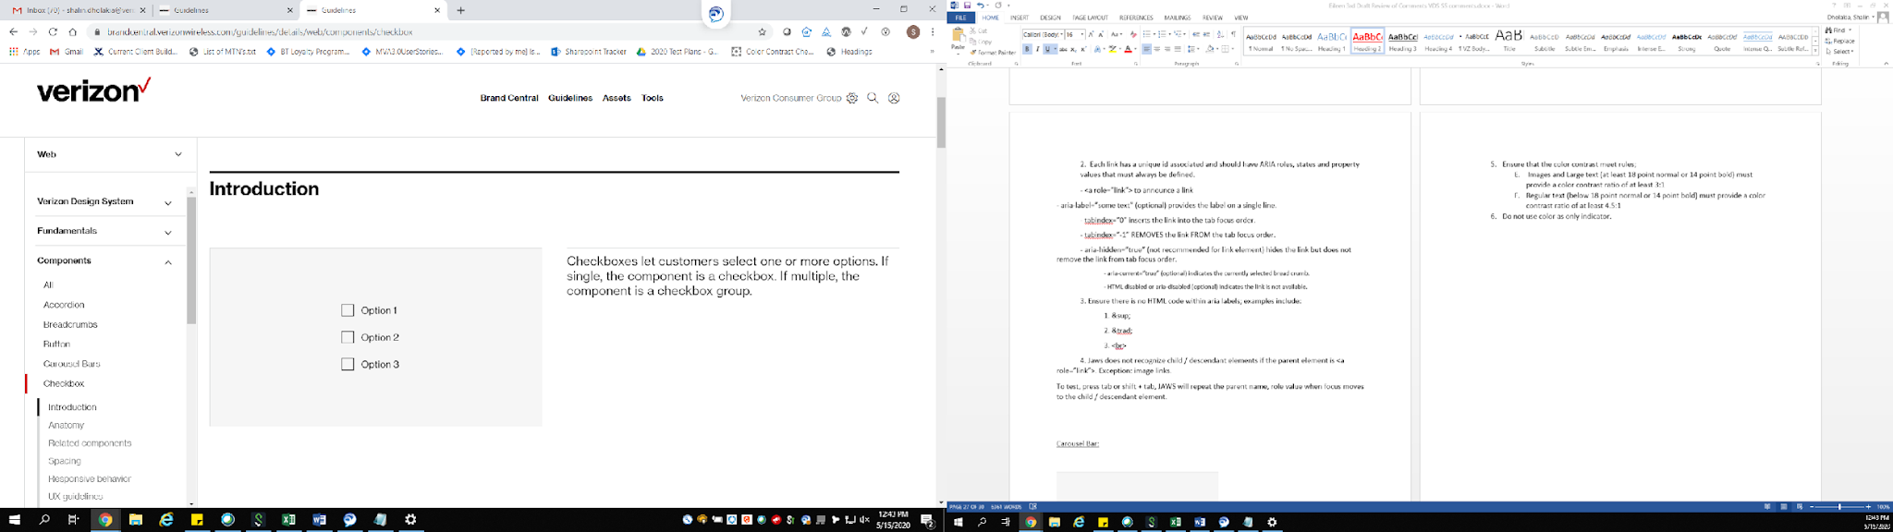

1.4 Distinguishable:
- Ensure that the color contrast meet rules;
- Images and Large text (at or over 18 point/24px /1.5em or bold 14 point/19px/1.2em) must provide a color contrast ratio of at least 3:1
- Regular text (below 18 point/24px /1.5em or bold 14 point/19px/1.2em) must provide a color contrast ratio of at least 4.5:1
- Do not use color as only indicator.
- Content must not rely solely on visual characteristics such as shape, size, visual location, or orientation to convey meaning.

2.4 Navigable:
- All checkboxes must be accessible using the keyboard alone (without a mouse), e.g. using the Tab and Shift Tab key.
- All checkboxes must have the ability to be activated using the ENTER or SPACEBAR keys, i.e., anything that can be clicked on with a mouse device, must also activate upon pressing the Enter or Spacebar key.
- All interactive elements must show a visual indicator when in a focus. And the color contrast for the focus indicator (at least 3px by 3px) against the background) must be at least 3 to 1.
- Screen reader users should be able to use the quick navigation key “x” to bring focus and navigate between the checkboxes.
- For Mobile Screen Reader users, the swipe right and left gesture should be used to navigate through the page, with the focus rendering in a consistent manner.
- For Mobile screen reader users, Double-tapping on the CheckBox selects/unselects the CTA.

4.1 Compatible
- All the checkbox elements on the page must be provided a unique label that is informative to the user. For example, "remember me", "I agree to ..." "turn on ...", "shipping address is the same as the billing address".
- The checkbox must inform the state to the user: “Checked/unchecked”.
- Valid role, name and states are:
- <label for="RefIDCheckbox">some checkbox text</label> indicates the purpose of the check box.
- aria-label (optional) may be used to display the label on one line for screen readers.
- <input type="checkbox" indicates a checkbox in the unchecked state.
- id="RefIDCheckbox" indicates the unique id of the checkbox
- checked indicates the checked state”

DropDown Select:
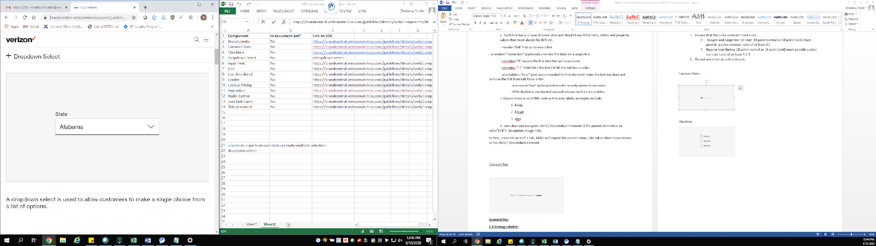

1.4 Distinguishable:
- Ensure that the color contrast meet rules;
- Images and Large text (at or over 18 point/24px /1.5em or bold 14 point/19px/1.2em) must provide a color contrast ratio of at least 3:1
- Regular text (below 18 point/24px /1.5em or bold 14 point/19px/1.2em) must provide a color contrast ratio of at least 4.5:1
- Do not use color as only indicator.
- Content must not rely solely on visual characteristics such as shape, size, visual location, or orientation to convey meaning.

2.4 Navigable
1. The dropdown must be operable using both keyboard only and screen reader ( Tab, Enter/Space, Escape, and Arrow keys). Dropdown list must read to screen readers as dropdown list label, count of list items and on moving through list (example: State list of 50, item 1 of 50)
2. Alt+Down Arrow or enter key opens and closes the dropdown list.
Up Arrow and Down Arrow moves focus up and down the list and navigates between the dropdown list options.
3. Pressing the first characters of the option should jump to that option (i.e. 50 states dropdown, typing “n” (listbox) or “new” (combobox) should move the focus to “New Hampshire”)
4. Enter selects the current item on the list and collapses the drop down (status must be provided for screen reader users
5. Escape closes the dropdown list.
6. Pressing the tab key collapses the dropdown and moves the focus to the next CTA.
7. The keyboard focus must never be locked or trapped at one particular option within the dropdown select list.
8. The user needs to be allowed to navigate to and from all navigable dropdown elements using only a keyboard.
9. All interactive elements within the dropdown must show a visual indicator when in a focus. And the color contrast for the focus indicator (at least 3px by 3px) against the background) must be at least 3 to 1.
10. For Mobile Screen Reader users, the swipe right and left gesture should be used to navigate through the page, with the focus rendering in a consistent manner.
11. Double-tapping on an interactive element activates the CTA.
Detailed swipe gestures for each screen reader and behavior for dropdowns on mobile:
- IOS list box (simple list of options, No edit field for user input)
  - Announced as "label, current selection, has-popup".
  - Double tap to expand the drop down.
  - Mobile web, VO announces "combo box label, picker item".
  - Mobile web and app, focus moves to expanded dropdown. Swipe down, or up with one finger to scroll to the bottom or top of the option list.
  - Mobile web, when desired option is announced, Swipe left to the "done" close "X" and double tap.
  - Focus returns to the dropdown and VO announces "combo box label".
  - VO must be able to report the drop down label and current selection.
- IOS and android combo box (edit field for user input + list box of results)
  - Announced as "label, current selection, combo box, has-popup".
  - Double tap opens an edit field. Type some characters.
  - Focus stays in edit field. Normal editing gestures apply. Note: Auto collapsing the drop down when the user touches white space is not acceptable. The user must be able to navigate between the keyboard, edit field and drop down list. The drop down must remain expanded until a selection is made or the edit field is cleared.
  - VoiceOver and Talkback announce the first selected item in list. The selected item changes and announces as typing continues.
  - Right and left swipe through the list of options, which is displayed as a simple text or links list.
  - Double tap selects an item and collapses the drop down. Focus must return to the drop down.
  - Voiceover must be able to report the drop down label and current selection.
- Android list box (simple list of options, No edit field for user input)
  - Announced as "label, current selection, has-popup".
  - Double tap to expand the drop down.
  - Swipe right and left to move through a modal containing the List of simple text or link options.
  - Double tap selects and option. The drop down collapses and focus returns to the drop down.
  - Talkback must be able to report the drop down label and current selection.

4.1 Compatible
1. Each dropdown select element has a unique id associated and should have ARIA roles, states and property values that must always be defined for the Screen Reader users. E.G. “sort by: combo box featured”.
2. The HTML code elements <label>, <select> and <option> are accessible by design. HTML is preferred over custom aria designs. Do not add aria roles or attributes to the HTML select and option elements.
3. The aria drop down has 3 parts.
A. Combobox Container Role, Property, State, and Tabindex Attributes
- <label id="IDREFTextLabel"> Provides a label.
- combobox Identifies the parent <div> element as a combobox. Enables screen reader users to perceive both the input and the popup when using reading mode.
- aria-haspopup=“listbox" Indicates that the combobox can popup a listbox to suggest values.
- aria-owns=“IDREFListbox” Refers to the element that serves as the listbox popup.
Tells browsers to arrange the screen reader reading order so the listbox,. when it is visible, immediately follows the other elements inside the combobox,
regardless of where the listbox element is in the DOM.
- aria-expanded=“false” Indicates that the popup element is not displayed. |
- aria-expanded=“true” Indicates that the popup element is displayed. |

B. Textbox Role, Property, State, and Tabindex Attributes
- <input type="text" > indicates the text entry element.
- id="IDREFInput" unique id for the input element
- aria-labelledby="IDREFTextLabel" Provides a label for the input element.
- aria-autocomplete=“list” indicates a non editable list. e.g. list all 50 states
or aria-autocomplete=“both” indicates both an edit field and a list of suggestions. e.g. Search for something.
- aria-controls=“IDREFListbox” Identifies the popup element that lists suggested values.
- aria-activedescendant Enables assistive technologies to know which element the application regards as focused while DOM focus remains on the
input element. For more information about this focus management technique, see Using aria-activedescendant to Manage Focus.

C. Listbox Popup Role, Property, State, and Tabindex Attributes
- listbox Identifies the ul element as a listbox.
- id="IDREFListbox" unique ID for the listbox.
- aria-labelledby=“IDREFTextLabel” Provides a label for the listbox element of the combobox. |
- option Identifies the li element as a listbox option. The text content of the li element provides the accessible name.

Dropdown Select Marketing:
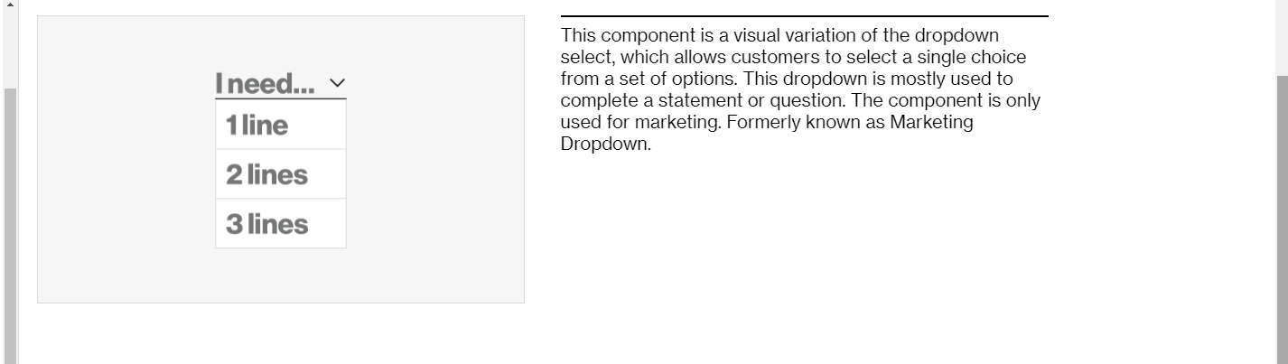

1.4 Distinguishable:
- Ensure that the color contrast meet rules;
- Images and Large text (at or over 18 point/24px /1.5em or bold 14 point/19px/1.2em) must provide a color contrast ratio of at least 3:1
- Regular text (below 18 point/24px /1.5em or bold 14 point/19px/1.2em) must provide a color contrast ratio of at least 4.5:1
- Do not use color as only indicator.
- Content must not rely solely on visual characteristics such as shape, size, visual location, or orientation to convey meaning.

2.4 Navigable
1. The dropdown must be operable using both keyboard only and screen reader (with default keys like Tab, Enter/Space, Esc, Arrow keys).
2. Alt+Down Arrow or enter key opens and closes the drop down list.
Up Arrow and Down Arrow moves focus up and down the list and navigates between the dropdown list options.
3. Pressing the first characters of the option should jump to that option (i.e. 50 states dropdown, typing “n” (listbox) or “new” (combobox) should move the focus to “New Hampshire”)
4. Enter selects the current item on the list and collapses the drop down.
5. Escape closes the dropdown list.
6. Pressing the tab key collapses the dropdown and moves the focus to the next CTA.
7. The keyboard focus must never be locked or trapped at one particular option within the dropdown select list. The user must be able to navigate to and from all navigable dropdown elements using only a keyboard.
8. The keyboard focus must never be locked or trapped at one particular point within the tooltip overlay.
9. All interactive elements within the dropdown must show a visual indicator when in a focus. And the color contrast for the focus indicator (at least 3px by 3px) against the background) must be at least 3 to 1.
10. For Mobile Screen Reader users, the swipe right and left gesture should be used to navigate through the page, with the focus rendering in a consistent manner.
11. Double-tapping on an interactive element activates the CTA.
Detailed swipe gestures for each screen reader and behavior for dropdowns on mobile:
- IOS list box (simple list of options, No edit field for user input)
  - Announced as "label, current selection, has-popup".
  - Double tap to expand the drop down.
  - Mobile web, VO announces "combo box label, picker item".
  - Mobile web and app, focus moves to expanded dropdown. Swipe down, or up with one finger to scroll to the bottom or top of the option list.
  - Mobile web, when desired option is announced, Swipe left to the "done" close "X" and double tap.
  - Focus returns to the dropdown and VO announces "combo box label".
  - VO must be able to report the drop down label and current selection.
- IOS and android combo box (edit field for user input + list box of results)
  - Announced as "label, current selection, combo box, has-popup".
  - Double tap opens an edit field. Type some characters.
  - Focus stays in the edit field. Normal editing gestures apply. Note: Auto collapsing the drop down when the user touches white space is not acceptable. The user must be able to navigate between the keyboard, edit field and drop down list. The drop down must remain expanded until a selection is made or the edit field is cleared.
  - VO and TalkBack announce the first selected item in the list. The selected item changes and announces as typing continues.
  - Right and left swipe through the list of options, which is displayed as a simple text or links list.
  - Double tap selects an item and collapses the drop down. Focus must return to the drop down.
  - VO must be able to report the drop down label and current selection.
- Android list box (simple list of options, No edit field for user input)
  - Announced as "label, current selection, has-popup".
  - Double tap to expand the drop down.
  - Swipe right and left to move through a modal containing the List of simple text or link options.
  - Double tap selects an option. The drop down collapses and focus returns to the drop down.
  - Talkback must be able to report the drop down label and current selection.

4.1 Compatible
1. Each dropdown select element has a unique id associated and should have ARIA roles, states and property values that must always be defined for the Screen Reader users. E.G. “sort by: combo box featured”.
2. The HTML code elements <label>, <select> and <option> are accessible by design. HTML is preferred over custom aria designs. Do not add aria roles or attributes to the HTML select and option elements.
3. The aria drop down has 3 parts.
A. Combobox Container Role, Property, State, and Tabindex Attributes
- <label id="IDREFTextLabel"> Provides a label.
- combobox Identifies the parent <div> element as a combobox. Enables screen reader users to perceive both the input and the popup when using reading mode.
- aria-haspopup=“listbox" Indicates that the combobox can popup a listbox to suggest values.
- aria-owns=“IDREFListbox” Refers to the element that serves as the listbox popup.
Tells browsers to arrange the screen reader reading order so the listbox,. when it is visible, immediately follows the other elements inside the combobox,
regardless of where the listbox element is in the DOM.
- aria-expanded=“false” Indicates that the popup element is not displayed. |
- aria-expanded=“true” Indicates that the popup element is displayed. |

B. Textbox Role, Property, State, and Tabindex Attributes
- <input type="text" > indicates the text entry element.
- id="IDREFInput" unique id for the input element
- aria-labelledby="IDREFTextLabel" Provides a label for the input element.
- aria-autocomplete=“list” indicates a non editable list. e.g. list all 50 states
or aria-autocomplete=“both” indicates both an edit field and a list of suggestions. e.g. Search for something.
- aria-controls=“IDREFListbox” Identifies the popup element that lists suggested values.
- aria-activedescendant Enables assistive technologies to know which element the application regards as focused while DOM focus remains on the
input element. For more information about this focus management technique, see Using aria-activedescendant to Manage Focus.

C. Listbox Popup Role, Property, State, and Tabindex Attributes
- listbox Identifies the ul element as a listbox.
- id="IDREFListbox" unique ID for the listbox.
- aria-labelledby=“IDREFTextLabel” Provides a label for the listbox element of the combobox. |
- option Identifies the li element as a listbox option. The text content of the li element provides the accessible name.

Dropdown Select – Inline Label:
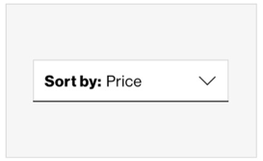

1.4 Distinguishable:
- Ensure that the color contrast meet rules;
- Images and Large text (at or over 18 point/24px /1.5em or bold 14 point/19px/1.2em) must provide a color contrast ratio of at least 3:1
- Regular text (below 18 point/24px /1.5em or bold 14 point/19px/1.2em) must provide a color contrast ratio of at least 4.5:1
- Do not use color as only indicator.
- Content must not rely solely on visual characteristics such as shape, size, visual location, or orientation to convey meaning.

2.4 Navigable
1. The dropdown must be operable using both keyboard only and screen reader (with default keys like Tab, Enter/Space, Esc, Arrow keys).
2. Alt+Down Arrow or enter key opens and closes the drop down list.
Up Arrow and Down Arrow moves focus up and down the list and navigates between the dropdown list options.
3. Pressing the first characters of the option should jump to that option (i.e. 50 states dropdown, typing “n” (listbox) or “new” (combobox) should move the focus to “New Hampshire”)
4. Enter selects the current item on the list and collapses the drop down.
5. Escape closes the dropdown list.
6. Pressing the tab key collapses the dropdown and moves the focus to the next CTA.
7. The keyboard focus must never be locked or trapped at one particular option within the dropdown select list. The user needs to be allowed to navigate to and from all navigable dropdown elements using only a keyboard.
8. The keyboard focus must never be locked or trapped at one particular point within the tooltip overlay.
9. All interactive elements within the dropdown must show a visual indicator when in a focus. And the color contrast for the focus indicator (at least 3px by 3px) against the background) must be at least 3 to 1.
10. For Mobile Screen Reader users, the swipe right and left gesture should be used to navigate through the page, with the focus rendering in a consistent manner.
11. Double-tapping on an interactive element activates the CTA.
Detailed swipe gestures for each screen reader and behavior for dropdowns on mobile:
- IOS list box (simple list of options, No edit field for user input)
  - Announced as "label, current selection, has-popup".
  - Double tap to expand the drop down.
  - Mobile web, VO announces "combo box label, picker item".
  - Mobile web and app, focus moves to expanded dropdown. Swipe down, or up with one finger to scroll to the bottom or top of the option list.
  - Mobile web, when desired option is announced, Swipe left to the "done" close "X" and double tap.
  - Focus returns to the dropdown and VO announces "combo box label".
  - VO must be able to report the drop down label and current selection.
- IOS and android combo box (edit field for user input + list box of results)
  - Announced as "label, current selection, combo box, has-popup".
  - Double tap opens an edit field. Type some characters.
  - Focus stays in edit field. Normal editing gestures apply. Note: Auto collapsing the drop down when the user touches white space is not acceptable. The user must be able to navigate between the keyboard, edit field and drop down list. The drop down must remain expanded until a selection is made or the edit field is cleared.
  - VoiceOver and Talkback announce the first selected item in list. The selected item changes and announces as typing continues.
  - Right and left swipe through the list of options, which is displayed as a simple text or links list.
  - Double tap selects an item and collapses the drop down. Focus must return to the drop down.
  - Voiceover must be able to report the drop down label and current selection.
- Android list box (simple list of options, No edit field for user input)
  - Announced as "label, current selection, has-popup".
  - Double tap to expand the drop down.
  - Swipe right and left to move through a modal containing the List of simple text or link options.
  - Double tap selects and option. The drop down collapses and focus returns to the drop down.
  - Talkback must be able to report the drop down label and current selection.

4.1 Compatible
1. Each dropdown select element has a unique id associated and should have ARIA roles, states and property values that must always be defined for the Screen Reader users. E.G. “sort by: combo box featured”.
2. The HTML code elements <label>, <select> and <option> are accessible by design. HTML is preferred over custom aria designs. Do not add aria roles or attributes to the HTML select and option elements.
3. The aria drop down has 3 parts.
A. Combobox Container Role, Property, State, and Tabindex Attributes
- <label id="IDREFTextLabel"> Provides a label.
- combobox Identifies the parent <div> element as a combobox. Enables screen reader users to perceive both the input and the popup when using reading mode.
- aria-haspopup=“listbox" Indicates that the combobox can popup a listbox to suggest values.
- aria-owns=“IDREFListbox” Refers to the element that serves as the listbox popup.
Tells browsers to arrange the screen reader reading order so the listbox,. when it is visible, immediately follows the other elements inside the combobox,
regardless of where the listbox element is in the DOM.
- aria-expanded=“false” Indicates that the popup element is not displayed. |
- aria-expanded=“true” Indicates that the popup element is displayed. |
B. Textbox Role, Property, State, and Tabindex Attributes
- <input type="text" > indicates the text entry element.
- id="IDREFInput" unique id for the input element
- aria-labelledby="IDREFTextLabel" Provides a label for the input element.
- aria-autocomplete=“list” indicates a non editable list. e.g. list all 50 states
or aria-autocomplete=“both” indicates both an edit field and a list of suggestions. e.g. Search for something.
- aria-controls=“IDREFListbox” Identifies the popup element that lists suggested values.
- aria-activedescendant Enables assistive technologies to know which element the application regards as focused while DOM focus remains on the
input element. For more information about this focus management technique, see Using aria-activedescendant to Manage Focus.
C. Listbox Popup Role, Property, State, and Tabindex Attributes
- listbox Identifies the ul element as a listbox.
- id="IDREFListbox" unique ID for the listbox.
- aria-labelledby=“IDREFTextLabel” Provides a label for the listbox element of the combobox. |
- option Identifies the li element as a listbox option. The text content of the li element provides the accessible name.

Drag and Drop Component

1.4 Distinguishable:
- Ensure that the color contrast meet rules:
- Images and Large text (at or over 18 point/24px /1.5em or bold 14 point/19px/1.2em) must provide a color contrast ratio of at least 3:1
- Regular text (below 18 point/24px /1.5em or bold 14 point/19px/1.2em) must provide a color contrast ratio of at least 4.5:1
- Do not use color as only indicator.
- Content must not rely solely on visual characteristics such as shape, size, visual location, or orientation to convey meaning.

2.4 Navigable:
- All objects that are draggable must be reachable using the keyboard alone.
- Use the Tab/Shift tab key to move to the item in a category that a user wants to drag and drop.
- Use the Up and down arrow keys to move between the items for drag and drop.
- Press Spacebar or Enter key to drag an item.
- Press Spacebar or Enter key to drop an item in a new position.
- Use Esc key to cancel the selection for drag and drop.
- All interactive elements of the Drag & Drop interface must show a visible keyboard focus indicator when in focus. And the color contrast for the focus indicator (at least 3px by 3px) against the background) must be at least 3 to 1.
- The keyboard focus must never be locked or trapped at one particular point within the Drag & Drop interface.
- Drag & Drop must be readable with up to 2x magnification enabled.
- All instructions and keyboard operations must be apparent and usable for both keyboard only and screen reader users.
- All instructions should use standard keyboard keystrokes, enter, spacebar, tab key, arrow keys, and escape key. No novel keystroke patterns should be required.
- All users must be able to determine which objects are draggable.
- For keyboard only users, an unique focus indicator should be provided to indicate which items are available for dragging.
- For screen reader users, use aria-grabbed="false" to indicate the item is “Draggable”.
- All users must be able to determine whether an object has been selected for dragging.
- For keyboard only users, an unique focus indicator should be used to convey that an item has been selected for dragging.
- For screen reader users, use aria-grabbed="true to indicate an item has been selected for dragging.
- At the same time, when an item is grabbed, ARIA-Dropeffect must be set to “move” on all available drop targets.
- All users must be able to select one or more elements to drag. Provide an “Add to drag session” option in the pop-up menu recommended below.
- All users must be able to determine the operation that will be performed when the selected object is dropped. Provide the “drop options” in the pop-up menu recommended below.
- All users must be able to identify targets/locations where an object may be dropped. Provide the “drop options” in the pop-up menu recommended below.
- When drag is cancelled, keyboard focus should be set to the last grabbed source object.
- Keyboard operation for the drop sections:
  - Drop section headings do not receive tab key focus.
  - Instead, the drop options are selected from a pop-up menu that appears when a drag item is selected via enter or space bar keys.
- Keyboard operation for the drag items:
  - Tab key focus moves logically from top to bottom left to right through all drag items.
  - Enter or spacebar selects the drag item.
  - Selecting a drop item triggers a pop-up menu containing the drop options.
  - Pressing escape dismisses the pop-up menu, unselects the drag item and returns focus to the drag item.
- Keyboard operation for the menu pop-up:
  - Focus programmatically moves to the currently matched drop item in the pop-up. If no drop item is matched, focus moves to the first menu item.
  - Up and down arrows move between menu items.
  - Enter key selects the option and completes the match. The pop-up disappears. Focus is programmatically, returned to the dragged item.
  - Escape key deselects the drag item, dismisses the menu pop-up and returns focus to the drag item.

4.1 Compatible
- Screen reader operation for the drop section items:
Each drop section has a logical heading level. <h2>Drop section 1</h2>
- Screen reader operation for the drag items:
  - Drag items are displayed in an unordered list under each drop section header.
  - In virtual cursor mode the drag items can be read with the up and down arrow keys.
  - <button Role=”button”> indicates the drag item is interactive.
  - aria-label announces the drag item label matched with the drop item. e.g. “Google home matched to 123-456-7890”..
  - aria-grabbed="false" indicates the item is draggable. Note: This attribute must be combined with a valid role.
  - aria-haspopup="true" indicates a pop-up menu will appear.
  - Warning: do not use role=”application”. Role application unnecessarily prevents screen reader users from accessing the webpage in the accustomed manner.
<ul><li><button Role=”button” tabindex="0" aria-grabbed="false" aria-haspopup="true">Drag item 1</li>
- Screen reader operation for the menu pop-up:
  - The pop-up menu consists of an unordered list containing the drop options.
  - Role menu groups the menu items.
  - Role menuitem indicates each menu choice.
<ul role="menu"><li role="menuitem">Drop option 1</li>
  - Completing the match triggers an alert stating something like "Apple Watch black matched to 123-456-7890."

Footnote
- Anchor link connects the footnote reference in the main content to the footnote itself. This allows users to easily navigate between the content and the footnote. Ensure that the target element for the anchor link receives focus. Example: <p>Some content here.<a href="#footnote1" id="content-footnote1">[1]</a></p> <p id="footnote1">1. This is the footnote text. <a href="#content-footnote1">Return to content</a></p>
- Ensure that users can navigate to the footnote link using the keyboard alone. The link should be focusable using the Tab key, on keyboard and activates enter key (since link just enter, does not need to activate with space key on keyboard) . Enter takes user back to the triggering footnote. If user interacts with footnote, at the end of the page, without being on the triggering footnote and there are more than one points of mention of the footnote (for instance footnote 1) then focus will go to the first instance of the related footnote number.
- Role and Name: The link should be identified correctly by screen readers. Ensure it has an accessible name (descriptive and in context) and is identified as a link. Using the HTML <a> tag provides this information.
- Screen Reader Output: When the user navigates to the footnote link, the screen reader should announce its purpose and role. Ensure that the link text is descriptive enough to put into context. Ensure the link text is descriptive and "in context" and that the screen reader correctly identifies the footnote link and its purpose. Example 1 subscript should have aria label of “Pricing Footnote 1”
- Verify that you can navigate to the footnote link using the tab key, on keyboard, and that pressing enter key on keyboard moves the focus to the footnote text. Enter takes user back to the anchor link, when they are on the footnote - so they can move through the rest of the interactive elements (back to where they were). If they have moved to an interactive element on the footnote and need to get back to the footnote itself (for instance footnote 1 at the bottom of the page use shift+tab then enter, will take user back to triggering element.
- Ensure that the color contrast meet rules, large text (at or over 18 point/24px /1.5em or bold 14 point/19px/1.2em) must provide a color contrast ratio of at least 3:1. Regular text (below 18 point/24px /1.5em or bold 14 point/19px/1.2em) must provide a color contrast ratio of at least 4.5:1
- Do not use color as only indicator. Red text, Black background (or vice versa) must not be used.
- Ensure the footnote link and the associated text provide a visible focus indicator Content must not rely solely on visual characteristics such as shape, size, visual location, or orientation to convey meaning. Color contrast must be met at a minimum of 4.5:1 for the text on background.

Headers

4.1 Compatible:
- Headers provide page structure to assistive technologies.
- Headings must be accurate and informative, as labels for the sections of text they describe.
- Headers should maintain a level of hierarchy:
<h1> indicates the main purpose of the page. All pages must have a h1 and only one h1 on the page.
<h2> indicates subtopics.
<h3> indicates subtopics or main points under each <h2>.
- Headers that appear on multiple lines should be read as a single unit when navigating with the quick key “h” or when displaying a list of headings on the page. Headers that appear on multiple lines should be read as a single unit when navigating with the quick key “h” or when displaying a list of headings on the page. If the page headings are visually split on multiple lines using the &lt;br&gt; tag, then add aria-hidden=”true” in the &lt;br&gt; tag to display the header as a single line to screen readers.
- Bypass Blocks. Screen readers allow users to navigate by headings, so headings are an effective way to bypass blocks of content, as required by WCAG 2.4.1. Note: Headings are not absolutely required by WCAG to pass 2.4.1, but are highly recommended, along with landmarks and skip links. But we require them at Verizon Accessibility.
Note: WCAG guidelines 1.3.1 and 2.4.6 do not explicitly carry out the additional information we add about h1, beginning main content but that is a requirement from VZ Accessibility.

1.4 Distinguishable:
- Ensure that the color contrast meet rules;
- Images and Large text (at or over 18 point/24px /1.5em or bold 14 point/19px/1.2em) must provide a color contrast ratio of at least 3:1
- Regular text (below 18 point/24px /1.5em or bold 14 point/19px/1.2em) (pmust provide a color contrast ratio of at least 4.5:1
- Do not use color as only indicator.
- Content must not rely solely on visual characteristics such as shape, size, visual location, or orientation to convey meaning.

Iframe:

4. 1 Compatible
- The iframe title attribute, on the parent page, must be accurate and descriptive, meaning that it should properly describe the iframe.
- Every iframe SHOULD have a unique title.
- Hidden frames or frames that do not convey content to users should be hidden from assistive technologies using aria-hidden="true".
- The source page of an iframe (the page embedded in the iframe) must have a valid, informative and descriptive <title>.

Images

4.1 Compatible:
1. All images must have an alt text.
- Images that are informative/provide value to the content, must have alt-text that accurately conveys the purpose of the image.
- Complex images must be briefly described using alt text and need to have a more complete extended description.
- If a background image conveys information, alternative text must be provided (e.g. via regular visible text, by adding role="image" and aria-label, or by other means).
- Active Background images should not be used. However, If a background image is the only "content" in an active element (e.g. a link, button, or control), the active element must have an accessible name (e.g. via aria-label or similar).
- If an image is not a complex image (i.e. chart/graph, etc.) then the alt text should be no more than 250 characters. E.G.”A woman holds a smart phone in front of a bridge.”
- Images that are purely decorative or not informative should be given empty (null) alternative text. (i.e. visual line breaks
- Images that are interactive must have an informative label that describes the element.
- Interactive images must be identifiable with the added role of button or link.
- Image links need to describe the link destination.
- Button/control links need to describe the purpose and/or resulting action of the button or control.
- An image must not include informative text if an equivalent visual presentation of the text can be rendered using real text (unless the text is essential — such as a logo — or the font, size, color, and background are customizable.).
- A text alternative for informative CSS-generated content must be provided, AND the CSS-generated text SHOULD be set to aria-hidden="true".
- If the image is a captcha,
- Must have alternative text describing the purpose of the image.
- Must be supplemented with at least one auditory alternative method.
- Images with animation, motion and timed content
- A page must not have content that flashes more than 3 times per second.
- There should be a replay option, allowing the user to replay the content.
- A method must be provided to play, pause, and stop content.

1.4 Distinguishable:
- Ensure that the color contrast meet rules;
- Images and Large text (at or over 18 point/24px /1.5em or bold 14 point/19px/1.2em) must provide a color contrast ratio of at least 3:1
- Regular text (below 18 point/24px /1.5em or bold 14 point/19px/1.2em) must provide a color contrast ratio of at least 4.5:1
- Do not use color as only indicator.
- Content must not rely solely on visual characteristics such as shape, size, visual location, or orientation to convey meaning.

2.4 Navigable:
1. If the image is an interactive element it must be keyboard navigable and operable using the Tab key to navigate between the CTA’s and Spacebar or Enter Key to interact with the CTA.
2. All interactive elements must show a visual indicator when in a focus. And the color contrast for the focus indicator (at least 3px by 3px) against the background) must be at least 3 to 1.
3. For mobile all informative and interactive images should be accessible with the left and right swipe gestures. Double tap should activate interactive images.

Input Field:
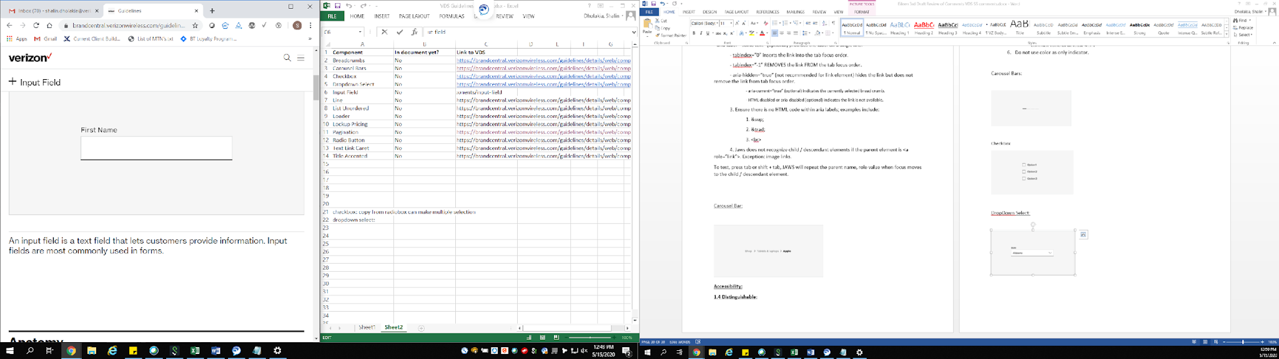

1.4 Distinguishable:
- Ensure that the color contrast meet rules;
- Images and Large text (at or over 18 point/24px /1.5em or bold 14 point/19px/1.2em) must provide a color contrast ratio of at least 3:1
- Regular text (below 18 point/24px /1.5em or bold 14 point/19px/1.2em) must provide a color contrast ratio of at least 4.5:1
- Do not use color as only indicator.
- Content must not rely solely on visual characteristics such as shape, size, visual location, or orientation to convey meaning.

2.4 Navigable:
- All Input Fields must be accessible using the keyboard alone (without a mouse), e.g. using the Tab and Shift Tab key.
- All Input Fields must have the ability to be activated using the ENTER or SPACEBAR keys, i.e., anything that can be clicked on with a mouse device, must also activate upon pressing the Enter or Spacebar key.
- All Input Fields and interactive elements must show a visual indicator when in a focus. And the color contrast for the focus indicator (at least 3px by 3px) against the background) must be at least 3 to 1.
- Screen reader users should be able to use the quick navigation key “e” to bring focus and navigate between the input fields.
- For Mobile Screen Reader users, the swipe right and left gesture should be used to navigate through the page, with the focus rendering in a consistent manner.
- For Mobile Screen Reader users, Double-tapping on an interactive element activates the CTA.
- Touching outside the keyboard and input field should not close a virtual on screen keyboard.
- Keyboard users should not need to close a virtual on screen keyboard to move to the next form field or submit the form.

4.1 Compatible:
1. Identify any specific criteria for Input (8 characters needed…)
2. Identify field that are required or optional in order to proceed.
3. Error text in an alert
4. If an input error is automatically detected and suggestions for correction are known, then the suggestions are provided to the user, unless it would jeopardize the security or purpose of the content.
5. If there is a disabled/Unavailable option; informative text should be rendered.
6. If the input is a password field, then the values should be replaced with asterisks, and be read as “Star”.
7. Valid role name values:
- <label for=”RefIDEdit”>birthday (MM/DD/YYY) </label> indicates the purpose of the edit field and may contain brief instructions.
- <input type=”text”> indicates an edit field.
- id=”RefIDEdit” indicates the unique id.
- required or aria-required=”true” (optional) indicates a required field to screen readers.
- disabled or aria-disabled=”true” (optional) indicates a disabled state.
- aria-invalid=”true” (optional) indicates an error in the data entered.
- placeholder=”MM/DD/YYY” (optional) provides brief instructions. It is not a substitute for the label.
- aria-describedby=”refIDMessagetext” (optional) appends instruction text to a label or error text to the input field. The text must be brief or user will have trouble validating the typed text.

Input Field – Date:
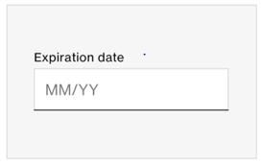

1.4 Distinguishable:
- Ensure that the color contrast meet rules;
  - Images and Large text (at or over 18 point/24px /1.5em or bold 14 point/19px/1.2em) must provide a color contrast ratio of at least 3:1.
  - Regular text (below 18 point/24px /1.5em or bold 14 point/19px/1.2em) must provide a color contrast ratio of at least 4.5:1.
- Do not use color as only indicator.
- Content must not rely solely on visual characteristics such as shape, size, visual location, or orientation to convey meaning.

2.4 Navigable:
- Input field must be accessible using the keyboard alone (without a mouse), e.g. using the Tab and Shift Tab key.
- Input field must have the ability to be activated using the ENTER or SPACEBAR keys, i.e., anything that can be clicked on with a mouse device, must also activate upon pressing the Enter or Spacebar key.
- Input field and interactive elements must show a visual indicator when in a focus. And the color contrast for the focus indicator (at least 3px by 3px) against the background) must be at least 3 to 1.
- Screen reader users should be able to use the quick navigation key “e” to bring focus and navigate between the input fields.
- For Mobile Screen Reader users, the swipe right and left gesture should be used to navigate through the page, with the focus rendering in a consistent manner.
- For Mobile Screen Reader users, Double-tapping on an interactive element activates the CTA.
- Touching outside the keyboard and input field should not close a virtual on screen keyboard.
- Keyboard users should not need to close a virtual on screen keyboard to move to the next form field or submit the form.

4.1 Compatible:
1. Identify any specific criteria for Input (8 characters needed…)
2. Identify field that are required or optional in order to proceed.
3. Error text in an alert.
4. If an input error is automatically detected and suggestions for correction are known, then the suggestions are provided to the user, unless it would jeopardize the security or purpose of the content.
5. If there is a disabled/Unavailable option; informative text should be rendered.
6. If the input is a password field, then the values should be replaced with asterisks, and be read as “Star”.
7. Valid role name values:
- <label for=”RefIDEdit”>birthday (MM/DD/YYY) </label> indicates the purpose of the edit field and may contain brief instructions.
- <input type=”text”> indicates an edit field.
- id=”RefIDEdit” indicates the unique id.
- required or aria-required=”true” (optional) indicates a required field to screen readers.
- disabled or aria-disabled=”true” (optional) indicates a disabled state.
- aria-invalid=”true” (optional) indicates an error in the data entered.
- placeholder=”MM/DD/YYY” (optional) provides brief instructions. It is not a substitute for the label.
- aria-describedby=”refIDMessagetext” (optional) appends instruction text to a label or error text to the input field. The text must be brief or user will have trouble validating the typed text.

Input Field – Phone Number:
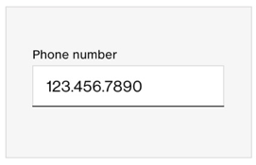

1.4 Distinguishable:
- Ensure that the color contrast meet rules;
  - Images and Large text (at or over 18 point/24px /1.5em or bold 14 point/19px/1.2em) must provide a color contrast ratio of at least 3:1
  - Regular text (below 18 point/24px /1.5em or bold 14 point/19px/1.2em) must provide a color contrast ratio of at least 4.5:1
- Do not use color as only indicator.
- Content must not rely solely on visual characteristics such as shape, size, visual location, or orientation to convey meaning.

2.4 Navigable:
- Input field must be accessible using the keyboard alone (without a mouse), e.g. using the Tab and Shift Tab key.
- Input field must have the ability to be activated using the ENTER or SPACEBAR keys, i.e., anything that can be clicked on with a mouse device, must also activate upon pressing the Enter or Spacebar key.
- Input field and interactive elements must show a visual indicator when in a focus. And the color contrast for the focus indicator (at least 3px by 3px) against the background) must be at least 3 to 1.
- Screen reader users should be able to use the quick navigation key “e” to bring focus and navigate between the input fields.
- For Mobile Screen Reader users, the swipe right and left gesture should be used to navigate through the page, with the focus rendering in a consistent manner.
- For Mobile Screen Reader users, Double-tapping on an interactive element activates the CTA.
- Touching outside the keyboard and input field should not close a virtual on screen keyboard.
- Keyboard users should not need to close a virtual on screen keyboard to move to the next form field or submit the form.

4.1 Compatible:
1. Identify any specific criteria for Input (8 characters needed…)
2. Identify field that are required or optional in order to proceed.
3. Error text in an alert.
4. If an input error is automatically detected and suggestions for correction are known, then the suggestions are provided to the user, unless it would jeopardize the security or purpose of the content.
5. If there is a disabled/Unavailable option; informative text should be rendered.
6. If the input is a password field, then the values should be replaced with asterisks, and be read as “Star”.
7. Valid role name values:
- <label for=”RefIDEdit”>birthday (MM/DD/YYY) </label> indicates the purpose of the edit field and may contain brief instructions.
- <input type=”text”> indicates an edit field.
- id=”RefIDEdit” indicates the unique id.
- required or aria-required=”true” (optional) indicates a required field to screen readers.
- disabled or aria-disabled=”true” (optional) indicates a disabled state.
- aria-invalid=”true” (optional) indicates an error in the data entered.
- placeholder=”MM/DD/YYY” (optional) provides brief instructions. It is not a substitute for the label.
- aria-describedby=”refIDMessagetext” (optional) appends instruction text to a label or error text to the input field. The text must be brief or user will have trouble validating the typed text.

Input Field – Security Code:
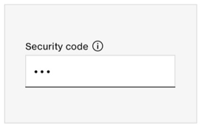

1.4 Distinguishable:
- Ensure that the color contrast meet rules;
  - Images and Large text (at or over 18 point/24px /1.5em or bold 14 point/19px/1.2em) must provide a color contrast ratio of at least 3:1.
  - Regular text (below 18 point/24px /1.5em or bold 14 point/19px/1.2em) must provide a color contrast ratio of at least 4.5:1.
- Do not use color as only indicator.
- Content must not rely solely on visual characteristics such as shape, size, visual location, or orientation to convey meaning.

2.4 Navigable:
- Input field must be accessible using the keyboard alone (without a mouse), e.g. using the Tab and Shift Tab key.
- Input field must have the ability to be activated using the ENTER or SPACEBAR keys, i.e., anything that can be clicked on with a mouse device, must also activate upon pressing the Enter or Spacebar key.
- Input field and interactive elements must show a visual indicator when in a focus. And the color contrast for the focus indicator (at least 3px by 3px) against the background) must be at least 3 to 1.
- Screen reader users should be able to use the quick navigation key “e” to bring focus and navigate between the input fields.
- For Mobile Screen Reader users, the swipe right and left gesture should be used to navigate through the page, with the focus rendering in a consistent manner.
- For Mobile Screen Reader users, Double-tapping on an interactive element activates the CTA.
- Touching outside the keyboard and input field should not close a virtual on screen keyboard.
- Keyboard users should not need to close a virtual on screen keyboard to move to the next form field or submit the form.

4.1 Compatible:
1. Identify any specific criteria for Input (8 characters needed…)
2 Identify field that are required or optional in order to proceed.
3. Error text in an alert.
4. If an input error is automatically detected and suggestions for correction are known, then the suggestions are provided to the user, unless it would jeopardize the security or purpose of the content.
5. If there is a disabled/Unavailable option; informative text should be rendered.
6. If the input is a password field, then the values should be replaced with asterisks, and be read as “Star”.
7. Valid role name values:
- <label for=”RefIDEdit”>birthday (MM/DD/YYY) </label> indicates the purpose of the edit field and may contain brief instructions.
- <input type=”text”> indicates an edit field.
- id=”RefIDEdit” indicates the unique id.
- required or aria-required=”true” (optional) indicates a required field to screen readers.
- disabled or aria-disabled=”true” (optional) indicates a disabled state.
- aria-invalid=”true” (optional) indicates an error in the data entered.
- placeholder=”MM/DD/YYY” (optional) provides brief instructions. It is not a substitute for the label.
- aria-describedby=”refIDMessagetext” (optional) appends instruction text to a label or error text to the input field. The text must be brief or user will have trouble validating the typed text.

Input Stepper
This component increases and/or decreases the numeric value displayed by tapping the options related to it. It's typically used on shopping carts and product display pages to indicate the amount of items being purchased. The component Includes:
- Plus or minus icon (visually + / - icons), each icon is fully clickable.
- Amount or value of items being purchased, the value will change after user interaction on + / - icons.
- Label must provide a descriptive text when the element expects user interaction. It can be supported by any other text that matches the tone of the experience. For e.g: 'how many do you want?' or ‘How many lines do you need?’.
Note: Any interactive element within the stepper must follow its related guidelines. For instance, if there is an icon it also must meet the icon related guidelines.
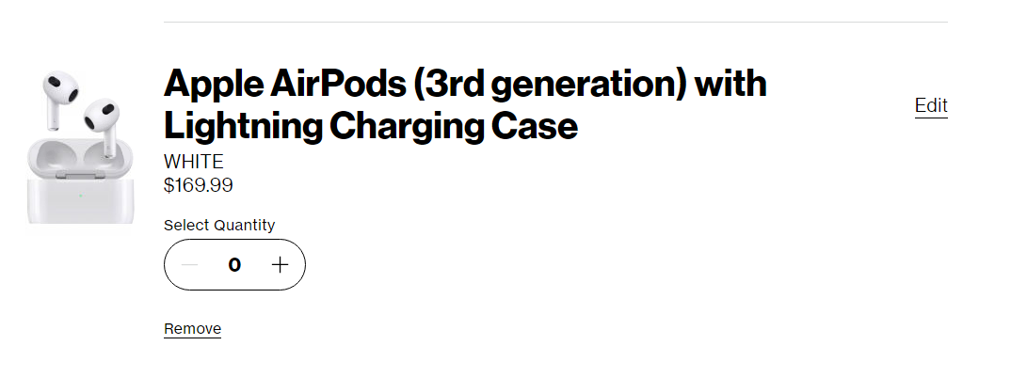

1.4 Distinguishable:
- Ensure that the color contrast meet rules;
  - Images and Large text (at or over 18 point/24px /1.5em or bold 14 point/19px/1.2em) must provide a color contrast ratio of at least 3:1.
  - Regular text (below 18 point/24px /1.5em or bold 14 point/19px/1.2em) must provide a color contrast ratio of at least 4.5:1.
- Do not use color as only indicator.
- Content must not rely solely on visual characteristics such as shape, size, visual location, or orientation to convey meaning.

2.4 Navigable:
- The increase button and/or decrease button allow the user to increase or decrease the numeric value displayed.
- The increase button and/or decrease button are activated with enter or space on the keyboard. Once user has activated (Pressing Enter/Spacebar) the numeric value displayed will change accordingly to the action to increase or decrease. The visual focus indicator should remain in the same button after activation.
- Each button is coded as a button and can be activated with space or enter on the keyboard.
- The decrease option should be disabled if the user can't reduce the quantity when it's on the minimum limit “0”, the same with increase (+) button, as a proactive approach making sure that the option is disabled to the user (where a certain limit has been reached for a product) in that way we indicate to the user that can't reduce or add more because it's on the limit.
- User can use the tab key on the keyboard to navigate through the decrease or increase button when is enabled. Focus should move in logical order. If the user is in the decrease button (when enabled on screen), after pressing tab key again it moves user to next button (increase button) and if the user does not activate any button and they hit tab again, the user will go out the stepper input to the next available interactive element on the page.
  - For the scenario when the decrease button is disabled on screen, when the user first presses the tab key, and enters the stepper input, Focus should move in the first enabled button (increase button from above example), after pressing enter, the decrease button will appear enabled on the screen and if the user presses Shift+tab key (to navigate back), decrease button will receive keyboard focus. Vice versa happens when the increase button is disabled on screen.
  - If a user is on the decrease button and reduces it to 0, the decrease button focused on should change to disabled state, focus should automatically move to the only enabled button (increase button). Vice versa happens for the increase button where the user reaches its maximum limit, the focus should return to the previous interactive element in the stepper component (decrease button).

- The user must never be trapped within the stepper input using keyboard (tab key) nor with screen reader (using arrow keys) and user must be able to use background navigation, shift+tab, on keyboard, to go back to the last interactive element visited within the stepper input.
- For screen reader users, the interactive element must be read with a descriptive label to help the users to understand the purpose of the control clearly. For e.g.: ‘Decrease Quantity’ and ‘Increase Quantity’.
- Screen reader users must be able to use the arrow keys (up/down), on the keyboard to ‘read ahead’ and have access to the buttons and numeric value displayed.
  - For the scenario when the decrease button is disabled on screen, the user can go to the button in disabled state as part of the logical navigational order, the same behavior applies when the increase button is disabled on screen. Screen reader should read button label with current state, for e.g.: ‘Button unavailable Decrease Quantity.’
- On activation (Pressing Enter/Spacebar) of the increase or decrease button:
  - The screen reader must automatically read (as an alert) the numeric value displayed because has changed after activation. For e.g.: ‘Quantity updated to 5’. This announcement must happen every time that the user activates the increase or decrease button.
  - For the scenario when the user reaches more than the lowest or highest values (that means go outside the boundaries range), the screen reader must automatically read (as an alert) a message for e.g.:
    - "You have reached minimum value" for values less than 0.
    - "You have reached maximum value" for values more than 99.
  - If a user is on the decrease button and reduces it to 0, the decrease button focused on should disappears, the screen reader should automatically read: "Quantity updated to <X>, you have reached minimum value" then, it should read and focus the only enabled button (Increase button). The same happens for the scenario where the user reaches its maximum limit, the screen reader focus should return to the previous interactive element in the stepper component (decrease button) and read "Quantity updated to <X>, you have reached maximum value" then, it should read and focus the only enabled button (decrease Quantity).
Mobile App Experience:
The only difference between the mobile experience (app or dotcom experience) is that the method for interaction changes based on the mobile gestures:
- Double tap to activate the increase or decrease button:
  - On activation of the increase or decrease button, the mobile screen reader must automatically read (as an alert) the numeric value displayed because has changed after activation. For example: “Quantity updated to 5”. This announcement must happen every time that the user activates the increase or decrease button.
  - For the scenario when the user reaches more than the lowest or highest values (that means go outside the boundaries range), the screen reader must automatically read (as an alert) a message for e,g:
    - "You have reached minimum value" for values less than 0.
    - "You have reached maximum value" for values more than 99.
- Swiping right or left the screen reader moves the user between increase or decrease button and the numeric value displayed.

Landmarks:

4. 1 Compatible
1. To Bypass blocks & VZ Accessibility required Landmarks:
- Bypass is the only WCAG specific requirement but VZ Accessibility requires Landmarks of header, banner, navigation, main, and footer.
- Landmarks may be designated with either HTML tags or their equivalent ARIA roles (e.g. <header> or role="banner", <nav> or role="navigation", <main> or role="main", <footer> or role="content info", etc.) to help screen reader users navigate by landmarks/regions.
2. Landmark Structural Organization
- Landmarks should be used to accurately designate pre-defined parts of the layout (e.g. the header, navigation, main content, and footer).
- All the text should be contained within a landmark.
- Multiple instances of the same type of landmark should be distinguishable by different discernible names (using aria-label or aria-labelledby).
- A page should not contain more than one instance of each of the following landmarks: header/banner, main, and footer/content info.
- The total number of landmarks should be minimized to the extent appropriate for the content. Note: Having a large number of landmarks defeats the main purpose of landmarks, which is to make it easy to navigate quickly to sections of the layout.

3.4 Navigable:

- All interactive elements must show a visual indicator when in a focus. And the color contrast for the focus indicator (at least 3px by 3px) against the background) must be at least 3 to 1.
- Screen readers allow users to navigate by landmarks, so landmarks are an effective way to bypass blocks of content, as required by WCAG 2.4.1.
- Screen Reader users should be able to use the quick navigation key “r” to navigate between the landmark regions.

Language - Page:

4. 1 Compatible
1. Primary language of the page must be identified accurately, using a standard language code, on the <html> element (e.g. <html lang="en"> or <html lang="fr">).
2. Inline language changes must be identified with a valid lang attribute. <html lang="en"> or <html lang="fr">)

Line:
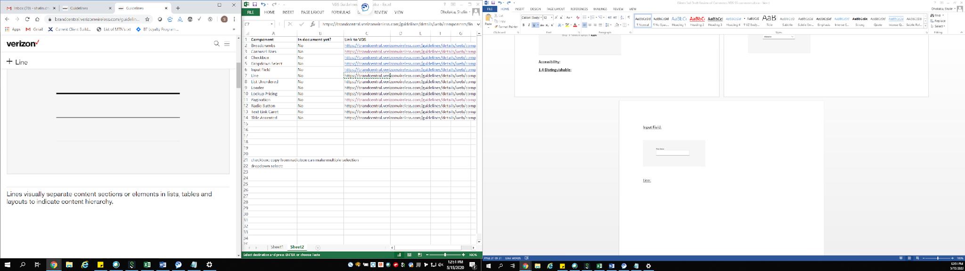

1.4 Distinguishable:
- Ensure that the color contrast meet rules;
- Images and Large text (at or over 18 point/24px /1.5em or bold 14 point/19px/1.2em) must provide a color contrast ratio of at least 3:1
- Regular text (below 18 point/24px /1.5em or bold 14 point/19px/1.2em) must provide a color contrast ratio of at least 4.5:1
- Do not use color as only indicator.
- Content must not rely solely on visual characteristics such as shape, size, visual location, or orientation to convey meaning.

4.1 Compatible:
1. Screen readers should not announce lines. Avoid using characters like dashes or asterisks to create visual separation. Screen reader users will use headers to understand the page layout.

Link - Text Link:
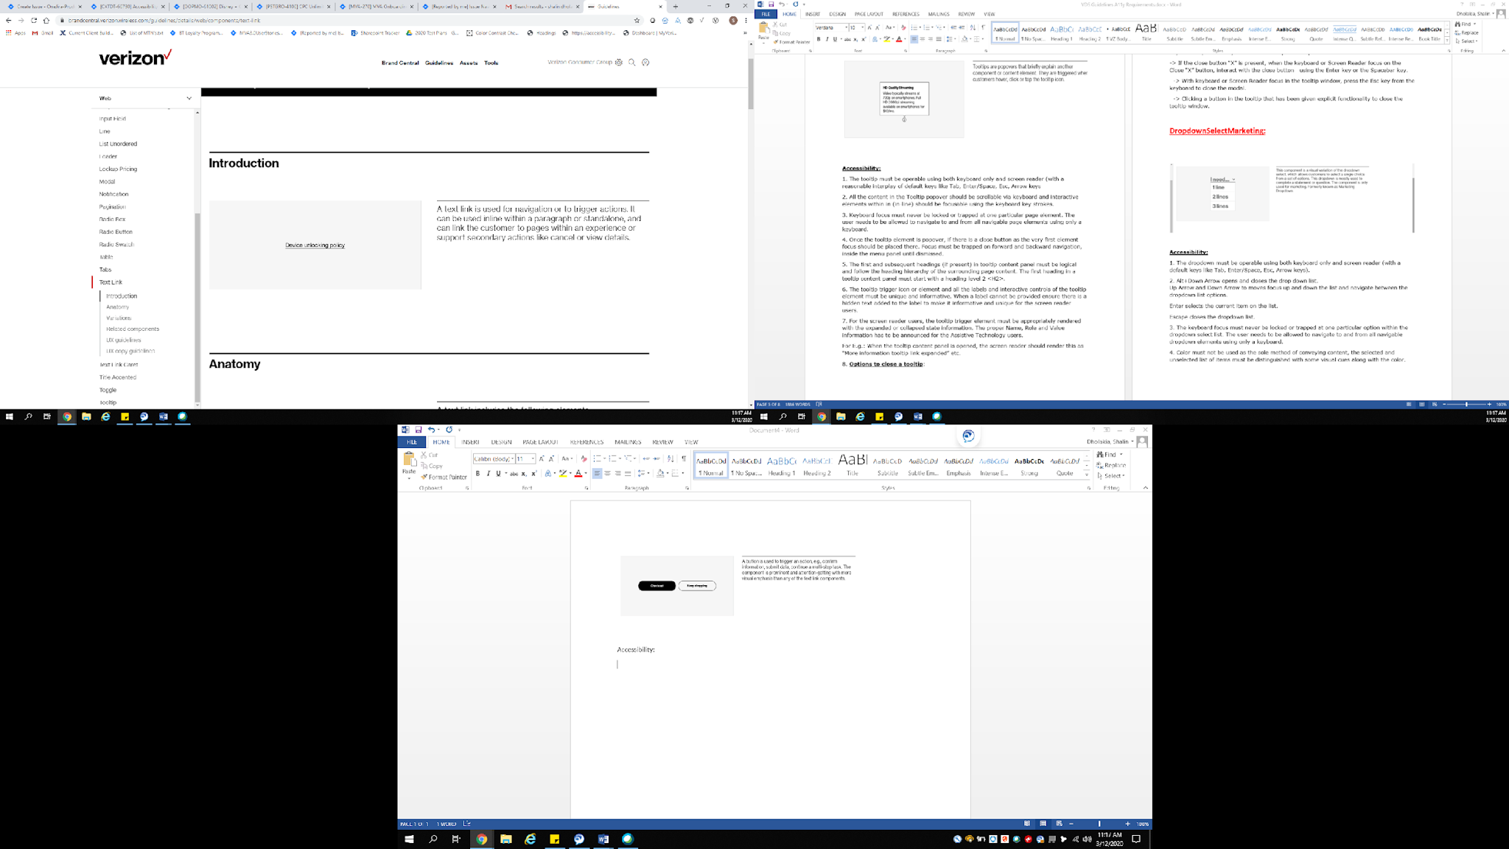

1.4 Distinguishable:
- Ensure that the color contrast meet rules;
- Images and Large text (at or over 18 point/24px /1.5em or bold 14 point/19px/1.2em) must provide a color contrast ratio of at least 3:1
- Regular text (below 18 point/24px /1.5em or bold 14 point/19px/1.2em) must provide a color contrast ratio of at least 4.5:1
- Color alone must not be used as the only way to distinguish links. Links must be visually distinguishable from surrounding non-link text.
- Content must not rely solely on visual characteristics such as shape, size, visual location, or orientation to convey meaning.

2.4 Navigable:
- All links must be accessible using the keyboard alone (without a mouse), e.g. using the Tab and Shift Tab key.
- All links must have the ability to be activated using the ENTER keys, i.e., anything that can be clicked on with a mouse device, must also activate upon pressing the Enter key.
- All links and interactive elements must show a visual indicator when in a focus. And the color contrast for the focus indicator (at least 3px by 3px) against the background) must be at least 3 to 1.
- All links that have the same functionality within a set of Web pages needs to be identified consistently.
- For Mobile Screen Reader users, the swipe right and left gesture should be used to navigate through the page, with the focus rendering in a consistent manner.
- Double-tapping on an interactive element activates the CTA.

4.1 Compatible:
1. All links elements on the page must be given a unique label that is informative to the user. A link must have a link name that describes what the user will see when they click the link. e.g. “learn more - Google Pixel 2 XL”, “Buy now! – Google Pixel 2 XL”, “shopping cart 2 items”, etc.
If that can't happen with the link then it must be there in the immediately surrounding context of the link
2. Discernible text for the link that is taking to the same destination point should be the same.
3. Each link has a unique id associated and should have ARIA roles, states and property values that must always be defined.
- <a role=”link”> to announce a link
- aria-label=”some text” (optional) provides the label on a single line.
- tabindex=”0” inserts the link into the tab focus order.
- tabindex=”-1” REMOVES the link FROM the tab focus order.
- aria-hidden=”true” (not recommended for link element) hides the link but does not remove the link from tab focus order.
- aria-current=”true” (optional) indicates the currently selected bread crumb.
- HTML disabled or aria-disabled (optional) indicates the link is not available.
4. Ensure there is no HTML code within aria labels; examples include:
- &sup;
- &trad;
- <br>
5. Links must be semantically designated. Ideally this means using an <a> element with a valid href value. In rare problematic cases, setting role="link" may be acceptable. Links should be used only for actions that take the user to other locations, and should not be used for button-like functionality.
6. Jaws does not recognize child / descendant elements if the parent element is <a role=”link”>. Exception: image links.
To test, press tab or shift + tab, JAWS will repeat the parent name, role value when focus moves to the child / descendant element.

Link - Text Link Caret:

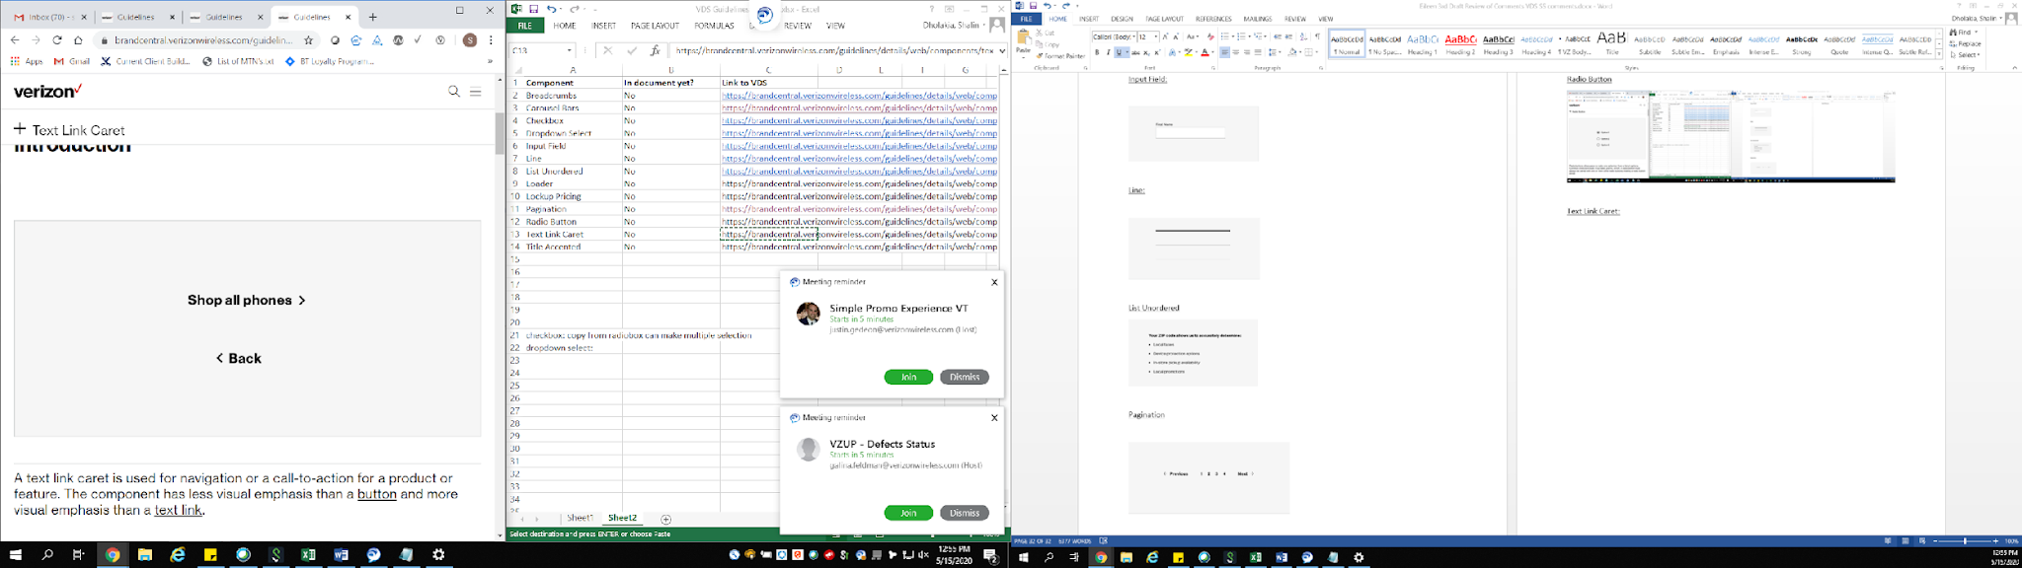

1.4 Distinguishable:
- Ensure that the color contrast meet rules;
- Images and Large text (at or over 18 point/24px /1.5em or bold 14 point/19px/1.2em) must provide a color contrast ratio of at least 3:1
- Regular text (below 18 point/24px /1.5em or bold 14 point/19px/1.2em) must provide a color contrast ratio of at least 4.5:1
- Color alone must not be used as the only way to distinguish link. Links must be visually distinguishable from surrounding non-link text.
- Content must not rely solely on visual characteristics such as shape, size, visual location, or orientation to convey meaning.

2.4 Navigable:
- All links must be accessible using the keyboard alone (without a mouse), e.g. using the Tab and Shift Tab key.
- All links must have the ability to be activated using the ENTER key, i.e., anything that can be clicked on with a mouse device, must also activate upon pressing the key.
- All links and interactive elements must show a visual indicator when in a focus. And the color contrast for the focus indicator (at least 3px by 3px) against the background) must be at least 3 to 1.
- All links that have the same functionality within a set of Web pages needs to be identified consistently.
- For Mobile Screen Reader users, the swipe right and left gesture should be used to navigate through the page, with the focus rendering in a consistent manner.
- Double-tapping on an interactive element activates the CTA.

4.1 Compatible:
1. All links elements on the page must be provided a unique label that is informative to the user. A link must have a link name that describes what user will see when they click the link. e.g. “learn more - Google Pixel 2 XL”, “Buy now! – Google Pixel 2 XL”, “shopping cart 2 items”, etc.
If that can't happen with the link then it must be there in the immediately surrounding context of the link.
2. Labels should be visually adjacent to their controls.
3. Discernible text for the link that is taking to the same destination point should be the same.
4. Each link has a unique id associated and should have ARIA roles, states and property values that must always be defined.
5. Note this can also be coded as a button as long as it states what it is to the user and the interactions following the action and activation with enter or space – where as if it is a link it is just activated by enter. It is not a defect If it is coded as a button if it acts like a button and is an action.
- <a role=”link”> to announce a link
- aria-label=”some text” (optional) provides the label on a single line.
- tabindex=”0” inserts the link into the tab focus order.
- tabindex=”-1” REMOVES the link FROM the tab focus order.
- aria-hidden=”true” (not recommended for link element) hides the link but does not remove the link from tab focus order.
- aria-current=”true” (optional) indicates the currently selected bread crumb.
- HTML disabled or aria-disabled (optional) indicates the link is not available.
4. Ensure there is no HTML code within aria labels; examples include:
- &sup;
- &trad;
- <br>
5. Links must be semantically designated. Ideally this means using an <a> element with a valid href value. In rare problematic cases, setting role="link" may be acceptable. Links should be used only for actions that take the user to other locations, and should not be used for button-like functionality.
6. Jaws does not recognize child / descendant elements if the parent element is <a role=”link”>. Exception: image links.
To test, press tab or shift + tab, JAWS will repeat the parent name, role value when focus moves to the child / descendant element.

Note: Accessibility team does not recommend using a caret on its own.

Lists:

Unordered lists, Ordered Lists, and Description list
Visual 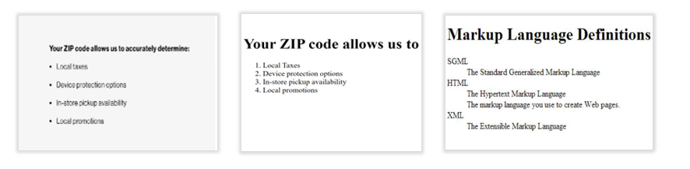

1.4 Distinguishable:
- Ensure that the color contrast meet rules;
- Images and Large text (at or over 18 point/24px /1.5em or bold 14 point/19px/1.2em) must provide a color contrast ratio of at least 3:1
- Regular text (below 18 point normal or 14 points bold) must provide a color contrast ratio of at least 4.5:1
- Do not use color as only indicator.
- Content must not rely solely on visual characteristics such as shape, size, visual location, or orientation to convey meaning.

2.4 Navigable:
- All elements in the Unordered list must be navigable using the up and down arrows
- All buttons must have the ability to be activated using the ENTER or SPACEBAR keys, i.e., anything that can be clicked on with a mouse device, must also activate upon pressing the Enter or Spacebar key.
- All buttons and interactive elements must show a visual indicator when in a focus. And the color contrast for the focus indicator (at least 3px by 3px) against the background) must be at least 3 to 1.
- For Mobile Screen Reader users, the swipe right and left gesture should be used to navigate through the page, with the focus rendering in a consistent manner.
- For Mobile Screen Reader users, Double-tapping on an interactive element activates the CTA.

4.1 Compatible
- Unordered lists (ul) are used when the order of the items is not relevant. List items in unordered lists are usually marked with a bullet.
Sample: Your ZIP code allows us to accurately determine ()
<ul>
<li>Local taxes</li>
<li>Device protection options</li>
<li>In-store pickup availability</li>
<li>Local promotions</li>
</ul>
Note:
- Regardless of list type, a list has one subject include related items under it and should not include anything that is not part of that subject under it. For instance, if you are doing an account list, the account list would not include list items that are unrelated within it. If you have an "account list" with "Notifications, Bill, Usage, Plans & Services, Apps & Add Ons" BUT it would not include the subject (account list) then unrelated items like a salutation of "Hi user". List items has a subject and the related list items under only.
- Caution <ul> is used to position radio buttons and drop down select items should be over ridden with the appropriate role Remove: hidden with role=”presentation” for screen readers.
- Ordered lists (ol) are used for sequential information and are enumerated

Sample: Your ZIP code allows us to
<ol>
<li>Local taxes</li>
<li>Device protection options</li>
<li>In-store pickup availability</li>
<li>Local promotions</li>
</ol>

- Description lists (also called Definition lists) are groups of related terms and descriptions which are connected programmatically.
Sample: Markup Language Definitions
<dl>
<dt> SGML</dt>
<dd> The Standard Generalized Markup Language</dd>
<dt>HTML</dt>
<dd>The Hypertext Markup Language</dd>
<dd>The markup language you use to create Web pages</dd>
<dt>XML</dt>
<dd>The Extensive Markup Language</dd>
</dl>

Loader:
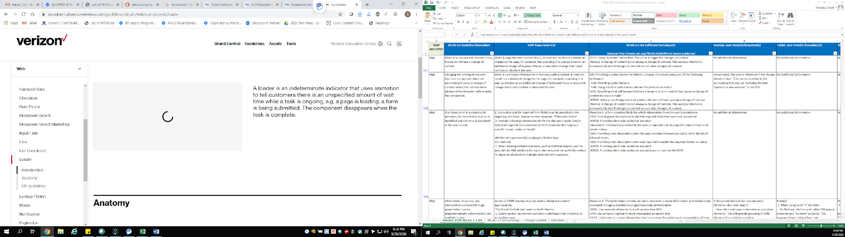

1.4 Distinguishable:
- Ensure that the color contrast meet rules;
- Images and Large text (at or over 18 point/24px /1.5em or bold 14 point/19px/1.2em) must provide a color contrast ratio of at least 3:1
- Regular text (below 18 point/24px /1.5em or bold 14 point/19px/1.2em) must provide a color contrast ratio of at least 4.5:1
- Do not use color as only indicator.
- Content must not rely solely on visual characteristics such as shape, size, visual location, or orientation to convey meaning.

4.1 Compatible:
1. The screen reader should convey to the user that there is an unspecified amount of wait time. The way it can be conveyed is ‘loading content’ or ‘content in process of loading’ or something similar.
2. The screen reader should convey to the user that the content/page is loading.
3. Informative and descriptive alt-text should be added to inform the user that the element is loading, if the wait time is more than 1 minute, then the status should announce “still loading”, which will be repeated every minute, thereafter.
4. Focus should be moved to the “please wait” or “loading” message and returned to the content when the message is hidden. These messages should be persistent text that can be reread using arrow key navigation for as long as the message is visible on the screen.
5. Lazy loading content should be identified with a “loading content” placeholder until all content loads. The place holder should have a heading level 2 for screen readers. The placeholder should be visually apparent for all users to prevent users with slow connections from overlooking content.

Lockup Pricing:
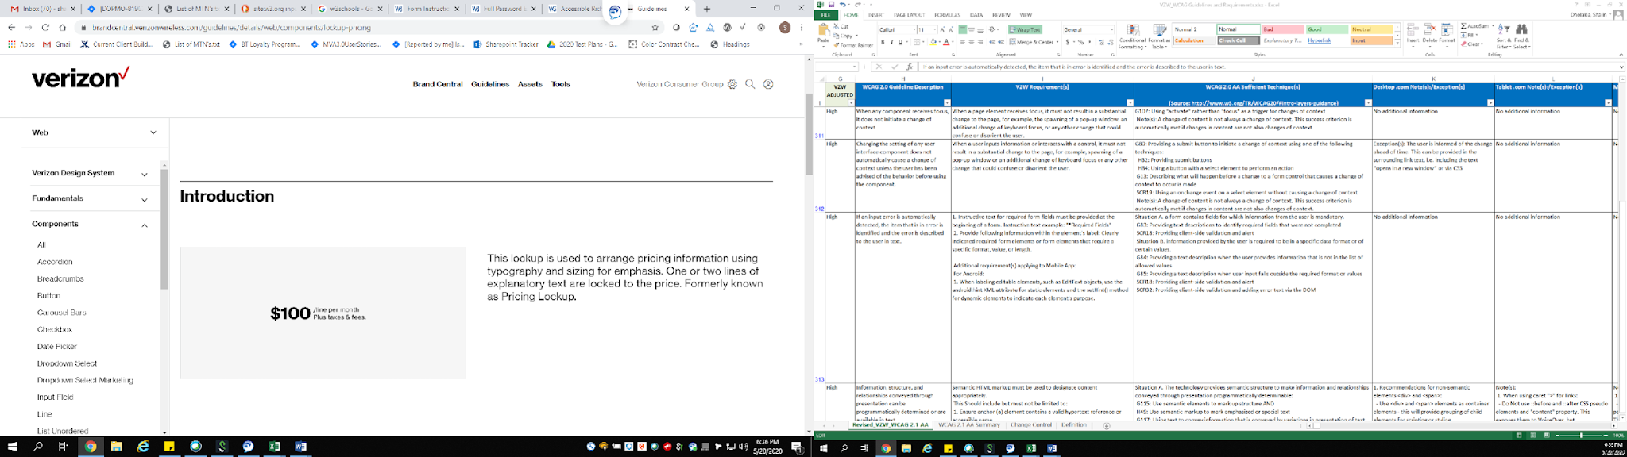

1.4 Distinguishable:
- Ensure that the color contrast meet rules;
- Images and Large text (at or over 18 point/24px /1.5em or bold 14 point/19px/1.2em) must provide a color contrast ratio of at least 3:1
- Regular text (below 18 point/24px /1.5em or bold 14 point/19px/1.2em) must provide a color contrast ratio of at least 4.5:1
- Do not use color as only indicator.
- Content must not rely solely on visual characteristics such as shape, size, visual location, or orientation to convey meaning.

4.1 Compatible:
1. Price changes must be indicated with words in addition to color, graphics, font and positioning.
For example, Screen reader should render the device information as: “iPhone 11 64GB gold, List price $800 Discounted price $650.

Note: Accessibility team prefers that price changes are indicated with text in addition to images, graphics. However, if images must be used, then alt text in 100 characters or less, must provide the price change and details in the image.

Modal (Default):
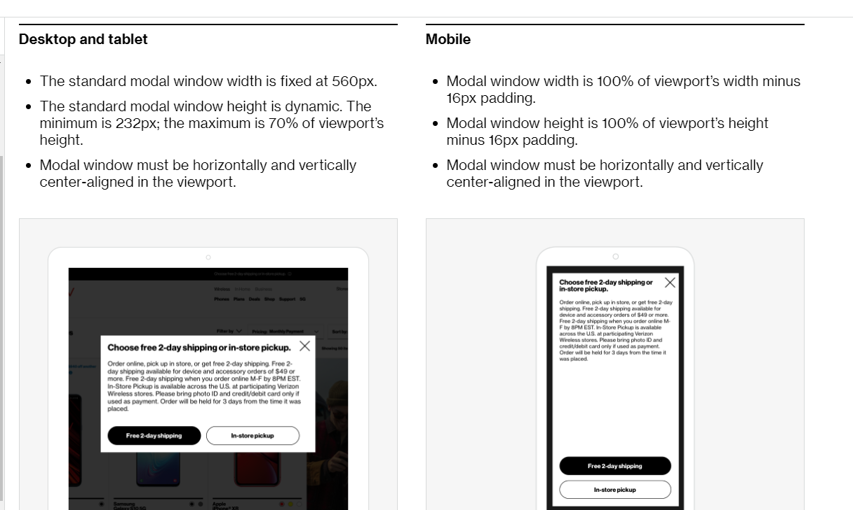

1.4 Distinguishable:
- Ensure that the color contrast meet rules;
- Images and Large text (at or over 18 point/24px /1.5em or bold 14 point/19px/1.2em) must provide a color contrast ratio of at least 3:1
- Regular text (below 18 point/24px /1.5em or bold 14 point/19px/1.2em) must provide a color contrast ratio of at least 4.5:1
- Do not use color as only indicator.
- Content must not rely solely on visual characteristics such as shape, size, visual location, or orientation to convey meaning.

2.4 Navigable
1. All the content and interactive elements of the modal overlay elements must be accessible using the keyboard alone (without a mouse), e.g. using the Tab and Shift Tab key.
2. All the content and interactive elements of the modal overlay must have the ability to be activated using the ENTER or SPACEBAR keys, i.e., anything that can be clicked on with a mouse device, must also activate upon pressing the Enter or Spacebar key.
3. All interactive elements of the modal overlay must show a visual indicator when in a focus. And the color contrast for the focus indicator (at least 3px by 3px) against the background) must be at least 3 to 1.
- Ensure that the focus order is given in a sequential manner that preserves meaning and operability.
- The focus MUST NOT become lost or reset to the top of the page, except when loading or re-loading a page. When modal is closed, focus goes back to triggering element - if not triggering element than it goes to the next interactive element on the page.
- Once the modal overlay is opened, the very first focus should be placed on the Close “X” button. The tab key focus must be trapped on forward and backward navigation, inside the modal panel until dismissed by the user.
- When the modal is open, restrict screen reader focus to the modal by setting aria-hidden=”true”, on each inactive portion of the parent page.
- The modal/dialog element cannot be a child/descendant of any element that has aria-hidden set to true.
- Ensure that captcha, chat, and time out modals are accessible even when they open concurrently with other modals.
- The main heading of the modal overlay should be of <H2> heading and all the subsequent headings must be logical and hierarchical.
- Options to Close a Modal:
-> With keyboard or Screen Reader focus on the Close “X” button. Interact with the close button using the Enter key or the Spacebar key.
-> With keyboard or Screen Reader focus in the Modal overlay, press the Esc key from the keyboard to close the modal.
-> Clicking a button in the Modal that triggers an action or navigates to another page. (e.g., “Continue” button, “Next” button etc.)
-> Clicking a button in the Modal that has been given explicit functionality to close the Modal.
- For Mobile Screen Reader users, the swipe right and left gesture should be used to navigate through the page, with the focus rendering in a consistent manner.
- Double-tapping on an interactive element activates the CTA.

Note: Exception: (iOS and Android / Mobile & Tablet Devices)
In iOS on a web browser, the voice over focus goes to the address bar and is the natural behavior of Voice Over. There is no way to trap Voice Over focus in the web page as that in the other platforms. As for web content, the focus should remain in the modal. However the focus going to the address bar in the browser is the OS level behavior

4.1 Compatible:
- All the labels and interactive controls of the modal must be unique and informative.
- When a label is not provided ensure there is a hidden text added.

Navigation - Skip Navigation Links:

2.4 Navigable:
- Keyboard functional skip link should be provided to allow keyboard users to navigate directly to the main content.
- The "skip link" SHOULD be the first focusable element on the page.
- The skip link must be either visible at all times or visible on keyboard focus. Note: Since Verizon websites and apps design requested non-visible goal will be to stay consistent on all sites and apps.

1.4 Distinguishable:
- Ensure that the color contrast meet rules;
  - Images and Large text (at or over 18 point/24px /1.5em or bold 14 point/19px/1.2em) must provide a color contrast ratio of at least 3:1
  - Regular text (below 18 point/24px /1.5em or bold 14 point/19px/1.2em) must provide a color contrast ratio of at least 4.5:1
- Do not use color as only indicator.
- Content must not rely solely on visual characteristics such as shape, size, visual location, or orientation to convey meaning.

4.1 Compatible:
1. The skip navigation link on the page must be provided an informative label. e.g. “Skip to main content”.
2. The skip navigation link on the page must be provided a specific role as link.

Notification:
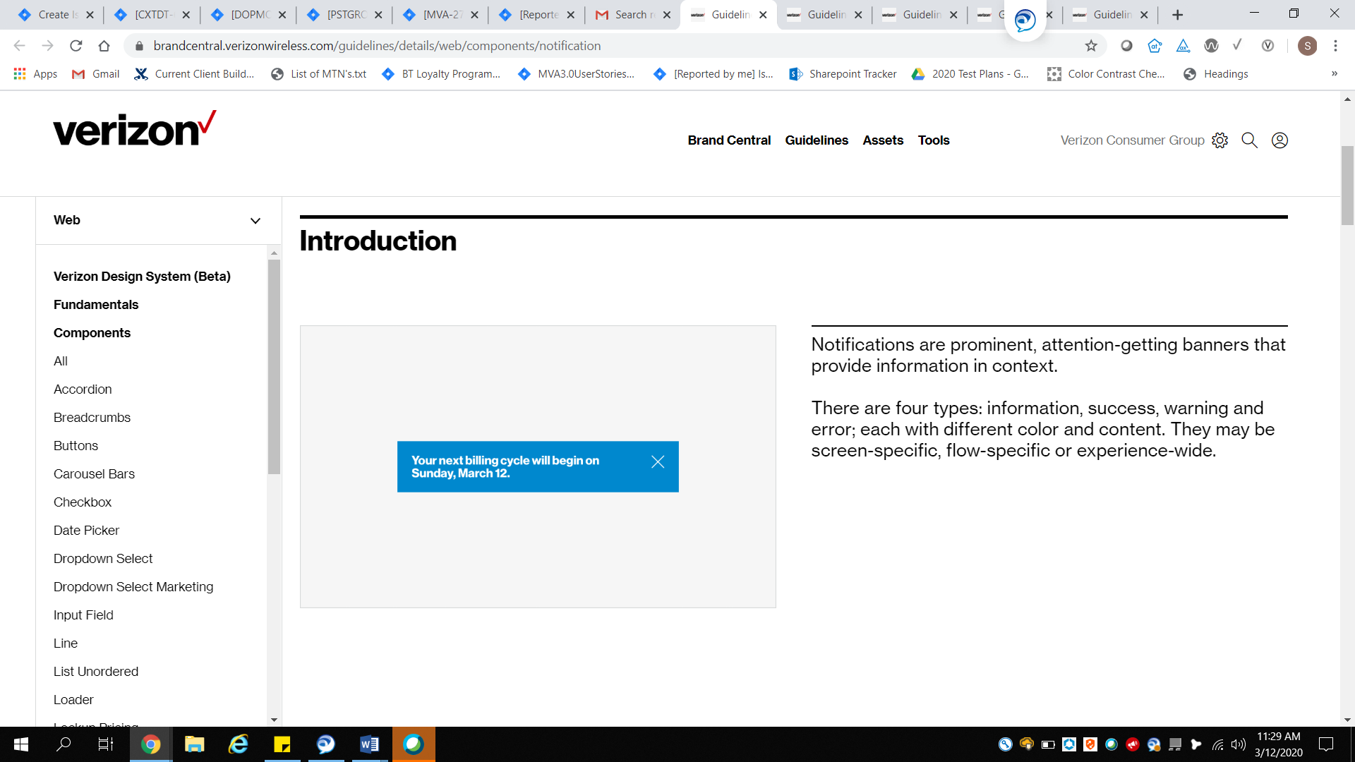

1.4 Distinguishable:
- Ensure that the color contrast meet rules;
- Images and Large text (at or over 18 point/24px /1.5em or bold 14 point/19px/1.2em) must provide a color contrast ratio of at least 3:1
- Regular text (below 18 point/24px /1.5em or bold 14 point/19px/1.2em) must provide a color contrast ratio of at least 4.5:1
- Color should not be the only indicator to identify differences, a visual cue is needed.
- Content must not rely solely on visual characteristics such as shape, size, visual location, or orientation to convey meaning.

2.4 Navigable:
- All interactive elements must be accessible using the keyboard alone (without a mouse), using the Tab, Shift+ Tab key, enter or space. Be sure developers are aware expectation is: In a notification, first focus goes on the close button and tab takes user to all the interactive elements within the notification. To get back to the close button user will need to use shift tab (focus is not locked within the notification window). When notification window closes focus goes back to the trigger element. If user tabs after reaching the last interactive element within the notification (instead of using shift + tab to get back to the close button) the user will be taken to the first interactive element after the notification.
- All interactive elements must have the ability to be activated using the ENTER or SPACEBAR keys, i.e., anything that can be clicked on with a mouse device, must also activate upon pressing the Enter or Spacebar key.
- All interactive elements within the notification popup must show a visual indicator when in a focus. And the color contrast for the focus indicator (at least 3px by 3px) against the background) must be at least 3 to 1.
- For Mobile Screen Reader users, the swipe right and left gesture should be used to navigate through the page, with the focus rendering in a consistent manner.
- Double-tapping on an interactive element activates the CTA.
- On activation focus should move to the notification text for screen readers.

4.1 Compatible:
- Checkmark icon - for success alert style, add hidden text = 'success message'.
- i - icon with blue background - for information alert, add hidden text = 'information notification message'
- i - icon with yellow background - for minor warning alert add hidden text = 'warning message'
- ! inside a triangle - catastrophic warning alert, add hidden text = error notification'

Pagination:
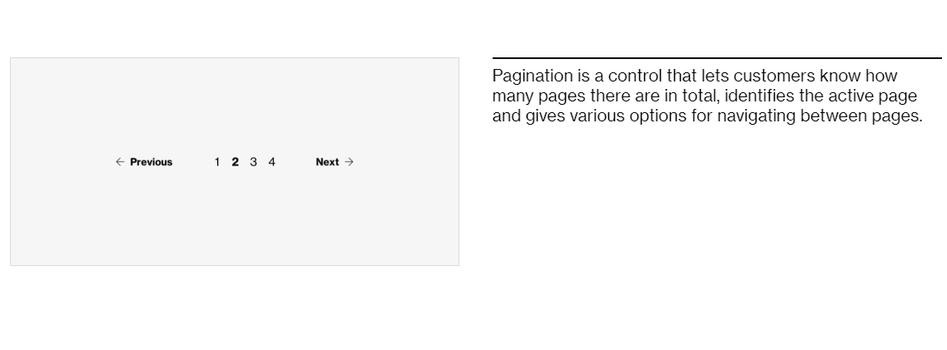

1.4 Distinguishable:
- Ensure that the color contrast meet rules;
- Images and Large text (at or over 18 point/24px /1.5em or bold 14 point/19px/1.2em) must provide a color contrast ratio of at least 3:1
- Regular text (below 18 point/24px /1.5em or bold 14 point/19px/1.2em) must provide a color contrast ratio of at least 4.5:1
- Do not use color as only indicator.
- Content must not rely solely on visual characteristics such as shape, size, visual location, or orientation to convey meaning.

2.4 Navigable:
- "The pagination icons or element links must have the ability to be activated using the ENTER or SPACEBAR keys, i.e., Clicking or tapping anywhere within the hit area must also activate upon pressing the Enter or Spacebar key and takes the user to the previous or next page. Breakout clarification: Links only need to be activated with the enter key whereas pagination icons enter or space.
- All interactive pagination controls must show a visual indicator when in a focus. And the color contrast for the focus indicator (at least 3px by 3px) against the background) must be at least 3 to 1.
- Pagination controls must be contained in a navigation landmark identified with role=”navigation” aria-label="pagination". All the interactive pagination elements must be accessible to the users using the keyboard alone (without a mouse), e.g. using the Tab and Shift Tab key.
- For Mobile Screen Reader users, a 3-finger swipe up/down gesture is required to navigate between screens, with the focus rendering in a consistent manner.
- For Mobile Screen Reader Users, Double-tapping on an interactive element activates the CTA.
- For mobile devices, a swipe up/down gesture is required for the user to navigate between screens.

4.1 Compatible:
1. The pagination icons button/link elements on the page must have unique labels e.g. “page 1 of 10”
2. Roles and attributes
- <a role=”Link”> indicates the pagination element.
- aria-current indicates selected status for links.
- Alternatively, <button role=”button> indicates the pagination element.
- aria-pressed indicates selected status for buttons.
- HTML Disabled or aria-disabled indicates the link or button is not available.

Radio Box:
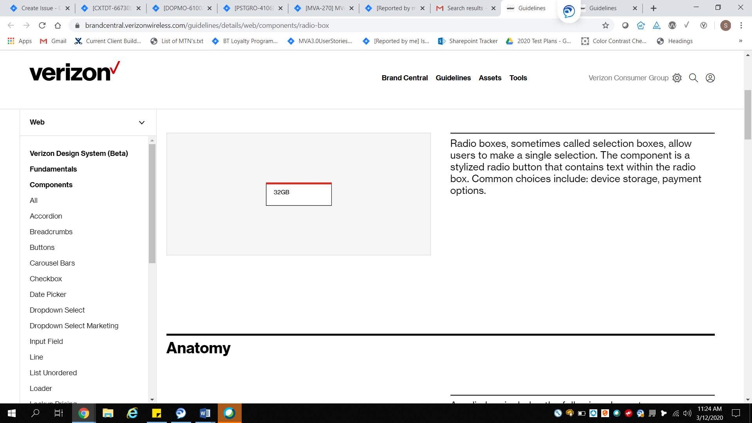

1.4 Distinguishable:
- Ensure that the color contrast meet rules;
- Images and Large text (at or over 18 point/24px /1.5em or bold 14 point/19px/1.2em) must provide a color contrast ratio of at least 3:1
- Regular text (below 18 point/24px /1.5em or bold 14 point/19px/1.2em) must provide a color contrast ratio of at least 4.5:1
- Do not use color as only indicator.
- Content must not rely solely on visual characteristics such as shape, size, visual location, or orientation to convey meaning.

2.4 Navigable:
- All buttons must be accessible using the keyboard alone (without a mouse), e.g. using the Tab and Shift + Tab key. If no radio button is checked, focus moves to the first radio button in the group.
- All radio buttons must have the ability to be activated using the ENTER or SPACEBAR keys, i.e., anything that can be clicked on with a mouse device, must also activate upon pressing the Enter or Spacebar key. Note: if the focused radio button, that was arrow up/down into, is not checked, unchecks the currently checked radio button and checks the focused radio button. Otherwise, enter or space does nothing.
- The Up and Left Arrow should move focus to the previous radio button in the group. If focus is on the first item, focus on the last item.
- The Down and Right Arrow should move focus to the next radio button in the group. If focus is on the last item, then focus wraps to the first item.
- All interactive elements must show a visual indicator when in a focus. And the color contrast for the focus indicator (at least 3px by 3px) against the background) must be at least 3 to 1.
- Screen reader users should be able to use the quick navigation key “a” to bring focus to and move” between the radio box elements.
- For Mobile Screen Reader users, the swipe right and left gesture should be used to navigate through the page and radio buttons, with the focus rendering in a consistent manner.
- Double-tapping on an interactive element activates the CTA.
Note:
- If the radio group has a default selection by the business, the screen reader should announce the name, role, and state. (checked/not-checked)
- If the radio group does not have a default selection by the business, then the user will use space/enter key to select the radio button and that is when it will announce the name, role, and state.

4.1 Compatible:
1. All the radio box elements on the page must be provided a unique label that is informative to the user.
2. Each radio box has a unique id associated and should have ARIA roles, states (checked/not-checked) and property values that must always be defined. An example of roles for the radio button are:
- radiogroup or <fieldset> groups related radio boxes together. Required parent role to radio element.
- <label for=”IDREFRadio”>some text</label> provides a text label for the interactive element and enlarges the touch target.
- aria-label=”some text” provides the label on a single line.
- <input type=”radio” role=”radio”> indicates the radio box element and is a child element to the radiogroup.
- id=”IDREFRadio” unique id referenced by the label element.
- HTML checked or aria-checked=”true” indicates the currently selected radio box.

Radio Button

1.4 Distinguishable:
- Ensure that the color contrast meet rules;
- Images and Large text (at or over 18 point/24px /1.5em or bold 14 point/19px/1.2em) must provide a color contrast ratio of at least 3:1
- Regular text (below 18 point/24px /1.5em or bold 14 point/19px/1.2em) must provide a color contrast ratio of at least 4.5:1
- Do not use color as only indicator.
- Content must not rely solely on visual characteristics such as shape, size, visual location, or orientation to convey meaning.

Navigable:
- All buttons must be accessible using the keyboard alone (without a mouse), e.g. using the Tab and Shift Tab key.
- All radio buttons must have the ability to be activated using the ENTER or SPACEBAR keys, i.e., anything that can be clicked on with a mouse device, must also activate upon pressing the Enter or Spacebar key. Note: if the focused radio button, that was arrow up/down into, is not checked, unchecks the currently checked radio button and checks the focused radio button. Otherwise, enter or space does nothing.
- The Up and Left Arrow should move focus to the previous radio button in the group. If focus is on the first item, then focus wraps to last item. Arrow up/down should read selected/not selected for screen reader users.
- The Down and Right Arrow should move focus to the next radio button in the group. If focus is on the last item, then focus wraps to first item. Selected/not selected state needs to be read to screen reader user.
- All interactive elements must show a visual indicator when in a focus. And the color contrast for the focus indicator (at least 3px by 3px) against the background) must be at least 3 to 1.
- For Mobile Screen Reader users, the swipe right and left gesture should be used to navigate through the page and radio buttons, with the focus rendering in a consistent manner.
- Double-tapping on an interactive element activates the CTA.
Note: If the radio buttons are auto selected, while navigating through, and is the same experience for mouse users than it is not a defect as long as screen reader users are notified. It isn’t the best practice but since in some cases we use default selections and auto-select as a design preference in some instances it is not a defect. Preference is not to select unless ‘activated’ by user.

4.1 Compatible:
1. All the radio box elements on the page must be provided a unique label that is informative to the user.
2. Each radio box has a unique id associated and should have ARIA roles, states (Selected/Unselected) and property values that must always be defined. An example of roles for the radio button are:
- radiogroup or <fieldset> groups related radio boxes together. Required parent role to radio element.
- <label for=”IDREFRadio”>some text</label> provides a text label for the interactive element and enlarges the touch target.
- aria-label=”some text” provides the label on a single line.
- <input type=”radio” role=”radio”> indicates the radio box element and is a child element to radiogroup.
- id=”IDREFRadio” unique id referenced by the label element.
- HTML selected or aria-selected=”true” indicates the currently selected radio box.

Note: Accessibility requirements for radio button, radio box, radio swatch are the same.

Radio Swatch:
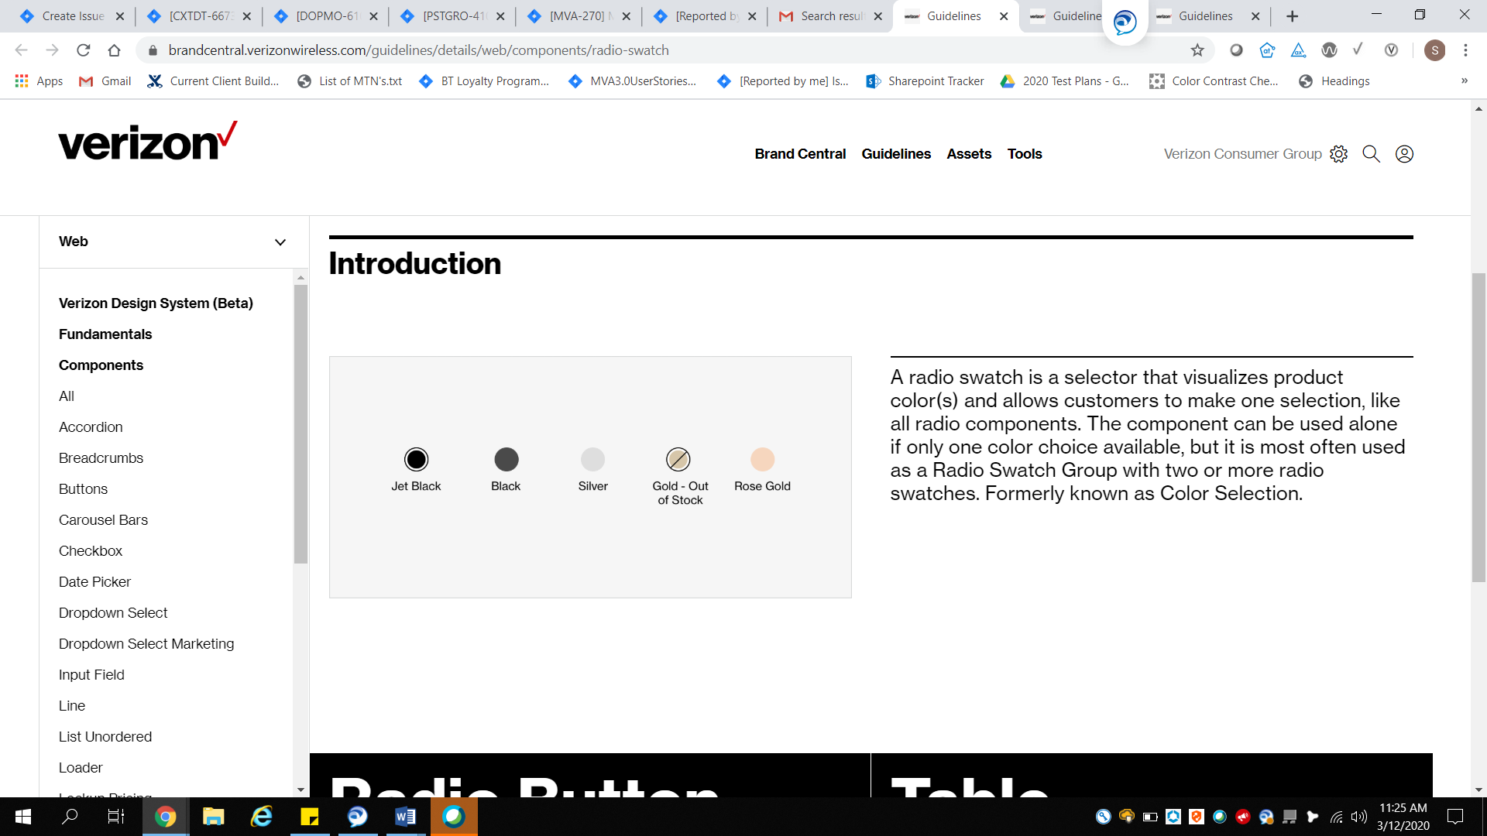

1.4 Distinguishable:
- Ensure that the color contrast meet rules;
- Images and Large text (at or over 18 point/24px /1.5em or bold 14 point/19px/1.2em) must provide a color contrast ratio of at least 3:1
- Regular text (below 18 point/24px /1.5em or bold 14 point/19px/1.2em) must provide a color contrast ratio of at least 4.5:1
- Do not use color as only indicator.
- Content must not rely solely on visual characteristics such as shape, size, visual location, or orientation to convey meaning.

2.4 Navigable:
- All buttons must be accessible using the keyboard alone (without a mouse), e.g. using the Tab and Shift + Tab key. If no radio button is checked, focus moves to the first radio button in the group.
- All radio swatches must have the ability to be activated using the ENTER or SPACEBAR keys, i.e., anything that can be clicked on with a mouse device, must also activate upon pressing the Enter or Spacebar key.
- The Up and Left Arrow should move focus to the previous radio button in the group. If focus is on the first item, then focus wraps to the last item.
- The Down and Right Arrow should move focus to the next radio button in the group. If focus is on the last item, then focus wraps to the first item.
- All interactive elements must show a visual indicator when in a focus. And the color contrast for the focus indicator (at least 3px by 3px) against the background) must be at least 3 to 1.
- For Mobile Screen Reader users, the swipe right and left gesture should be used to navigate through the page, with the focus rendering in a consistent manner.
- Double-tapping on an interactive element activates the CTA.
Note:
- If the radio group has a default selection by the business, the screen reader should announce the name, role, and state. (checked/not-checked)
- If the radio group does not have a default selection by the business, then the user will use space/enter key to select the radio button and that is when it will announce the name, role, and state.

4.1 Compatible:
1. All the radio swatch elements on the page must be provided a unique label that is informative to the user.
2. Each radio swatch has a unique id associated and should have ARIA roles, states (Selected/Unselected) and property values that must always be defined. An example of roles for the radio button are:
- radiogroup or <fieldset> groups related radio swatches together. Required parent role to radio element.
- <label for=”IDREFRadio”>some text</label> provides a text label for the interactive element and enlarges the touch target.
- aria-label=”some text” provides the label on a single line.
- <input type=”radio” role=”radio”> indicates the radio box element and is a child element to the radiogroup.
- id=”IDREFRadio” unique id referenced by the label element.
- HTML selected or aria-selected=”tru” indicates the currently selected radio swatch.

Session Timeout

4.1 Compatible:
1. The screen reader should convey to the user that there is a specific amount of wait time and allow user to extend the session and/or save data.
2. A session must not end without a warning.
3. Focus must be moved to the timeout notification and returned to the content when the timeout closes.

2.4 Navigable:
1. Interactive elements in the modal overlay must be keyboard navigable and operable using the Tab key and Arrows to navigate between the CTA’s and Spacebar or Enter Key to interact with the CTA.
2. Keyboard focus should move to the time out modal overlay and return to the form control that was in focus when the timeout opened.
3. All interactive elements must show a visual indicator when in a focus. And the color contrast for the focus indicator (at least 3px by 3px) against the background) must be at least 3 to 1.
4. Screen reader users should be able to use the quick navigation key “b” to bring focus to the session timeout button.

1.4 Distinguishable:
- Ensure that the color contrast meet rules;
- Images and Large text (at or over 18 point/24px /1.5em or bold 14 point/19px/1.2em) must provide a color contrast ratio of at least 3:1
- Regular text (below 18 point/24px /1.5em or bold 14 point/19px/1.2em) must provide a color contrast ratio of at least 4.5:1
- Do not use color as only indicator.
- Content must not rely solely on visual characteristics such as shape, size, visual location, or orientation to convey meaning.

Superscripts (In-Text Citations):
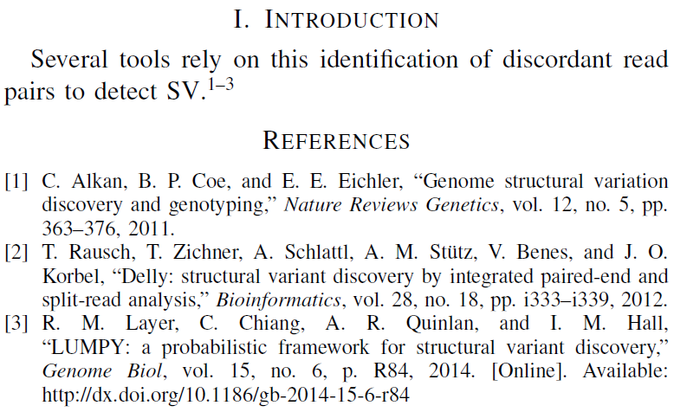
Image Taken From: https://i.stack.imgur.com/RAAsT.png

1.4 Distinguishable:
- Ensure that the color contrast meet rules;
- Images and Large text (at or over 18 point/24px /1.5em or bold 14 point/19px/1.2em) must provide a color contrast ratio of at least 3:1
- Regular text (below 18 point/24px /1.5em or bold 14 point/19px/1.2em) must provide a color contrast ratio of at least 4.5:1
- Do not use color as only indicator.
- Content must not rely solely on visual characteristics such as shape, size, visual location, or orientation to convey meaning.

2.4 Navigable:
- All buttons must be accessible using the keyboard alone (without a mouse), e.g. using the Tab and Shift Tab key.
- All buttons must have the ability to be activated using the ENTER or SPACEBAR keys, i.e., anything that can be clicked on with a mouse device, must also activate upon pressing the Enter or Spacebar key.
- All buttons and interactive elements must show a visual indicator when in a focus. And the color contrast for the focus indicator (at least 3px by 3px) against the background) must be at least 3 to 1.
- Screen reader users should be able to use the quick navigation key “Jaws-key+f3” to bring focus.
- For Mobile Screen Reader users, the swipe right and left gesture should be used to navigate through the page, with the focus rendering in a consistent manner.
- Double-tapping on an interactive element activates the CTA.

4.1 Compatible:
1. All the in-text citations elements on the page must be provided a unique label that is informative to the user.

Table:
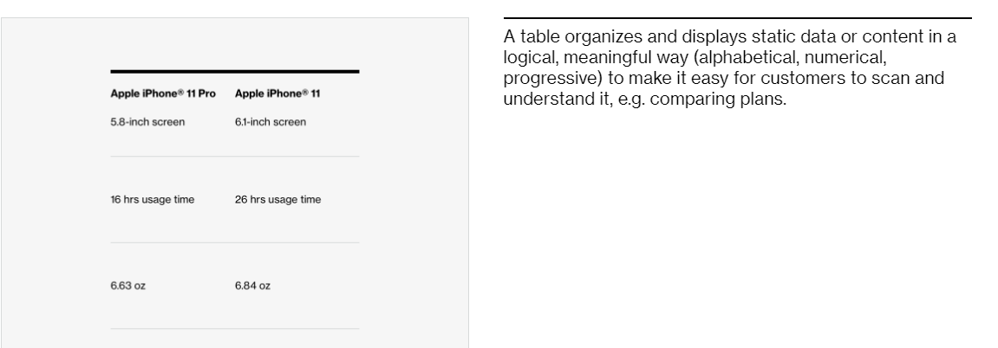

Table related Images for example are for presentation purposes only and source is Accessibility UMN EDU

Table - Data:
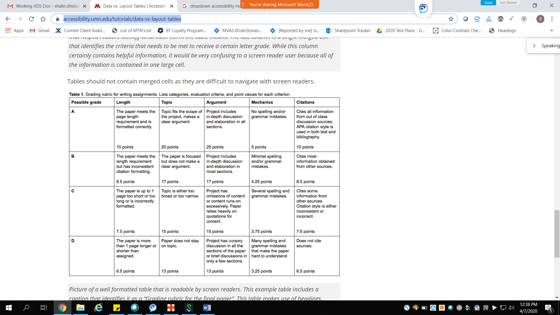

1.4 Distinguishable:
- Ensure that the color contrast meet rules;
- Images and Large text (at or over 18 point/24px /1.5em or bold 14 point/19px/1.2em) must provide a color contrast ratio of at least 3:1
- Regular text (below 18 point/24px /1.5em or bold 14 point/19px/1.2em) must provide a color contrast ratio of at least 4.5:1
- Do not use color as only indicator.
- Content must not rely solely on visual characteristics such as shape, size, visual location, or orientation to convey meaning.

2.4 Navigable
- The data tables must be operable using both keyboard only and screen reader
- Keyboard and screen-reader navigation shortcut key commands. TAB key should allow to focus on any interactive element within a data table. Note: the accessibility team recommends not using interactive elements within data tables (tooltips within data tables are a good example).
      - Use the down arrow to focus on the table.
      - Use Ctrl + Alt + Up/Down arrow to navigate the table per cell.
      - Screen Reader should identify row and column headers associated with each cell.
- All the interactive elements of the Data Table must show a visual indicator when in a focus. And the color contrast for the focus indicator (at least 3px by 3px) against the background) must be at least 3 to 1.
- Screen reader users should be able to use the quick navigation key “t” to bring focus to and move” between tables.
- For Mobile Screen Reader users, the swipe right and left gesture should be used to navigate through the page and table, with the focus rendering in a consistent manner.
- For mobile screen reader users, Double-tapping on an interactive element activates the CTA.

4.1 Compatible:

- Provide a table summary of a sufficient length to accurately and informatively describe the table when a description of the table structure is needed to allow non-visual users to gain the description and information of the table.
- Data tables should have a programmatically-associated <caption> or name (e.g. via aria-label or aria-labelledby).
Note: In most circumstances, <caption> is preferred, because it is the native method of giving a name to a table, and the <caption> is visible and available to all users by default.
- Cells in a table header row or column must use <th> consistently and must define either an id or a scope attribute for each cell in a header row or column.
- Header/data associations that cannot be designated with <th> and scope must be designated with the headers and id attributes.
- Data tables must identify the header cells that label the data cells in the same column or row. The header cells must be identified with an id so that each data cell <td> has a header attribute that references the id attribute of the <th> elements that are headers for the data cell. Table data cells must be associated with their corresponding header cells.
- Use of scope (<th scope="col"> and <th scope="row">) is highly recommended and Verizon accessibility requires (i.e. if all cells in the first row are marked as <th> without scope, most modern screen readers will infer that the scope is the column below each header cell).
- Table data group headers (if any) must be associated with their corresponding data cell groups (e.g. via scope="rowgroup" or scope="colgroup").
- Table data/headers in separate columns must be rendered in separate table cells i.e., each distinct header and data element within a data table should be placed in its own table cell.
- If possible try to avoid using nested data tables to properly identify tables and allow navigation within them.Data table headers and data associations must not be referenced across nested, merged, or separate tables.
- Tabular data should be represented in a <table>. Even if the data are not represented in a table, WCAG 1.3.1 requires the data to be associated with their labels.
- Data table headers cells must not be blank. Data tables must identify text for header cells that label the data cells in the same column or row.
- The data tables must be operable using both keyboard only and screen reader.

Table Layout:

1.4 Distinguishable:
- Ensure that the color contrast meet rules;
- Images and Large text (at or over 18 point/24px /1.5em or bold 14 point/19px/1.2em) must provide a color contrast ratio of at least 3:1
- Regular text (below 18 point/24px /1.5em or bold 14 point/19px/1.2em) must provide a color contrast ratio of at least 4.5:1
- Do not use color as only indicator.
- Content must not rely solely on visual characteristics such as shape, size, visual location, or orientation to convey meaning.

2.4 Navigable
- The layout tables must be operable using both keyboard only and screen reader
- Keyboard and screen-reader navigation shortcut key commands. TAB key should allow to focus on any interactive element within a layout table.
- The enter and spacebar keys should activate all CTAs.
- All the interactive elements of the layout table must show a visual indicator when in a focus. And the color contrast for the focus indicator (at least 3px by 3px) against the background) must be at least 3 to 1.
- For Mobile Screen Reader users, the swipe right and left gesture should be used to navigate through the page, with the focus rendering in a consistent manner.
- Double-tapping on an interactive element activates the CTA.
Note: The accessibility team suggests using layout tables for positioning of CTAs and form fields only, for example device comparison charts.

4.1 Compatible
- Ensure layout tables are linearized properly... meaning, when the sequence in which content is presented affects its meaning so that the Screen Readers must render a correct reading sequence in which the page content appears.
- Screen readers render layout tables in a linear format starting with c1r1, c2r1, c3r1, etc.
- Ensure that the layout tables indicate their role of presentation by adding role="presentation" within <table> tag. For Example: <table role="presentation">

Tabs: Vertical and Horizontal

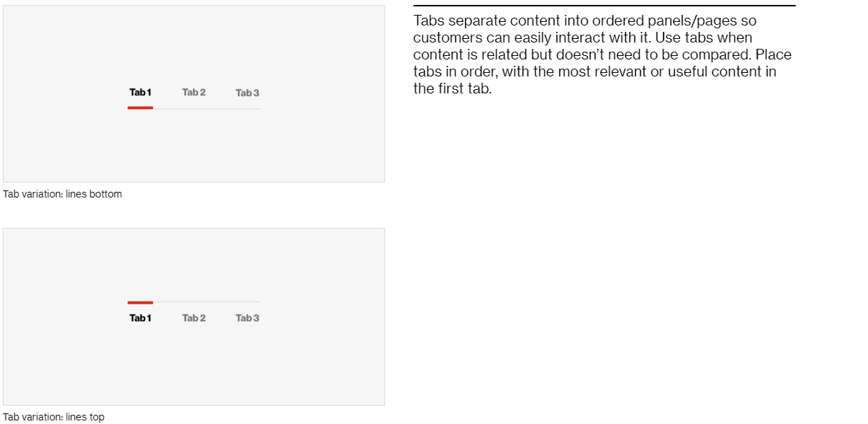

1.4 Distinguishable:
- Ensure that the color contrast meet rules;
- Images and Large text (at or over 18 point/24px /1.5em or bold 14 point/19px/1.2em) must provide a color contrast ratio of at least 3:1
- Regular text (below 18 point/24px /1.5em or bold 14 point/19px/1.2em) must provide a color contrast ratio of at least 4.5:1
- Do not use color as only indicator.
- Content must not rely solely on visual characteristics such as shape, size, visual location, or orientation to convey meaning.

2.4 Navigable:
- Vertical and Horizontal tab panel: All the tab elements must be navigable and accessible using the keyboard alone (without a mouse), e.g. using the Tab and Shift Tab key.
- Horizontal tab: The right and left arrow keys should move between the tabs, and the Home and End (fn+home / fn+end) Key should move between the first and last tab, respectively. Vertical tab: The up and down arrow keys should move between the tabs, and the Home and End (fn+home/fn+end) Key should move between the first and last tab, respectively. BOTH Vertical and Horizontal should also read selected when activated with enter or space and should indicate The up Tab list items should read x of y and list item accessible name.
- Vertical and Horizontal tab: The interactive tabbed elements must be activated using the ENTER or SPACEBAR keys, i.e., Clicking or tapping anywhere within the hit area must also activate upon pressing the Enter or Spacebar key.
- Vertical and Horizontal tab: Pressing the Enter or Spacebar key moves keyboard focus to the associated tab panel content.6.
- For Mobile Screen Reader users, the swipe right and left gesture should be used to navigate through the page, with the focus rendering in a consistent manner.
- Double-tapping on an interactive element activates the CTA and moves keyboard focus to the related tab panel content.

4.1 Compatible
1. All the tab elements on the page must be provided a unique label that is informative to the user.
2. Once selection has been made the screen reader should announce the selected state and specify the name of the tab, e.g. “selected Billing tab 1 of 3”
3. Roles and attributes for the tab and tab panel components are:
A. Trigger elements
- tablist indicates the container for tab elements. (parent)
- Tab indicates the trigger CTA that reveals the tab panel content and moves focus to the beginning of the tab panel. (child)
- aria-selected=“true” Indicates the tab control is active and its associated panel is displayed
- aria-controls=“IDREFTabpanel” Refers to the tabpanel element associated with the tab.
B. Content displayed in the Panel / slide.
- tabpanel Indicates the element serves as a container for content
- id=“IDREFTabpanel” unique id referenced by aria-controls.
- tabindex=“0” puts the interactive elements in the page Tab sequence on visible tab panels. Do not add tab index 0 to the slide container <div> because it is not an interactive element.
- tabindex=“-1” has two uses. First, it removes hidden interactive elements from the Tab key sequence (aria-hidden does not do this). Second, it is used to programmatically move focus to non-interactive text. E.G. If focus is placed directly on the <h2> header element, the screen reader announces the header.

Text Size Minimums:
Text styles are 13 pixel. Any text that falls below the 13px threshold are Body Small (12px) and MIcro (11px), both of which exclusively utilize the Verizon NHG eText (digital-optimized) typeface to ensure legibility/accessibility for those small text sizes. As we have known that the Micro (11px) text size has only been approved by your team for use in legal text, we have a guideline on the typography page stating this and we do not use the Micro text size in any of our components except Typography itself and the Footnotes and Unordered List components which can be used to feature legal text.

Text Resize and Reflow:

Desktop Zoom:
1. Text MUST be resizable at least up to 200% larger.
2. The page SHOULD be functional when only the text is magnified to 200% of its initial size.
3. The page SHOULD be readable when only the text is magnified to 200% of its initial size.
4. Text SHOULD magnify without losing content overlapping text with interactive elements to retain readability.
5. Text SHOULD reflow to fill most of the width of the viewport, without causing any horizontal viewport overflow.

Mobile Zoom:
1. The page MUST allow users to zoom in on mobile devices (The following is NOT allowed: <meta name="viewport" content="user-scalable=no">).

One Scroll Direction Only:
1. Content MUST NOT require scrolling in two directions (both vertically and horizontally) — even when the viewport is set or zoomed to 320 CSS pixels wide (for vertically-scrolling content) or 256 CSS pixels high (for horizontally-scrolling content) — unless both scrolling directions are essential to the usage or meaning of the content.
2. MUST respond to the viewport size or zoom state by resizing and/or reflowing, at viewport resolutions of up to 320px for vertically-scrolling content, and 256px for horizontally-scrolling content.

Tilelet
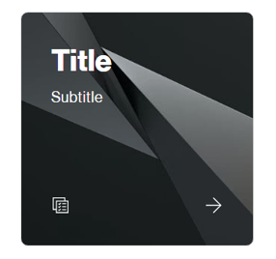
A tilelet is a clickable component that displays content including text, images and icons. A tilelet is used for navigation, though it cannot hold another interactive element, such as a tooltip or CTA except it can hold a directional arrow icon. A tilelet group displays a collection of tilelet components in a row or a grid.

4 Distinguishable:

- Ensure that the color contrast meet rules.
  - Images and Large text (at or over 18 point/24px /1.5em or bold 14 point/19px/1.2em) must provide a color contrast ratio of at least 3:1
  - Regular text (below 18 point normal or 14 points bold) must provide a color contrast ratio of at least 4.5:1
- Content must not rely solely on visual characteristics such as shape, size, visual location, or orientation to convey meaning.

2.4 Navigable:

- Tilelet must be accessible using the keyboard alone (without a mouse), e.g., using the Tab and Shift Tab key.
- Tilelet must have the ability to be activated using the ENTER key, i.e., anything that can be clicked on with a mouse device, must also activate upon pressing the key.
- Tilelet element must show a visual indicator when in a focus. And the color contrast for the focus indicator (at least 3px by 3px) against the background) must be at least 3 to 1.
- A screen reader user using tab key only should be able to read the entire Tilelet content. If user uses continuous reading (Up and Down arrows) the title, subtitle, and subsequent content of the tilelet needs to be read continuously through tilelet until user stops continuous reading.
- For Mobile Screen Reader users, the swipe right and left gesture should be used to navigate through the page, with the focus rendering in a consistent manner.
- For Mobile Double-tapping on an interactive element activates the tilelet.

4.1 Compatible
      - The tilelet elements on the page must be provided with at least one main header <h2> or <h3>.
      - Each tile container has a unique id associated and should have ARIA roles.
        - <a> or role=”link” indicates a link element.
        - <button> or role=”button” indicates a button element.

Title

4. 1 Compatible

1. Every page must have a title.
2. The title must be an informative, specific, and accurate description of the page to let user know what the context of the page is all about.
3. Dynamic Page content. The page <title> of dynamic pages (e.g. in single page apps) must be updated when the purpose of the page changes.
4. Change of context. User if a page is the result of a user action or scripted change of context, the text of the <title> should describe the result or change of context to the user.
5. The page <title> must be present and must contain title text. Make sure that it is concise and unique. We don't want the same title used on multiple pages otherwise customer won't know they are there. If adding a device to cart but on the customize section then the title can be “customize protection options”.
6. Present the unique portions of the title first. E.G. “customize protection options – Verizon”.

1.4 Distinguishable:
- Ensure that the color contrast meet rules;
- Images and Large text (at or over 18 point/24px /1.5em or bold 14 point/19px/1.2em) must provide a color contrast ratio of at least 3:1
- Regular text (below 18 point/24px /1.5em or bold 14 point/19px/1.2em) must provide a color contrast ratio of at least 4.5:1
- Do not use color as only indicator.
- Content must not rely solely on visual characteristics such as shape, size, visual location, or orientation to convey meaning.

Title Accented:

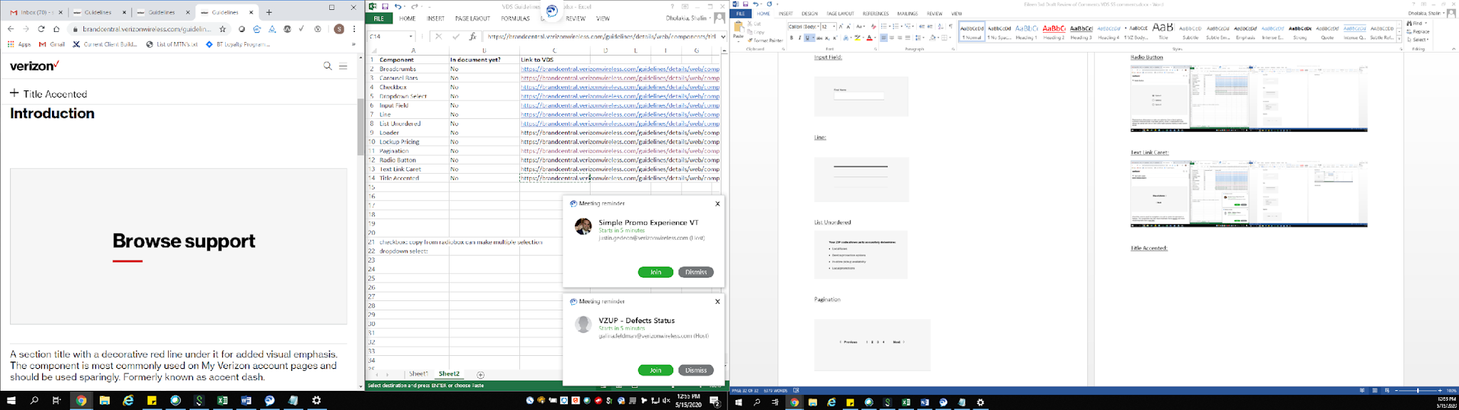

1.4 Distinguishable:
- Ensure that the color contrast meet rules;
- Images and Large text (at or over 18 point/24px /1.5em or bold 14 point/19px/1.2em) must provide a color contrast ratio of at least 3:1
- Regular text (below 18 point/24px /1.5em or bold 14 point/19px/1.2em) must provide a color contrast ratio of at least 4.5:1
- Do not use color as only indicator.
- Content must not rely solely on visual characteristics such as shape, size, visual location, or orientation to convey meaning.

Toggle:
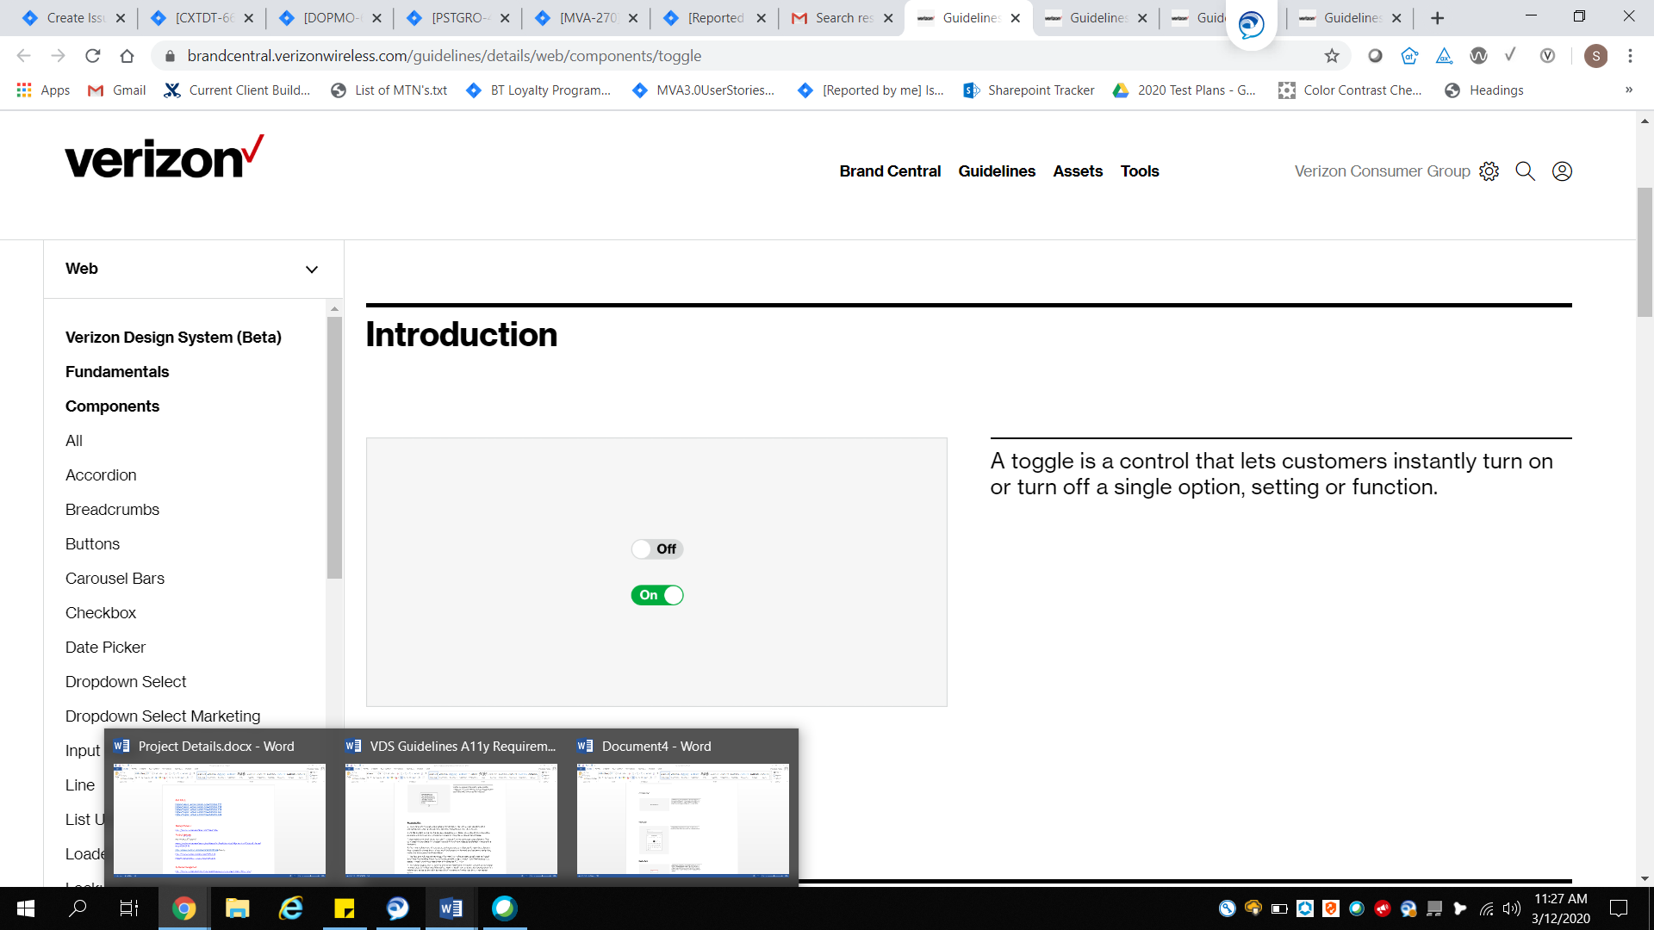

1.4 Distinguishable:
- Ensure that the color contrast meet rules;
- Images and Large text (at or over 18 point/24px /1.5em or bold 14 point/19px/1.2em) must provide a color contrast ratio of at least 3:1
- Regular text (below 18 point/24px /1.5em or bold 14 point/19px/1.2em) must provide a color contrast ratio of at least 4.5:1
- Do not use color as only indicator.
- Content must not rely solely on visual characteristics such as shape, size, visual location, or orientation to convey meaning.

2.4 Navigable:
- All toggles must be accessible using the keyboard alone (without a mouse), e.g. using the Tab and Shift Tab key.
- All toggles must have the ability to be activated using the ENTER or SPACEBAR keys, i.e., anything that can be clicked on with a mouse device, must also activate upon pressing the Enter or Spacebar key.
- All interactive elements must show a visual indicator when in a focus. And the color contrast for the focus indicator (at least 3px by 3px) against the background) must be at least 3 to 1.
- Screen reader users should be able to use the quick navigation key “alt n” to bring focus and navigate between the buttons.
- For Mobile Screen Reader users, the swipe right and left gesture should be used to navigate through the page, with the focus rendering in a consistent manner.
- Double-tapping on an interactive element activates the CTA.

4.1 Compatible:
1. All the toggle elements on the page must be provided a unique label that is informative to the user. (can be checkbox/switch/button please see ‘note on toggle’ (source: W3C)
2. Each toggle has a unique id associated and should have ARIA roles, states and property values that must always be defined. An example of roles, states, and values for a toggle button are: (please see note)
- <button> or role=”button” to announce a button
- aria-pressed="true" to announce ON state of trigger element
- aria-pressed="false" to announce OFF state of trigger element
- aria-label=”some text” (optional) provides the label on a single line.
Note on toggle:
A switch is an input widget that allows users to choose one of two values: on or off. Switches are similar to checkboxes and toggle buttons, which can also serve as binary inputs. One difference, however, is that switches can only be used for binary input while checkboxes and toggle buttons allow implementations the option of supporting a third middle state. Checkboxes can be checked or not checked and can optionally also allow for a partially checked state. Toggle buttons can be pressed or not pressed and can optionally allow for a partially pressed state.
Since switch, checkbox, and toggle button all offer binary input, interchangeable and allowed. Roles should match both visual design and semantics of the user interface. For instance, there are some circumstances where the semantics of on or off would be easier for assistive technology users to understand than the semantics of checked or unchecked, and vice versa. This means the toggle can be coded as a checkbox and work as expected as long as it reads the state properly (off/on or enabled/disabled or whatever matches the situation for the toggle.

Tooltip:
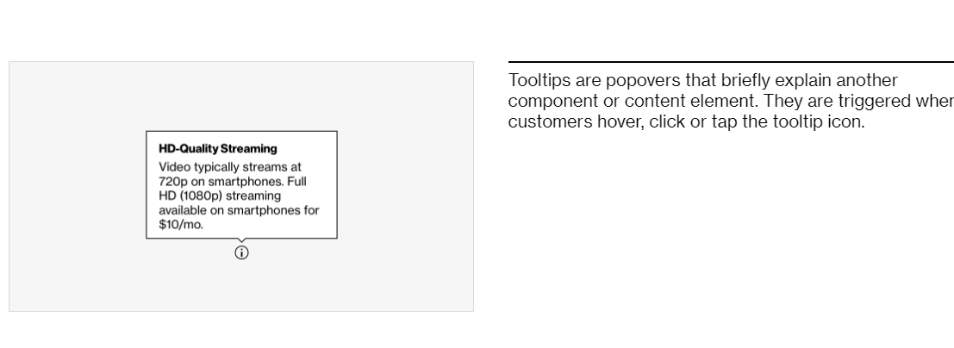

1.4 Distinguishable:
- Ensure that the color contrast meet rules;
- Images and Large text (at or over 18 point/24px /1.5em or bold 14 point/19px/1.2em) must provide a color contrast ratio of at least 3:1
- Regular text (below 18 point/24px /1.5em or bold 14 point/19px/1.2em) must provide a color contrast ratio of at least 4.5:1
- Do not use color as only indicator.
- Content must not rely solely on visual characteristics such as shape, size, visual location, or orientation to convey meaning.

2.4 Navigable:
1. The tooltip must be operable using a keyboard only with or without a screen reader.
2. Tooltip must be scrollable by keyboard, using the “up and down arrows”
3. All interactive elements of the tooltip must show a visual indicator when in a focus. And the color contrast for the focus indicator (at least 3px by 3px) against the background) must be at least 3 to 1.
4. Once the tooltip is opened, the very first focus should be placed on the Close “X” button. If the tooltip does not have an X to close out, then it should close on escape or if the tab key is used to go to the next interactive element.
5. The keyboard focus must never be locked or trapped at one particular point within the tooltip overlay.
6. The focus MUST NOT become lost or reset to the top of the page, except when loading or re-loading a page.
7. Tooltips must be readable with up to 2x magnification enabled.
8. For tooltips that contain simple non-interactive text, Tab key focus or enter key press opens the text content. Enter key press toggles the text content open and closed, Pressing the enter key, escape key, and tabbing away from the triggering element all close the text content.
9. Once a screen reader User opens the tooltip with enter or space, the screen reader announces "expanded" after reading all of the content – and a user can use the arrow up/down to stop and read/re-read content and tooltip needs to provide more information in context (what is the tooltip for)
10. A screen reader user should be able to use the Up and down arrow keys to read the tooltip content.
11. For tooltips that contain simple non-interactive text, Tab key focus or enter key press opens the text content. Enter key press toggles the text content open and closed, Pressing the enter key, escape key, and tabbing away from the triggering element all close the text content
For Mobile Screen Reader users, the swipe right and left gesture should be used to navigate through the page, with the focus rendering in a consistent manner.
- If Double-tapping is required for interactive elements, refer to the accessibility guidelines for modals instead of this tooltip.
Note: For tooltips already on the website that contain a close button, “X”, links or interactive elements, refer to the accessibility guidelines for modals instead of this tooltip.

4.1 Compatible:
1. Roles and attributes for the trigger and related text content.
A. Trigger element
- <button role=”button”> indicates the trigger element.
- aria-expanded=”true” indicates the tooltip is expanded and related content is visible.
B. Related content
-Not required, role="tooltip" indicates the content is read only. Never use it for interactive content.
- aria-hidden=”true” hides the text from screen readers.
- aria-hidden=”false” reveals the text to screen readers.
- Note: Tooltip content coded as a child / descendant of the tooltip trigger element is not read correctly by the JAWS screen reader.

